BLMK ICS
2019/20-2023/24 Primary Care Strategy
Version Control
Version Number | Date | Author | Details of Update
1.0 | 5.06.19 | BLMK Commissioners/ PC leads | BLMK Exec  Include risks - finance
 | 7.06.19 | BLMK Commissioners/ PC leads | PC leads meeting  Revised content (whole doc)
 | 10.06.19 | BLMK Commissioners/ PC leads | BLMK Transformation Board – assured content
 | 17.06.19 | BLMK Commissioners/ PC leads | PC leads meeting  Revised content (whole doc)
 | 18.06.19 | BLMK Commissioners/ PC leads | LCCG Board – assured content.  Prevention, Digital Plan, Vision
1.7 | 20.06.19 | BLMK Commissioners | Draft NHSE submission

Authorisation
Date | Name | Position
20.06.19 | Geraint Davies | Director of System Commissioning (BLMK CCGs Commissioning Collaborative)
 | BLMK Executive team
Table of Contents
1 List of Tables and Figures 6
2 Executive Summary 8
3 Vision 11
3.1 Context 11
3.2 Our Vision for BLMK Primary Care 11
3.3 Primary Care Home within BLMK 13
3.4 Population Health 13
4 Introduction 17
4.1 Bedfordshire, Luton & Milton Keynes 17
4.2 Primary Care Networks & Practices 18
4.3 Primary care workforce statistics 19
5 The case for change 20
5.1 Demographic profile and health inequalities 20
5.2 Workforce profile 24
5.3 Estates 31
6 Key element 1 - We will boost ‘out-of-hospital’ care, and finally dissolve the historic divide between primary and community health services 35
6.1 BLMK’s six enabler approach to developing mature Primary Care Network (PCN) integrated teams 35
6.2 Workforce Configuration 40
6.3 GP resilience programmes across BLMK 45
6.4 BLMK governance for PCN development including GPFV initiatives 51
7 Key element 2 - The NHS will reduce pressure on emergency hospital services 53
7.1 Emergency hospital services: current situation 53
7.2 Investment and Impact Fund 55
7.3 Improving access to primary care 55
7.4 Complex Care/Care homes 58
7.5 Mental Health and Learning Disabilities 61
7.6 Children 64
7.7 Workforce Configuration 65
8 Key element 3 - People will get more control over their own health and more personalised care when they need it 68
8.1 Personalised Care Programme 68
8.2 The role of Primary Care in personalising healthcare services. 68
8.3 Workforce within Personalised Care 69
8.4 Technology 69
9 Key element 4 - Digitally-enabled primary and outpatient care will go mainstream across the NHS 71
9.1 The Current Situation 71
9.2 Delivering Digitally Enabled Healthcare within Primary Care 72
9.3 Impact for Workforce 73
9.4 NHS Future Collaboration Platform 73
9.5 Delivery 74
9.6 Governance and Operational Arrangements 76
9.7 Resources 76
9.8 Workforce Configuration 77
10 Key element 5 - Local NHS organisations will increasingly focus on population health – moving to Integrated Care Systems everywhere 78
10.1 Population Health 78
10.2 Primary Care Network PHM group 79
11 Governance 84
11.1 Integrated Care System 84
11.2 ICS priority workstreams 84
11.3 Workforce 85
12 Measurement 86
12.1 GP Patient Survey 86
12.2 National Reporting 87
12.3 Patient Participation Groups 88
13 Finance 91
13.1 Primary Medical Care Allocations 91
13.2 Funding the New Models of Care 91
13.3 PCN DES payments 94
13.4 GPFV 95
13.5 Investment in Estates and Technology 96
13.6 Investment and Impact Fund 99
13.7 Risks & Mitigations 99
14 Useful Data Sources 100
15 Appendices 101
15.1 Appendix A: BLMK PCN Development Checklist 101
15.2 Appendix B: The Core Elements of Primary Care Home 102
15.3 Appendix C: Time series of baseline figures for GP’s (workforce) 103
15.4 Appendix D: BLMK ICS Leadership & OD plan 103
15.5 Appendix E: BLMK Local Workforce Plan 103
15.6 Appendix F: Hubs - Service Model Framework 104
15.7 Appendix G: Priority Primary Care Estates Scheme 105
15.8 Appendix H: BLMK Cluster Maturity Map – March 2019 107
15.9 Appendix I: NHS E Maturity Matrix 108
15.10 Appendix J: Complex Children 109
15.11 Appendix K: Personalisation Programme 110
15.12 Appendix L: PCN Network Map – Required Support from May 2019 114
15.13 Appendix M: Primary Medical Allocations 115
15.13 Appendix N: Primary Care Medical Services Forecast Spend 117
15.14 Appendix O: Engaging the team 120

List of Tables and Figures
Figure 1 Primary Care Home Model 12
Figure 2 Strategies and associated footprints 14
Figure 3 Map of BLMK ICS 18
Figure 4 Projected population growth in BLMK, 2017-2035. 20
Figure 5 Projected populations by place and age-group, 2017-2035. 21
Figure 6 Ethnicity and deprivation in BLMK. 22
Figure 7 Levels of prevention 23
Figure 8 BLMK Primary Care workforce profile 25
Figure 9 Workforce trajectories 26
Figure 10 Workforce strategy and development plan summary 28
Figure 11 BLMK training hub governance 29
Figure 12 Training hub timeline 30
Figure 13 10 High Impact Actions 31
Figure 14 Primary Care Home approach 36
Figure 15 Six emerging care models 37
Figure 16 Care models 38
Figure 17 Anticipatory care plan approach 39
Figure 18 New Models of Care 40
Figure 19 New Ways of Working within Primary Care 41
Figure 20 - Components of the MDT model 42
Figure 21 Population Health Approach to Workforce Modelling for MDT 42
Figure 22 Integrated health and Care MDT Configuration 43
Figure 23 Workforce requirements to deliver the MDT model (Core team) 43
Figure 24 Workforce requirements to deliver the MDT model (Extended team) 44
Figure 25 National timeframes for funding new roles within Primary Care 45
Figure 26 GP Resilience Programme Process 47
Figure 27 GP Resilience programme timeline 50
Figure 28 Governance for PCN development 51
Figure 29 Bedford Hospital A&E attendances 53
Figure 30 Milton Keynes Hospital A&E attendances 54
Figure 31 Luton and Dunstable Hospital A&E attendances 54
Figure 32 Patient survey data 56
Figure 33 Summary of weekly extended access hours delivered 56
Figure 34 Extended access core requirements 57
Figure 35 Current DES activity and PCN requirement 58
Figure 36 BLMK House of Care 59
Figure 37 PCN MDT planning assumptions 64
Figure 38 NHS Future Collaboration Platform 72
Figure 39 Digital developments timeline 73
Figure 40 Digital strategy governance 74
Figure 41 BLMK Digital Programme Workforce Implications 75
Figure 42 Population health priorities 77
Figure 43 Engagement model 78
Figure 44 Population health grid 79
Figure 45 Population Health Approach to Workforce Modelling for MDT 80
Figure 46 MDT workforce model metrics 81
Figure 47 Design principles 81
Figure 48 ICS governance 82
Figure 49 BLMK ICS Priorities 83
Figure 50 LWAB operating model 84
Figure 51 Patient survey data 85
Figure 52 PCN support 91
Figure 53 NAPC PCN support 92
Figure 54 PCN DES payments 93
Figure 55 GPFV MoU allocations 93
Figure 56 2019/20 ETTF funding 95
Figure 57 2020/21 ETTF funding 96
Figure 58 Useful data sources 98

Executive Summary
Responsive, proactive and accessible primary care needs to be led by general practice. It must be delivered in partnership with a wide range of professionals who are supported to better understand the health and wellbeing needs of the local communities they serve. In BLMK, we see this being achieved through an enhanced delivery model which, in design and operating model, draws inspiration from the Primary Care Home (PCH) model. The integration of community health, mental health and social care services with primary care clinicians is crucial. However, this integration will be effective and sustainable only if services are co-designed with GPs and communities, to be wrapped around a strengthened and scaled primary care delivery model.
We are co-designing a resilient, multi-disciplinary and high quality primary care system in the heart of our local communities across BLMK. GPs will be at the centre of patient care, supporting and directing the provision and co-ordination of high quality medical care and treatment for those that are ill, but also in bringing about improved health and well-being for our population as a whole.
We have continued to grow and develop as a system in the last year, building on our track record of delivery and collaborative working.
Our Single System Operating plan acts as an umbrella for the plans developed and owned by each of our four place-based Transformation Boards and the operational plans for each of BLMK’s partner organisations.
All 15 statutory organisations, and other essential partners, comprising the BLMK ICS recognise this and are committed to supporting new models of working with and alongside general practice.
Using tried and tested PCH methodology across BLMK we have co-designed and tested an approach for developing fully integrated community-based healthcare through expanded community teams focused on identified and agreed priority patient population cohorts in 7 out of the 22 emerging BLMK PCNs with another 5 set to quickly achieve step 1 as described in NHSE PCN maturity matrix.
Please see Appendix A for the BLMK PCN Development Checklist.
The six elements outlined below provide the underpinning principles and a framework to assessing need and understanding how best to utilise resources to maximise potential to achieving mature PCNs across BLMK:
- Understand need (current and future)
- Agree care functions
- Develop skill mix and pool of existing staff
- Build and embed team based culture
- Deliver the education and training required
- Develop the plan for future supply
The new model of care ‘a complete care community’ is built around patients and for patients, ensuring they receive the Right Care in the Right Place at the Right Time.
The GP remains central to patient care and care planning, supported by the multi-disciplinary team to coordinate care across all elements of their physical/ mental health and social care needs.
Patients will benefit by being able to access services quickly and will be helped to be more independent and manage their own health needs, understanding when and who to call for assistance if their condition exacerbates.
Like many areas BLMK faces challenges around access to primary care services. In order to respond to this:
- We are now delivering extended access to 100% of patients across the ICS and will be supporting the implementation of extended hours via PCNs in 2019/20, preparing them for the access specification to be published by NHS England later this year.
- BLMK CCGs have been working with practices, 111 providers, extended access services and IM&T providers to roll out direct booking from 111. This is being utilised in all extended access services and the vast majority of practices in BLMK with the rest set to come online during 2019/20.

The longer term sustainable solution to improving access is to continue to ensure the delivery of the Primary Care Home model underpinned by a population health management approach.

In order to achieve transformation we will need to continue to invest in workforce development.

The BLMK Training Hub will continue to build on the work already underway by supporting Primary Care Networks to develop workforce plans.

We have undertaken system level workforce modelling. This facilitates a more accurate assessment of future workforce capability and capacity to ensure the workforce profile for PCNs across BLMK meet the current needs of the local population and forecasted demand over the next 5 years.

Social prescribing is in place across BLMK and we are committed to further expanding the offer, to incorporate Social Prescribing Link Workers in line with NHS England’s role reimbursement scheme. This will enable people to be linked to local groups, activities and new hobbies. Individuals will have support tailored to their needs, ranging from very regular, intensive support to single-contact interventions.

High Intensity User Programmes are an integral element of providing enhanced support to people with complex needs across BLMK. Each place has initially prioritised different cohorts – and ‘place’ models will evolve and be developed through shared learning across primary care networks, place and at ICS level.

BLMK has developed and is now adopting a ‘house of care’ approach, which provides a standardised framework for each ‘place’ to develop local models of care; ensuring key components of care feature in all models and are aligned to the aspirations of our Primary Care Networks.
Work is underway to align care and nursing homes with emerging PCNs. Primary Care Investment Scheme funding has been used to provide care home visiting/elderly frail visiting services in many areas of BLMK.
A programme is underway to develop information sharing with care homes across BLMK, including the piloting of SystmOne access to allow access to the same record as primary care/community services/local hospices. A remote monitoring solution has been successfully piloted across a number of BLMK care homes with support from the community-based Complex Care Team and GPs, this has helped reduce the number of ambulance call outs and admissions from these care homes. Further rollout of remote monitoring across BLMK is now planned.
An End of life transformation programme is currently underway, which includes:

- Focus on advanced care planning in Primary Care – training and education around good conversations with people
- To identify more people who are in last year of life (with long term conditions)
- Implementing EPaCCS (Electronic Palliative Care Co-ordination system)

BLMK will continue to deliver the Personalisation programme ensuring people have choice and control over decisions that affect their own health and wellbeing within a system that harnesses the expertise, capacity and potential of people, families and communities in delivering better outcomes and reducing health inequalities. Shared Decision making training will be rolled-out to include primary care as we seek to ensure the approach is business as usual going forward.
Digital, workforce and estates strategies are our key enablers to support delivery of the new model of primary care sustainably for our changing and growing population.

All of the GP Forward View initiatives currently ongoing across BLMK, as described within this document, will support the delivery of our wider primary care strategy:
- Practice resilience
- GP retention
- Reception and clerical training (to increase time for care)
- Online consultations
- Practice nursing development

Vision

Context
Definition of primary care
‘Primary care is the day-to-day healthcare available in every local area and the first place people go when they need health advice or treatment. Primary care services are much broader than just GP practice services (Primary Medical Care). An effective primary care system requires close working with community, mental, secondary, social and voluntary care services. Throughout this document when we refer to primary care we mean the whole system as described above’.
This document sets out the local vision for Primary Care across the Bedfordshire, Luton & Milton Keynes Integrated Care System (BLMK:ICS). It includes details of the local delivery plans, framed at the CCG level, by which we want to realise this vision. It describes how the CCGs will commission services and work with providers to promote illness prevention and to deliver, safe, high quality and sustainable care in the context of the ambitions and commitments outlined within the recently published NHS Long Term Plan (LTP) and other publications including the DHSC mandate.
The strategy covers the period 2019/20 to 2023/24 and sets out how we will implement specific LTP priorities, ensuring sustainability of and providing support to general practice whilst fulfilling our wider ambition to help our residents to stay well for longer, to direct them to effective sources of support sitting outside the statutory sector and to offer a joined-up service when they receive care from us in community and home settings.
Our vision sets out how we will work with and support GPs to address the challenges facing primary and Out of Hospital Care. This will ensure we co-design a resilient, multi-disciplinary and high quality primary care platform to be front and centre in our local communities across BLMK. GPs will be at the centre of patient care, supporting and directing the provision and co-ordination of high quality medical care and treatment for those that are ill, but also in bringing about improved health and well-being for our population as a whole. Our local plans underpin broader BLMK ICS goals. These goals see local partners commissioning and providing more care in community and home settings, along streamlined care pathways, by making better use of the resources available to us.

Our Vision for BLMK Primary Care
‘That every person in Bedfordshire, Luton and Milton Keynes can live healthy lives for as long as possible’.
Responsive, proactive and accessible primary care delivered in partnership with a wide range of professionals who are supported to better understand the health and wellbeing needs of the local communities they serve. In BLMK, we see this being achieved through an enhanced delivery model which, in design and operating model, draws inspiration from the Primary Care Home (PCH) model. The integration of community health, mental health and social care services with primary care clinicians is crucial. However, this integration will be effective and sustainable only if services are co-designed with GPs and communities, to be wrapped around a strengthened and scaled primary care delivery model.
We know that this will happen only if we do more with what we already have. As a result, we will need to facilitate transformation through:-
- Continued multidisciplinary leadership development supporting our clinical and management leaders to drive the required system change and delivery
- Freeing up time for our senior primary and community clinicians to provide clinical leadership for delivery of delegated care across community settings, ensuring they can focus their scarce clinical capacity on people with the most complex needs
- Maximising the contributions that the wider primary and community services workforce can make to deliver safe and effective care in community settings. This includes developing 111 to be the first ‘port of call’ with primary and community care responding to patients that previous would have used blue light services
- Harnessing technology that enables primary care to in-reach into people’s homes and gives a peripatetic workforce the digital tools it needs to work effectively and efficiently
- Supporting those individuals (and their family carers) who have the appetite and capacity to take more control of their own care. Focus on preventing ill health where possible.

At the heart of the NHS Long Term Plan is the principle that prevention is better than cure; and when illness cannot be prevented, it should (where clinically appropriate) be treated in primary and community care. Integrated primary and community care, and personalised care, are at the forefront of the Plan – and primary care networks will have a key role in achieving the Plan's aims. Across BLMK ICS we will continue investment and commitment to integrated primary and community care, including the development of its Primary Care Home (PCH) model and establishment of primary care networks. 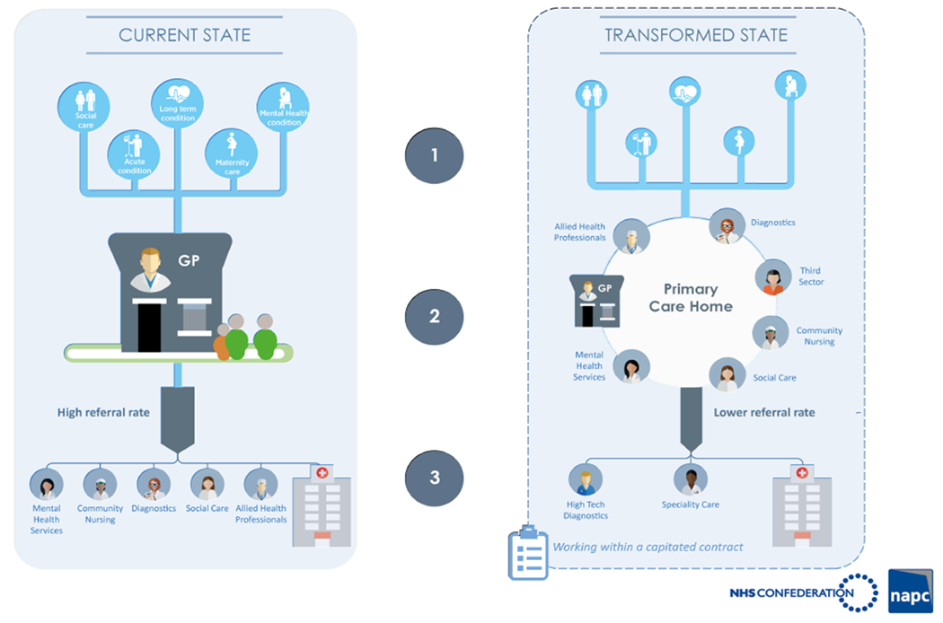
Figure 1 Primary Care Home Model

Primary Care Home within BLMK
We believe that, scaled at the 30-50,000 population level as described within Investment and Evolution, community, mental health and appropriate secondary care services can be effectively and efficiently integrated with primary care. Across BLMK we have Networks that range from 30,000-70,000, these are based on natural geographies and long-standing relationships. In addition, we can align ourselves closely with Council services, where there is direct interplay with health services, such as social care, and those, such as housing, that make such a significant contribution in determining the health and well-being of our residents. We intend to use the PCH model as the common design template across BLMK by which our vision for primary care will be achieved. The PCH solution will, of course, manifest itself in different ways in different parts of the footprint. However, general practices will be supported to create coherent and cohesive networks to manage the health and well-being, and deliver “out of hospital” care, to their localities numbering between 30-50,000 through:-
- Strengthening primary care services - enabling sustainability and transformation
- Empowering communities and individuals through community support
- Improving population health and maximising self-care and prevention
- Boosting ‘out of hospital’ care to enable greater shift appropriate activity from acute settings into the community
- Expanding & reforming urgent & emergency care services – increasing the accessibility of urgent care “on the day” services reducing reliance on A&E
- Integration of health and social care services, to include community and mental health services across clusters of 30-50,000 populations
- Integration of physical and mental health services and achievement of parity of esteem
- Integration of the workforce & service delivery
- Digitally enabled primary and outpatient care – shared care records and increasing interoperability of information management technology
- Expanding the choices and control people have over their own care - increasing personalised care
- Greater focus on population health – maturing the Integrated Care System

Population Health
The NHS England Long-term Plan for the NHS sets out an enhanced role for ICSs as the future for the NHS. This includes:
- ICSs will have a key role in working with Local Authorities at ‘place’ level and through ICSs, commissioners will make shared decisions with providers on how to use resources, design services and improve population health.
- Each ICS will be required to implement integral services that prevent avoidable hospitalisation and tackle the wider determinants of mental and physical ill-health.
- ICSs will agree system-wide objectives with the relevant NHS England/NHS Improvement regional director and be accountable for their performance against these objectives. This will be a combination of national and local priorities for care quality and health outcomes, reductions in inequalities, implementation of integrated care models and improvements in financial and operational performance. ICSs will then have the opportunity to earn greater authority as they develop and perform.
- As ICSs take hold, we will support organisations to take on greater collaborative responsibility. There will be a clear expectation that strong, successful organisations not only provide high-quality care and financial stewardship from an institutional perspective, but also take on responsibility, with system providers, for wider objectives in relation to the use of NHS resources and population health. This will mean that neither trusts nor CCGs will pursue actions which, whilst potentially improving their institutional financial position, would result in a worse position for the system overall. This will be supported by a system oversight approach which reviews organisational and system objectives alongside the performance of individual organisations, whereby our regions seek to understand the drivers of challenges facing organisations and ensure that solutions reflect the wider system changes required.

Our Sustainability and Transformation Partnership (STP) is one of the ten first wave Integrated Care Systems (ICSs) and our Single System Operating plan reflects this, bringing together our individual organisational plans to support our work as one system. We have continued to grow and develop as a system in the last year, building on our track record of delivery and collaborative working.

Our Single System Operating plan acts as an umbrella for the plans developed and owned by each of our four place-based Transformation Boards and the operational plans for each of BLMK’s partner organisations. It has been developed in the context of national policy and local needs, illustrated below:
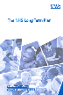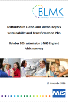
National
NHS long Term Plan
ICS Memorandum of Understanding
BLMK Footprint
BLMK Sustainability and
Transformation Plan and Single
System Operating Plan 18/19
Place
Central Bedfordshire Health &
Wellbeing Strategy
Bedford Borough Health &
Wellbeing Strategy
Luton Health & Wellbeing Strategy
Milton Keynes Health & Wellbeing
Strategy
Figure 2 Strategies and associated footprints
What does our System Look Like Now
- There are 15 statutory organisations, with many other essential partners, within the ICS who are responsible for delivering or organising the delivery of health and care services in Bedfordshire, Luton and Milton Keynes alongside many other provider partners. These include local councils (for social care, public health and other services that impact on health and wellbeing including education, housing, transport and the environment), hospitals, clinical commissioning groups (led by GPs and responsible for the planning and buying of NHS healthcare), and organisations providing community and mental health services. There are also many, many charities, voluntary carers and community groups providing help, care and support to residents.
- There are many ongoing initiatives across BLMK that are really starting to make a difference to patient care. Examples include the significant cross-sector progress being made to ensure:

  - care is personalised and based on the needs of the individual. See key element 3.
  - High Intensity Users are well supported to manage their care with better access to appropriate services, See key element 2.

- However, we also know that there is still much work to do. Many organisations work independently and provide the care and services that is within the scope of their contract. This means that people who need those services from multiple organisations have to work out how and where to get them. Sometimes that’s simple – most of us know who our GP is, or how to call 111, how to get emergency care at A&E or by calling 999. But sometimes it’s very complicated – many of us wouldn’t know who to contact if our elderly relative was about to be discharged from hospital and needed transport, community care support and care from a district nurse.
- When getting care and support is difficult, we tend to use those services that are familiar – our GP, A&E and the ambulance service. That may mean we don’t get the right care and support at the right time, in the right place. It also means that there is a greater pressure on these services.
- Organisations working separately mean that patients and residents are not at the centre of services – institutions are. Care starts and stops at the door of the organisations responsible for providing it. This means people – often at their most vulnerable – have the challenging task of navigating a complex health and care system.
What do we want the future to look like?
- That every person in Bedfordshire, Luton and Milton Keynes can live healthy lives for as long as possible. People will have the knowledge and support to live healthy lives and to manage their long-term conditions and are able to participate in their communities. Evidence shows that healthcare accounts for between 15% and 43% of our health outcomes. We recognise the need to address the underlying social, environmental and behavioural factors that influence our physical and mental wellbeing.
- That every resident has access to community, mental health, primary and social care that is personalised and organised around the individual. Integrated Health and Care Hubs, Primary care hubs, where GPs work hand-in-hand with specialists across community, mental health and social care, pharmacy and therapies are established for every community.
- That there is parity between mental and physical health for mental health and learning disability services, with services built around the needs of residents.
- That staff working across BLMK are well supported and have fulfilling and rewarding roles offering excellent integrated care for the population they serve
- That the three acute hospitals provide services for their populations, with every resident having access to world-class specialist care as close to home as possible. Reduce variations in quality of care received by those who use services outside of the BLMK footprint.
- That care records are shared so there is real continuity of care, and data is used to predict and plan health care interventions and proactively meet the demand for services.
- For Bedford, Central Bedfordshire, Luton and Milton Keynes to develop as an Integrated Care System with shared goals and targets focussed on improving health outcomes and services for local people with local democratic legitimacy and the support of statutory boards.
The interactions with, and influence of, other organisations and stakeholders has an impact on the pace and scope of the primary care transformation programme. PCNs have needed to reframe their relationships with key stakeholders in order to move forwards. For example, some PCN leaders have had to ensure they involve community provider organisations currently working at place level (e.g. 250k population) in the redesign of services for their local populations of 30- 50k.

Introduction

Bedfordshire, Luton & Milton Keynes
Almost one million people live in Bedford, Central Bedfordshire, Luton and Milton Keynes (BLMK). These are four very different places that are also diverse within themselves. These differences affect what local people need from their health and social care services. BLMK has a combined population of nearly 930,000 which is projected to grow to 1,081,400 (ONS, 2016) by 2035. The number of people aged 85 and over is projected to double by 2035 and there will be higher than average growth the number of adults aged 65 to 84.
Luton is the most urban, most deprived and most ethnically diverse of the four local authority areas; Bedford Borough and Milton Keynes are urban with significant ethnic minority communities with some rural areas; Central Bedfordshire is the most rural, least deprived and least diverse of the four areas. It does however have pockets of deprivation and around 30% of its residents use acute hospitals outside of the BLMK footprint.
BLMK is included within the Oxford – Milton Keynes – Cambridge Arc, which is expected to have 1 million new homes by 2050. BLMK partners are working together to ensure appropriate health and social care infrastructure is in place to meet the challenges of this significant growth in BLMK population. There are also significant differences in demographics, ethnic diversity and deprivation within the footprint which our plans need to be alive to.
Across the BLMK geography we have some significant variances in health and wellbeing outcomes. For example, healthy life expectancy, an estimate of the average number of years lived in good health, varies from 61.3 years for men in Luton to 67.6 years for women in Central Bedfordshire.
In some parts of BLMK there is an 11 year difference in life expectancy between the least and most deprived areas and demand for our health services is increasing at a faster rate than ever before – around 10% more people every year come to our A&E departments and more than people than ever are being admitted to hospital. We focus much of our resource on treating rather than preventing ill health.
There are 102 GP practices within the BLMK footprint, employing c. 419 WTE GPs (March 2019), with a system vacancy rate of 55 GPs. At 2837 the average list size per GP compares unfavourably with England as a whole (with Luton a particular outlier at 3336 patients per GP). The legacy infrastructure with which general practice in BLMK is wrestling dictates the need for radical transformation, designed to develop capabilities, to re-purpose existing capacity and to deepen the multi-disciplinary resource base that can be drawn upon. All 15 partner organisations comprising the BLMK ICS recognise this and are committed to supporting new models of working with and alongside general practice.
We need to do more to recruit and retain doctors, nurses and other health and care professionals. Around 28% of the GPs in Bedfordshire, Luton and Milton Keynes are eligible for retirement in the next five years. Recruiting specialist consultants is becoming increasingly challenging. Changes in how nurse training is funded, and the uncertainty created by Brexit, means fewer nurses are coming into the profession.
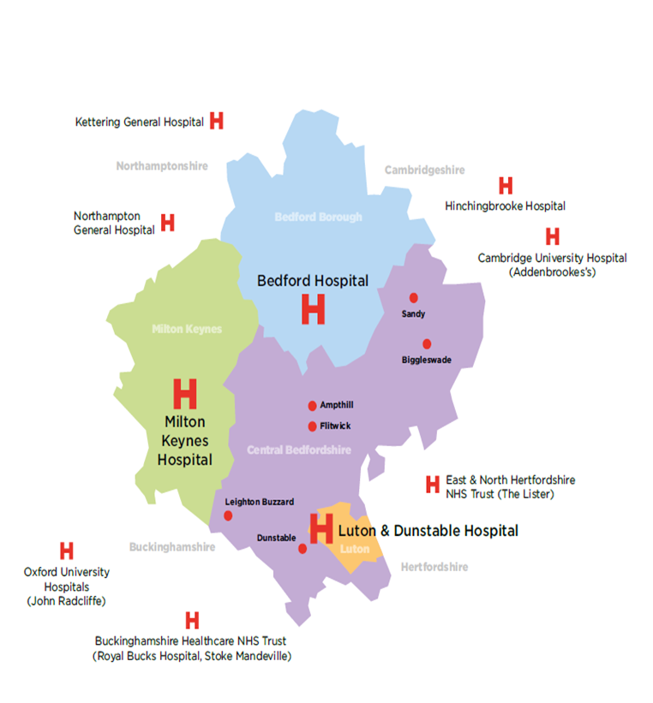
Figure 3 Map of BLMK ICS

Primary Care Networks & Practices
BLMK has been working with the National Association of Primary Care (NAPC) since April 2018 to develop Primary Care Homes (PCH) as part of its Primary Care development strategy. The core characteristics of a PCH align with NHS England’s Primary Care Networks (PCN) that is described in the LTP as the building blocks of system transformation. There are 102 GP practices, 22 PCNs (NB this number could change prior to July 1st 2019 deadline).
In BLMK we have followed the Primary Care Home model and methodology to support PCN development. BLMK have adopted the NAPC’s Primary Care Home model because:
- In a world of different models of care, PCH was a well-established, tested and evaluated model that was being backed nationally
- It gave BLMK access to a PCH community of practice of over 200 PCHs nationally, PCH consultancy advice and expertise
- NAPC was willing to act as an ‘embedded’ partner, working alongside BLMK colleagues to enable delivery of local primary care transformation plans
- There were a number of PCHs (GP Clusters) already registered with NAPC across each CCG area

The diagram in Appendix B provides an overview of the core elements of a PCH (which align to NHSE’s PCN maturity matrix). Using this as a guide BLMK commissioners and PCN providers are able to track PCN maturity

Primary care workforce statistics
Across BLMK ICS;
- 28% of our GPs are aged 55 and over, slightly higher than the East of England figure of 27.5%
- 34% of our GPNs are aged 55 and over, lower than the East of England figure of 35%
- GP locum rates remain low at 4% a reduction from 11% (local workforce profile Oct 18)
- GP vacancy rates remain at 10% lower than the national average of 15.8%
- GPN vacancy rates sit at 6% lower than the national average of 11.8%
Between March 2018-2019
- GP WTE numbers have remained relatively static decreasing slightly by 1.9% higher than the national figure of 1.5%
- GPN WTE numbers have increased by 2.9% higher than the national figure of 1.9%
- Direct patient care staff have increased by 3.4% and admin and clerical staff by 2.8%, higher than the national figure of 2%

The case for change

Demographic profile and health inequalities
Bedfordshire, Luton and Milton Keynes has a combined population of 932,121 (ONS Mid-Year Estimate, 2017), which is projected to grow by 16% to 1,081,400 by 2035 if recent trends continue (ONS Population Projections for Local Authorities, 2016-based).
The number of people aged 85 and over is projected to double by 2035 and there will be higher than average growth in the number of adults aged 65 to 84 years (Figure 4). The number of children and young people is projected to peak in the next 10 years. Place-specific population growth projections are given in Figure 5.
These projections do not factor in the population growth that is expected to accompany the development of the Oxford-Cambridge Arc, which is yet to be agreed locally, but would lead to significant additional population growth across the age spectrum.

Age group | 2017 ONS mid-year estimate | 2025 ONS projection | 2035 ONS projection | % change,  2017 to 2035
0-4 | 66,198 | 64,400 | 63,200 | -5%
5-19 | 178,545 | 203,800 | 201,500 | 13%
20-64 | 545,730 | 574,700 | 595,600 | 9%
65-84 | 123,649 | 149,400 | 184,200 | 49%
85+ | 17,999 | 23,200 | 36,700 | 104%
All ages | 932,121 | 1,015,100 | 1,081,400 | 16%
Figure 4 Projected population growth in BLMK, 2017-2035.

Figure 5 Projected populations by place and age-group, 2017-2035.
Diversity and inequalities in BLMK
Luton is the most urban, most deprived and most ethnically diverse of the four local authority areas. Bedford Borough and Milton Keynes are mostly urban with large ethnic minority communities and some rural areas. Central Bedfordshire is the most rural, least deprived and least ethnically diverse of the four areas (Figure 6), although there are still pockets of deprivation in some of the towns.
Across BLMK total of 3,965 people are registered blind and partially sighted (NHS Digital, 2016). A total of 1,970 were registered as deaf or hard of hearing in 2009/10 (NHS Digital).
The proportion of children with learning disabilities known to schools ranges from 3.4% in Central Bedfordshire to 5.2% in Luton (Department for Education, 2017). 4,206 people in BLMK (all ages) have a learning disability that is recorded by their GP (QOF, 2017/18) – this is equivalent to 0.4% of the registered population. Fewer than half receive an annual learning disability health check (QOF, 2016/17).

 | Bedford Borough | Central Bedfordshire | Luton | Milton Keynes
% of population from Black, Asian and Minority Ethnic groups (non-White British) (Census 2011) | 28.5% | 10.3% | 55.4% | 26.1%
Number (%) of children under 16 from low income families (2016) | 4,960  (14.9%) | 5,765  (11.3%) | 9,960  (19.0%) | 8,680  (15.1%)
Index of Multiple Deprivation score (national rank, 1=most deprived) (2015) | 19.2  (95/152) | 12.2  (137/152) | 27.7  (47/152) | 18.0  (106/152)
Figure 6 Ethnicity and deprivation in BLMK.
Life expectancy across BLMK has been rising for decades but in the last couple of years this rise has slowed or halted. Male life expectancy at birth ranges from 78.3 years in Luton to 81.4 years in Central Bedfordshire; female life expectancy at birth ranges from 82.3 years in Luton to 84.4 years in Central Bedfordshire (PHOF, 2015-17).
Healthy life expectancy for men ranges from 61.3 years in Luton to 66.4 years in Central Bedfordshire. For women it ranges from 62.7 in Luton to 67.6 in Central Bedfordshire (PHOF, 2015-17).
There are significant health inequalities within each local authority area, for example, the life expectancy gap for men living in the least and most deprived areas is largest in Bedford Borough (11.4 years); whilst for women is largest in Milton Keynes (7.4 years) (PHOF, 2015-17).
Prevention in primary care
The NHS Long Term Plan acknowledges the role of the NHS in prevention working closely with our partners in local government. Primary care has an important part to play in all levels of prevention:

Figure 7 Levels of prevention
In Luton in 2018/19 1 in 3 children aged 2 and 3 received a seasonal flu vaccination whilst in the other BLMK CCG areas more than the children were vaccinated (NHS England). None of the BLMK CCG areas are currently achieving the 95% targets for second dose DTaP/IV and MMR vaccination targets for 5 year olds (PHE COVER statistics, Q3 2018/19).
None of the BLMK CCG areas are currently achieving the cervical screening coverage target of 80%. This reflects a national performance challenge.
Across BLMK in 2017/18 20,020 adults aged 40-74 years received an NHS Health Check. This ranged from 5.8% of the eligible population in Bedford Borough to 9.4% in Central Bedfordshire.
Long term condition management in primary care
In 2017/18 across BLMK there were 40 atrial fibrillation-related strokes where a patient had known AF but wasn’t on anticoagulation medication. Across BLMK only 52% of patients under 79 with known high blood pressure and on GP hypertension registers are recorded as being managed to the NICE target of 140/90 mmHg.
There are very significant proportions of people living with undiagnosed Chronic Obstructive Pulmonary Disease (COPD) in BLMK. Almost a third of people admitted to hospital with an acute exacerbation of COPD have not been previously diagnosed. Additionally, there are high levels of respiratory related admissions in the under 5s and opportunities to improve asthma management in all ages. There are opportunities to improve proactive case finding and diagnostics for COPD, support for smoking cessation, uptake of flu vaccination in vulnerable groups, access to pulmonary rehabilitation and improved asthma management.
There are 53,051 people aged 17 and over in BLMK with a diagnosis of diabetes, and has grown by approximately 3% a year over the past 9 years (QOF, 2017/18). The prevalence OF diabetes is highest in Luton (8.0%) and lowest in Milton Keynes (6.1%). The proportion of type 2 diabetes patients receiving all eight recommended care processes ranges from 53.5% for Luton CCG to 66.8% for Milton Keynes CCG, while the proportion achieving the three treatment targets (blood pressure, blood cholesterol and blood sugar) ranges from 35.4% for Bedfordshire CCG to 40.6% for Milton Keynes CCG (National Diabetes Audit, 2017/18).
There are 72,008 adults in BLMK with a diagnosis of depression, ranging from 7.5% of the population in Luton to 11.0% in Bedford Borough (QOF, 2018/19). There are a further 8,619 adults with diagnosed serious mental illness, ranging from 0.7% of the population in Central Bedfordshire to 1.1% of the population in Bedford Borough.
There are 5,764 people in BLMK aged 65 and over with a diagnosis of dementia, ranging from 3.4% of the population in Central Bedfordshire to 4.2% in Luton (NHS Digital, December 2018). The dementia diagnosis rate in BLMK, 61.7%, is below the England average (67.8%) (Rightcare, August 2018).

Workforce profile
The figure below illustrates the current Primary Care Workforce profile extracted from practice systems as of 31st March 2019. The time series of baseline figures for GPs and the Wider Workforce from Sept 15 to March 2019 is included in Appendix C. (NB GP registrar figures are inaccurate prior to June 18)

Figure 8 BLMK Primary Care workforce profile

Challenges
Across BLMK we continue to face the following challenges;
- GP recruitment and retention
- GP, GPN and PM retirement profile
- Capacity (Educational and Estate) to support and supervise new roles and learners to ensure they are ‘general practice ready’
- Demographic growth & ageing population with multiple co-morbidities
- Capacity to effectively workforce plan to meet population health needs & increased demand
- Capacity to effectively workforce plan to enhance and expand skill mix and succession plan
- Capacity & willingness to share staff across providers / organisational boundaries
- Workload demands effecting staff morale & wellbeing

The following figure outlines the actual baseline WTE figures for GPs (excl registrars), Nurses, Direct Patient Care and Admin/non-clerical from March 2018 – March 2019 and planned trajectories. The final column illustrates positive growth against each of the staff groups, with the exception of GP numbers. All baseline figures include retirements and leavers. Whilst the figures indicate annual growth, with the exception of Nurses, there is negative variance from planned trajectories. Our workforce strategy is focussed on growth of these WTE numbers.

Figure 9 Workforce trajectories

Opportunities
The development of Primary Care Networks provides us with the opportunity to address many of these challenges by;
- Expanding training and supervisory capacity by sharing expertise and space across the network
- Developing PCN career frameworks for all staff, boosting retention and enhancing morale
- Enabling PCN portfolio career options for all staff
- Developing rotational placement options across providers to enhance skills and create hybrid roles focussed on population health needs
- Maximising opportunities to train and learn together and reduce duplication
- Creating a PCN culture of a supportive work environment where staff learn and grow together
Culture and Leadership
The BLMK ICS Leadership and OD Plan (Appendix D) is targeted at all staff groups, at all levels, across all organisations and sectors. It supports the development of relationships and culture that underpins systems working. We recognise the need for an on-going focus on Primary Care Network Leadership and organisational development support to enhance practice and network based teams and galvanise energy and pace of change.

The Primary Care Workforce Development Programme has supported our Clinical and Practice Managers leads to undertake a number of leadership / development programmes over the course of the past year;

- Leading Transformation in Primary Care Programme – Robert Varnam
- Next Generation GP – RCGP
- Confident Practice Manager Programme – PCC
- GP Business Fundamentals – Beds & Herts LMC
- Coaching for resilience
- Coaching for career development

Developing our Practice Nurses and engaging them to lead service change

We are cognisant of the important role our Practice Nurses can play in the development and leadership of Primary Care Networks and the need to empower them to do so. In order to understand the potential barriers to this, a number of commission and CCG nurse leads are being supported by NAPC to identify and actively coach a cohort of 13 General Practice Nurses who had expressed an interest in Primary Care Network development. The finding of this approach will help inform our GPN Leadership strategy and development plans.

Following on from this initiative BLMK have since been sponsored by NHSE to be the first ICS to run a targeted programme of work to identify and develop 10 GPNs to become future PCN leaders.
GPN Fellowships
Following this piece of work we have been selected as 1/2 national test bed sites for the GPN Fellowship scheme and shaping the national work on development of GP Fellowships described in the Long Term Plan.
BLMK ICS Local workforce plan
The BLMK ICS General Practice Workforce Strategy and Development Plan (2017-2020) (Appendix E) was finalised in April 2018. The plan is focussed on attraction, recruitment and retention of all staff groups while simultaneously expanding skill mix, portfolio, rotational and apprenticeship opportunities.

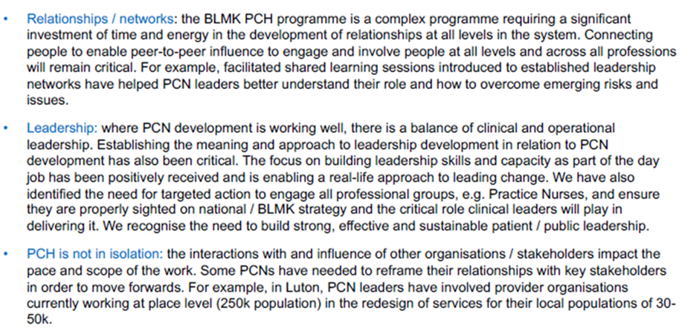
BLMK ICS Local workforce plan
The BLMK ICS General Practice Workforce Strategy and Development Plan (2017-2020) (Appendix E) was finalised in April 2018. The plan is focussed on attraction, recruitment and retention of all staff groups while simultaneously expanding skill mix, portfolio, rotational and apprenticeship opportunities.
The figure below is a high level summary of the current projects and initiatives already underway;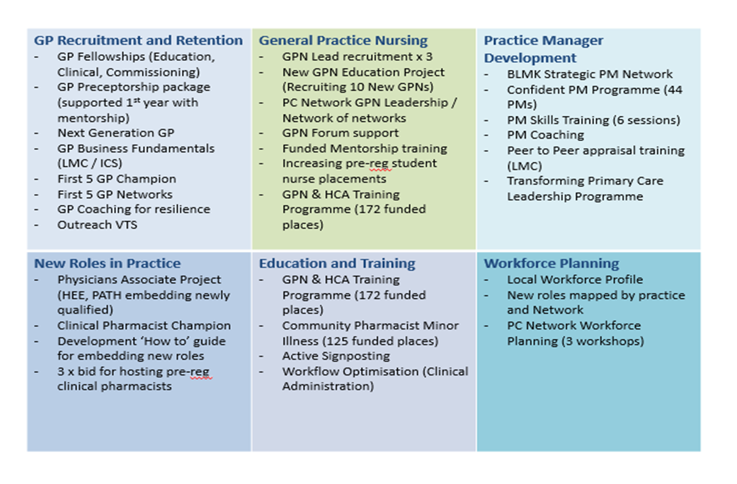
Figure 10 Workforce strategy and development plan summary
The BLMK ICS Primary Care Workforce Programme has coalesced delivery of the NHS England GPFV Workforce priorities and Health Education England Training Hub priorities to focus on the following;

- increasing resilience through new ways of working
- providing education and development to create a system-wide energised and sustainable workforce
- motivating, valuing and engaging existing teams
- creating vibrant organisations, interesting roles, career structures and supported development opportunities
- attracting more people to want a career in BLMK through targeted marketing campaigns
- working in partnership with our provider organisations to develop a flexible workforce made up of skill mixed teams and extended teams that reflect the needs of the population
- supporting the implementation of new approaches to the delivery and organisation of care such as integration, extended roles in risk stratification, care planning and case management.
Delivery of this plan is driven by the BLMK ICS Primary Care Workforce Education & Development Network BLMK Training Hub (previously CEPN). The diagram below illustrates the governance framework surrounding the Network and Hub, the strategic priorities and current work streams.
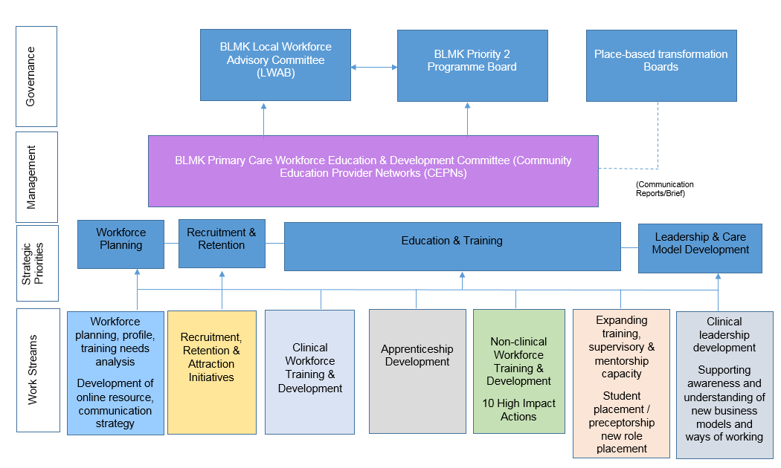
Figure 11 BLMK training hub governance
BLMK ICS Training Hub
Informed by a recent maturity assessment, the BLMK Training Hub has established a development plan to work towards ‘mature/advanced’ status by March 2020, subject to sufficient infrastructure funding. The BLMK Training Hub will continue to build on the work already underway by supporting Primary Care Networks to develop workforce plans that;
- Identify what workforce Practices will share and for what purpose
- Identify what workforce Networks will share and for what purpose
- Sustains general practice / provide core services
- Successfully embed new roles, where needed e.g. social prescribers, clinical pharmacists
- Establishes and grows its training, supervisory and mentorship capacity
- Establishes and grows a shared PCN Educator resource
- Establishes a PCN approach to hosting students, supervision & mentorship of new roles
- Offer Portfolio career options, career development, preceptorships and rotational placements for all staff
- Promotes staff wellbeing and welfare
- Attracts, recruits and retains staff

March 2020 Ambition - The Core Functions of the Primary & Community Care Training Hub will include;
- Workforce planning
- Develop and manage - existing and expansion of placement capacity
- Recruitment - Develop, expand and enhance the recruitment and development of the capabilities of multi-professional educators that supports the delivery of high-quality clinical learning placements
- Support the development and realisation of educational programmes to develop the primary / community care workforce at scale to address identified population health needs, support service re-design and delivery of integrated care for example through rotational placements / programmes and integrated educational programmes
- New roles – to enable, support and embed “new roles” within primary care
- Retention - to support retention of the primary care workforce across all key transitions including promoting primary care as an employment destination to students, through schools and higher education institutions
- Clinical Placement Tariff - enable both workforce planning intentions, placement co-ordination through active management of clinical placement tariffs including “place based” tariffs

 | 2019-20 |  |  |  | 2020-21
Ambition | Q1 | Q2 | Q3 | Q4 | Q1 | Q2 | Q3 | Q4
Primary Care Network Workforce Planning
Develop expert resources to support practices / networks to successfully embed new roles enabling them to thrive

Primary Care Network collaborative approach to hosting students / embedding new roles
Evolution of BLMK Training Hub to March 2020 vision

Figure 12 Training hub timeline
10 High Impact Actions

The following figure outlines the % coverage of the 10 High Impact Actions across the practices within BLMK ICS as at June 2019;

10 High Impact Actions | BLMK Practices % coverage 2019-20 | Future Plan
- Active Signposting | 81% of practices have undergone training. | There is variation across the three CCGs in the training provider used and depth of training. Assessment underway of uptake and gaps
- New Consultation Types | Circa 50% of practices have online consultations mobilised (Engage Consult and Footfall) | 3 PCNs piloting Group Consultations
- Reduce DNAs | 16% of practices have focussed on reducing DNAs | Learning to be shared across PCNs
- Develop the team | 85% of practices have accessed an initiative via the PC Workforce Programme | Ongoing monitoring
- Productive Workflows | 50% of practices have undergone training | There is variation across the three CCGs in the training provider used and depth of training. Assessment underway of uptake and gaps
- Personal Productivity | 30% of practices report that staff have worked on their personal productivity | Support PCNs to increase
- Partnership Working | 75% of practices are undertaking partnership working / network MDT | Increase to 100%
- Social Prescribing | In Luton and Milton Keynes all practices have access to Social Prescribing services at place.  8 GP practices in Central Bedfordshire and 3 Practices in Bedford Borough with access to social prescribing. | Plans are in place to ensure the implementation of Additional Role Reimbursment scheme for Social Prescribers 2019-20
- Support self-care | 23% of practices are utilising the Footfall website | Support PCNs to increase
- Develop QI expertise | 10% of practices have undertaken QI training | Planned roll out of further Time for Care workshops and 10 HIA conference
Figure 13 10 High Impact Actions

Estates
In some parts of BLMK, primary care teams are hindered in their delivery of care and in developing new ways of working by the limitations of the buildings they operate from. Many GP practices across Bedfordshire and Luton are struggling with space, and this can make it harder to deliver the levels of access that their patients expect, and can prevent the development of new services to be offered in primary care. The current configuration of premises can also restrict services from working more closely together, even in some of the areas in Milton Keynes with less capacity restrictions.
Significant housing growth and demographic changes are likely to result in additional demand for services which may compound these issues. The delivery of local aspirations for improving primary care services will therefore be dependent in part on a corresponding transformation of the estate.
Current Position

A large proportion of the estate across Luton and Bedfordshire comprises former residential properties which are increasingly becoming unfit for purpose, and a number of temporary surgery buildings. The current status of the estate has repercussions for the delivery of primary care services, not least the ability of many practices to retain and recruit new staff, or the ability to introduce new services.

BLMK has a diverse population, which brings a range of challenges and requirements for health and care. In line with the population health management approach, a different range of services may be required across each community to help maximise the wellbeing of local people, and this is being factored into local estates planning.

Estates Planning

As the challenges of a growing and ageing population intensify, and the face of health and care across BLMK changes in response, the primary care estate (including community care) will come under increasing pressure. It is vital that the estate adapts to support the delivery of new models of integrated services.

The greater emphasis on education, patient engagement, prevention, earlier intervention and delivering a greater range of diagnosis, treatment, advice and support in community (‘out of hospital’) settings, means that in some cases, buildings will need to be larger and more flexible - and open to use by a range of service delivery partners. Facilities will need to be focussed in core locations accessible to those who need to access the services. The currently disparate pattern of health and care facilities across BLMK will need to align and consolidate to meet service integration objectives.

Both nationally and locally, it is recognised there can be value in bringing a range of services together into “Hub” facilities, enabling close integration between a range of teams and professionals, including the wider community, where this is geographically and demographically appropriate, and where this can be achieved cost-effectively.

Each of the three CCGs in BLMK are working closely with providers and Local Authority partners to develop detailed Primary Care Estates plans under an umbrella BLMK framework. Where this planning is further progressed, priority estates schemes are being brought forward, including a number of integrated Hub schemes where national capital or Local Authority funding has been secured.

Estates Planning Principles

The CCGs have developed the following principles to underpin estates planning, to support delivery of the Primary Care Strategy:

- Primary Care Networks (PCNs) will be based on 30,000 – 50,000 people, however, exceptions maybe considered if they have appropriate critical mass to be cost effective.
- Primary Care Networks will be enabled through a range of virtual and physical Hub arrangements, depending on local circumstances.
- Will work towards establishing a minimum core service offer across all Primary Care Networks, which will align with the proposed Hub service model.
- Services to be delivered within each Hub (over and above minimum service offer) will be based on local population health need.
- Estates/Hub solutions need to be cost effective, will need to maximise existing premises, and maximise opportunities to work with other public sector partners under the principles of “One Public Estate”
- Estates and digital developments will be progressed in tandem, in particular Primary Care Networks will be supported to develop online digital consultations.
- Estates solutions will support the development of integrated teams of GPs/community health and social care staff, and the development of expanded community health teams to provide fast support to people in their own homes as an alternative to hospitalisation.
- Opportunities will be maximised to integrate health and social care services with other community-based services that can positively impact on health and well-being of patients, e.g. via social prescribing, and voluntary sector.

The service model for any Hubs (virtual or physical) will necessarily vary according to the needs of the communities they serve, but to ensure a consistency and equity of approach, the CCGs have developed a Hub service model framework (Appendix F) which sets out the CCGs’ expectations for Hub developments.

Priority Schemes

As part of the Strategy development work, a number of core locations have been identified across BLMK where additional capacity to support health and care services will be needed in the future reflecting population growth areas, clinical need and the provision of equal access to services.

Whilst each of the proposals is subject to the development of a detailed business case and affordability considerations (and patient engagement/consultation as required), the priority primary care estates schemes already in planning/delivery are shown in Appendix G.
Further schemes have been highlighted as priorities for the next few years, a number of which are at the early planning stage, including further proposed Hubs in Central Bedfordshire. Work is also underway to develop detailed estates plans across Luton and Milton Keynes, to complement work already completed in Bedfordshire. This will ensure a robust pipeline of schemes, and will support the CCGs and practices in accessing external funding opportunities as and when they become available, e.g. ETTF, national ICS capital bidding opportunities, One Public Estate.
In addition, all three CCGs work closely with Local Authority Planning teams to maximise access to Section 106 / Community Infrastructure Levy contributions.
Governance
Please refer to the governance diagram in Element 5.
Resources
As the three CCGs are working more closely together, the level of capacity and expertise to support delivery of priority estates schemes will be assessed. Expertise is regularly accessed from external consultants to support the development of business cases, and closer working across BLMK may provide opportunities to refine the procurement approach for this expert support.
A range of financial resources have been secured by each of the CCGs to support delivery of the estates strategy. These include ETTF funding, Section 106, Local Authority capital, One Public Estate pump priming and national capital secured via the ICS.

Key element 1 - We will boost ‘out-of-hospital’ care, and finally dissolve the historic divide between primary and community health services

BLMK’s six enabler approach to developing mature Primary Care Network (PCN) integrated teams
Using tried and tested PCH methodology across BLMK we have co-designed and tested an approach for developing fully integrated community-based healthcare through expanded community teams focused on identified and agreed priority patient population cohorts in 7 out of the 22 emerging BLMK PCNs.
The 7 (accelerator) sites highlighted in the map in Appendix H were on track to achieve step 2 on the NHSE maturity matrix, with another 5 set to achieve step 1 (see Appendix I, for more detail on the NHSE maturity matrix). These were the BLMK Clusters prior to the introduction of Primary Care Networks.
All BLMK PCNs will be supported to develop in line with the NHS maturity matrix, with many being encouraged in future to go further faster utilising opportunities including those outlined in the national PCN development prospectus, as listed in (Section 13).
The six elements outlined below provide the underpinning principles and a framework to assessing need and understanding how best to utilise resources to maximise potential to achieving mature PCNs across BLMK:

- Understand need (current and future)
- Agree care functions
- Develop skill mix and pool of existing staff
- Build and embed team based culture
- Deliver the education and training required
- Develop the plan for future supply

The NAPC Primary Care Home approach being made available to support our PCNs across BLMK is set out visually in figure 14 below:

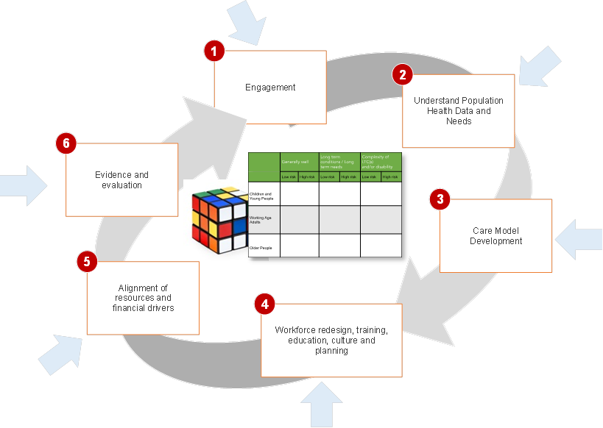
Figure 14 Primary Care Home approach
The nature of the programme requires a combination of a ‘core team' approach working through the 6 enablers and more ‘fluid’ team members who support the work as and when required. This can be a hard balance to achieve and requires a constant focus on the understanding of language and the model, the direction of travel and agile resource planning. For example, Population Health Management expertise will be needed during the early planning stages, but once priorities have been agreed, service model redesign expertise is required.
Appendix J provides an example of how this methodology is being practically implemented within a local PCN to support the re-design and integration of health, care and support services for children with very complex needs.
BLMK ICS will utilise the PCNs and their core groups to facilitate enthusiastic like-minded practices with the will and vision to formalise the ‘Primary Care Home’ model of care which can be described as:
- Provision of care to a defined, registered population of approximately 50,000.
- An integrated workforce, with a strong focus on partnerships spanning primary, secondary and social care
- A combined focus on personalisation of care with improvements in population health outcomes-(shared decision making and supported self-care)
- Aligned clinical and financial drivers through a unified, capitated budget with appropriate shared risks and rewards
The new model of care ‘a complete care community’ as depicted above is built around patients and for patients, ensuring they receive the Right Care in the Right Place at the Right Time. This will ensure:
- Integrated working across the wider health, social care and voluntary community ensuring that our residents and patients receive care from the appropriate service or professional
- Patients are provided with personalised, coordinated and responsive care nearer to their home
- The GP remains central to patient care and care planning, supported by the multi-disciplinary team to coordinate care across all elements of their physical/ mental health and social care needs
- GP shared decision making and involvement during transitions between sites of care, e.g. when patients are being discharged from the hospital;
- Clear and timely communication and information flows between health and social care professionals, patients and their families.
- The needs of the registered population are better analysed to inform, workforce development, early detection, prevention and improved health screening.
Through implementation of this approach with our 7 PCN accelerator sites we now know there is a need for at least 6 emerging integrated care models (Prevention, Acute Care, long term conditions management, children and young people with complex needs, working age adults with complex needs and older people with complex needs) as detailed in figure 8 below:
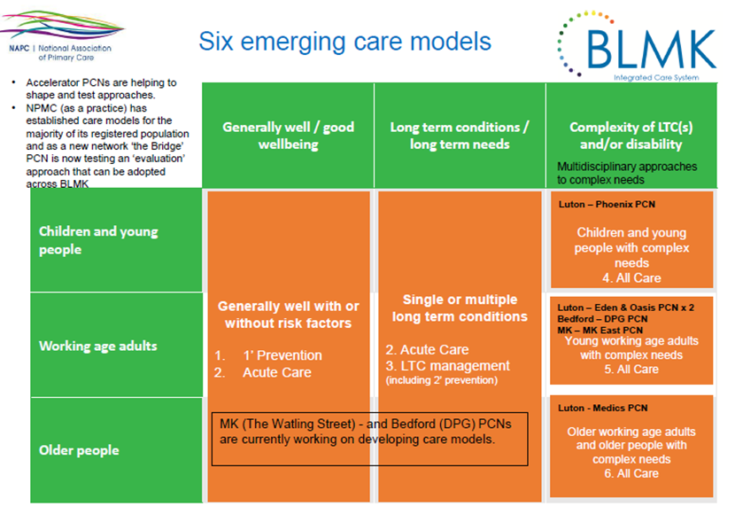
Figure 15 Six emerging care models

It is envisaged that specialists from the local acute trusts will align with PCNs to support the PCH agenda, offering clinical advice for complex patients within a multidisciplinary environment. This process will enable the continued professional development of community and practice based clinicians across the ICS.
Patients will benefit by being able to access services quickly and will be helped to be more independent and manage their own health needs, understanding when and who to call for assistance if their condition exacerbates.
There are a number of different integrated multidisciplinary team models currently being co- designed at CCG/place and PCN level across BLMK. In section 1 we discussed the emerging integrated ‘delivery’ models of care. The diagram below provides a visual aide to start to describe a PCN model to manage the acute needs and demands of the generally well, or those with just 1 or 2 LTCs (referred to in figure 9 as care model 2):
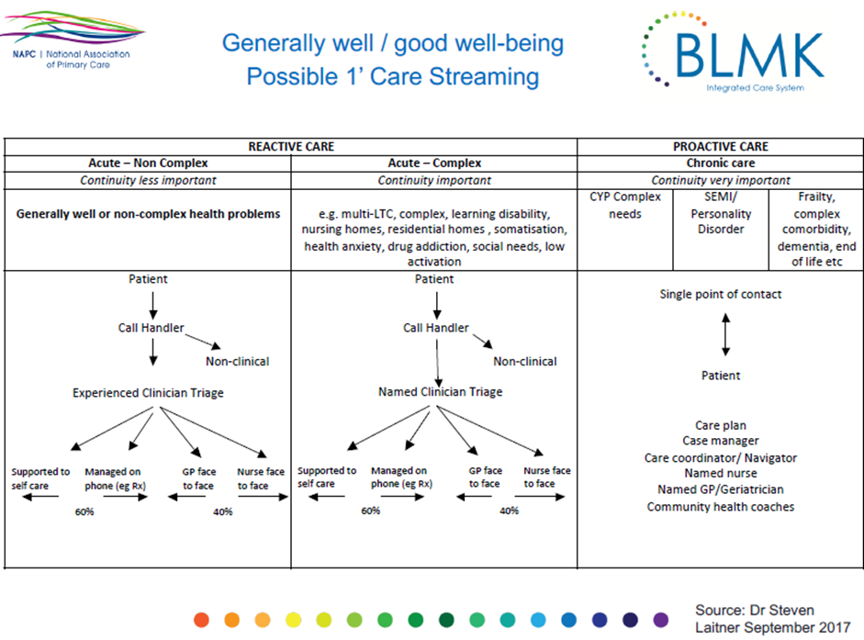
Figure 16 Care models
Currently 7 of the PCNs are embedding the NAPC PCH methodology and it is envisaged that, over time, other PCNs will see the benefits and gravitate towards this model. The approach of innovative practices demonstrating the benefits to others offers the ICS the best opportunity to achieve higher levels of resilience through scale. Participating in PCNs will encourage practices to forge partnership working with organisations that have the skills not traditionally found in general practice to be able to manage at scale services and resources successfully, learning from these new partnerships.
Another example model well embedded within BLMK is an intensive case management model for older complex patients with strengthened General Practice jointly providing coordinated joined -up care, community integrated health (including mental health) and social care. These multidisciplinary teams will provide intensive case management and rapid response services.
The diagram below shows how an approach like this builds a holistic ‘Anticipatory Care Plan’ that enables the patient and carers to access appropriate support services and information, and to escalate if their health needs urgent assessment and treatment in order to remain at home.
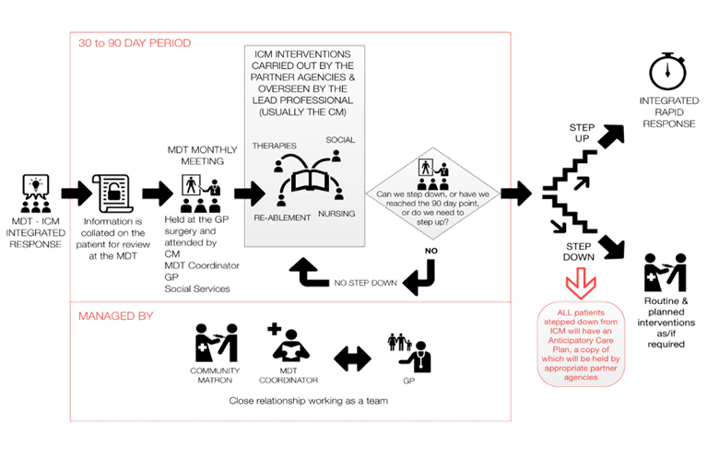
Figure 17 Anticipatory care plan approach
BLMK’s strategy, informed by research ¹, is to encourage PCNs to create the right environment to develop truly integrated PCN teams operating as ‘real teams’- not a ‘pseudo team’ working remotely and in a way that is less effective than individual staff members working in silo².
To allow true MDT integration the following three enablers are critical:
- The team have clear objectives
- They are able to work closely with all team members to achieve the team’s objectives
- The team meet regularly to discuss its effectiveness and how it could be improved
We know by encouraging this approach as a system the likely benefits will be:
- Reduced hospitalisation and costs
- Increased effectiveness and innovation
- Increased well-being of team members
- Inter-disciplinary teams deliver higher quality patient care and implement more innovations
- Lower patient mortality
- Reduced error rates
- Reduced turnover and sickness absence
- Increased staff engagement

- West, M.A. (2004). Effective Teamwork: Practical lessons from organizational research. Oxford: Blackwell/British Psychological Society
- Aston Organisation Development Ltd (2017)

Workforce Configuration
Underpinning the Primary, Community and Social care model within BLMK are the primary care home principles of a single integrated and multidisciplinary team, working to provide comprehensive and personalised care to individuals.

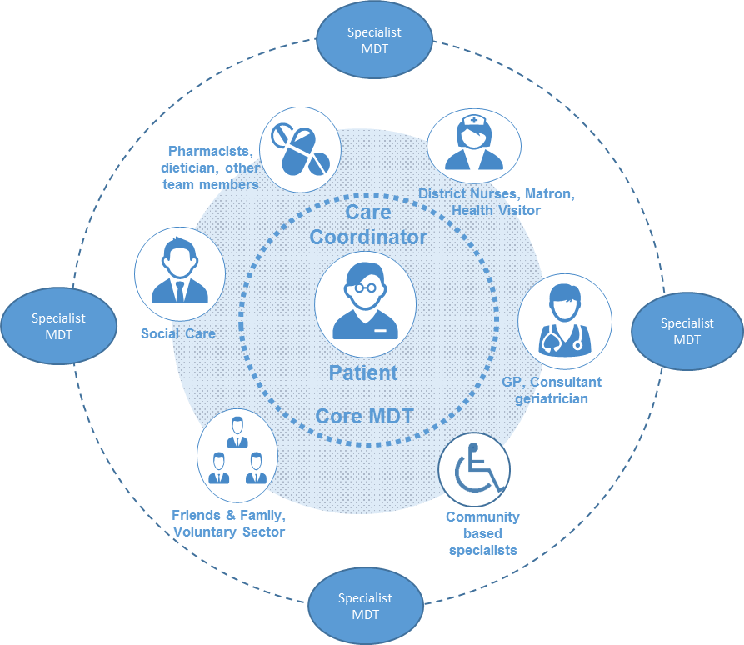

This will be delivered through new ways of working within general practice and primary care, providing strengthened, enhanced GP services and also supported through a wider health and social care workforce, wrapped around GP services, to offer coordinated, joined up, place-based care .

.

Figure 18 New Models of Care

This approach enables us to think differently about how teams of staff support general practice workload and consider what aspects of GP care could be delivered by a range of other staff groups

New Ways of Working in Primary Care

The Primary Care Home initiative in Luton provides a test bed for new ways of working in General Practice that will be rolled out across BLMK to develop strengthened, enhanced GP services.

Since May 2016 Lea Vale Medical Group in Luton have revolutionised the general practice team, introducing new ways of working and new roles with significant results:
- GP capacity increase by 44%
- DNA rate reduced from 8% to 2%
- Patients seen by most appropriate clinician = 16% of GP work moved to nursing team, ECP and practice pharmacist
- Team based working = reduced stress of whole team

Figure 19 New Ways of Working within Primary Care

Enhanced Primary Care Services at the heart of Community Integrated Health and Social Care Teams
Wrapped around enhanced, strengthened Primary Care and jointly providing coordinated, joined -up care, community integrated health (including mental health) and social care multidisciplinary teams will provide intensive case management and rapid response services. Our focus for this multidisciplinary team (MDT) development is at Primary Care Network Level.
Adoption of MDT approach for enhanced primary care support
It is well known that a Multi-Disciplinary Team (MDT) approach, comprising of primary care staff and health professionals from various disciplines, is an effective way to improve the quality of care and outcomes for patients requiring an enhanced level of input and support from health and social care services.
Successful implementation requires at a minimum:
- An identified MDT coordinator who oversees and facilitates the work of the whole team
- Regular joint meetings attended by the core MDT team
- Effective sharing of electronic patient records and data

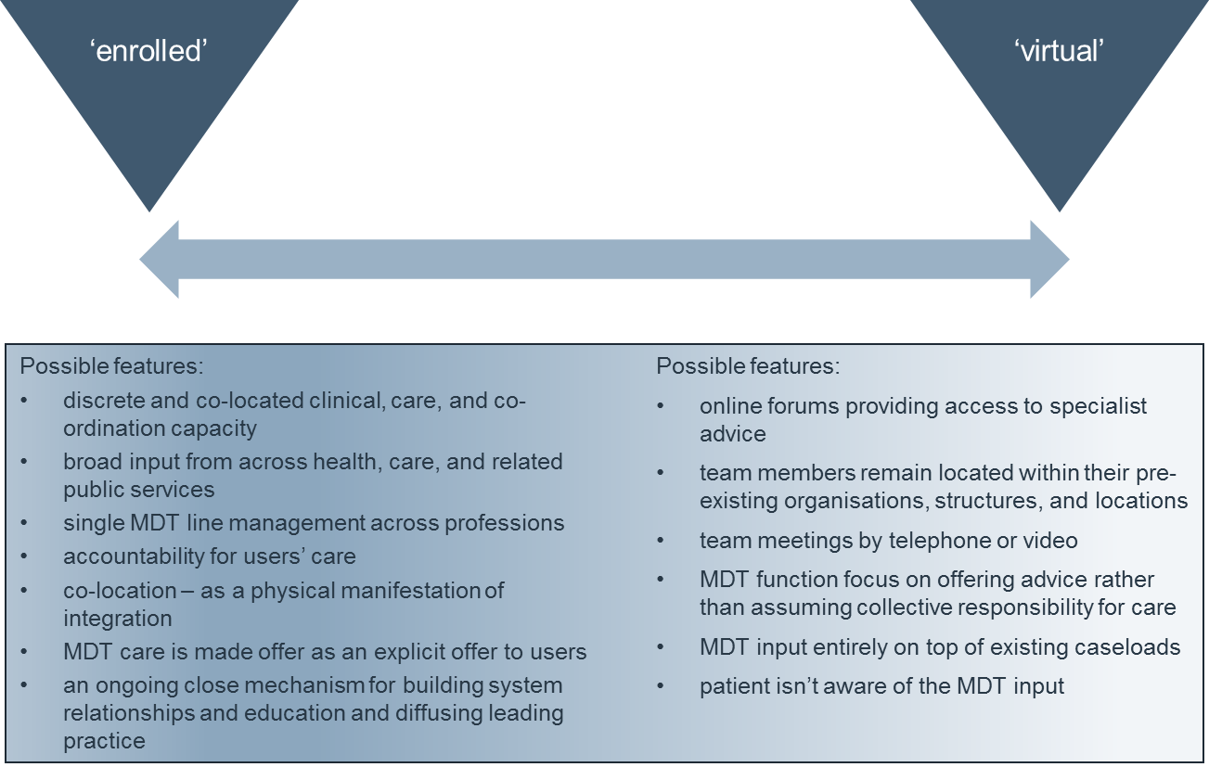
Figure 20 - Components of the MDT model
Strategic Workforce Modelling to support integrated MDT Development
Whilst our programme of support has enabled focus upon population health need and subsequent service/workforce redesign at PCN level, we have also undertaken system level workforce modelling. This facilitates a more accurate assessment of future workforce capability and capacity to ensure the workforce profile for PCNs across BLMK meet the current needs of the local population and forecasted demand over the next 5 years. To achieve this, by adopting a co-design approach with clinicians and managers/service leads from Primary Care, Community health (including mental health) and social care, we developed a single MDT PCN model for the purposes of workforce planning. The aims of this work have been to:
- Identify workforce options to meet future demand on core general practice services
- Identify workforce requirements to deliver a MDT model across BLMK
- Estimate the costs associated with employment of the additional workforce

Identifying the optimal workforce profile for a primary care MDT
Alongside review of the evidence regarding the most effective components of an MDT model, we adopted a population health approach (figure 14) to define a workforce model that will best support MDT components that meet care needs/interventions. We identified that people over 65 years of age, with complex care needs would gain the most improved outcomes from an MDT approach.
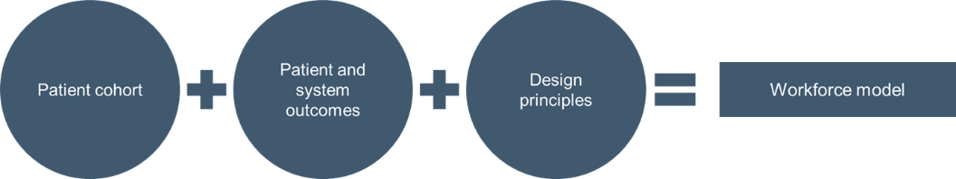
Figure 21 Population Health Approach to Workforce Modelling for MDT

It was agreed that the MDT workforce profile to be adopted for modelling purposes should comprise of a core team, supported by additional resources available on a case by case basis. The workforce types comprising the MDT are outlined in figure 15 below.
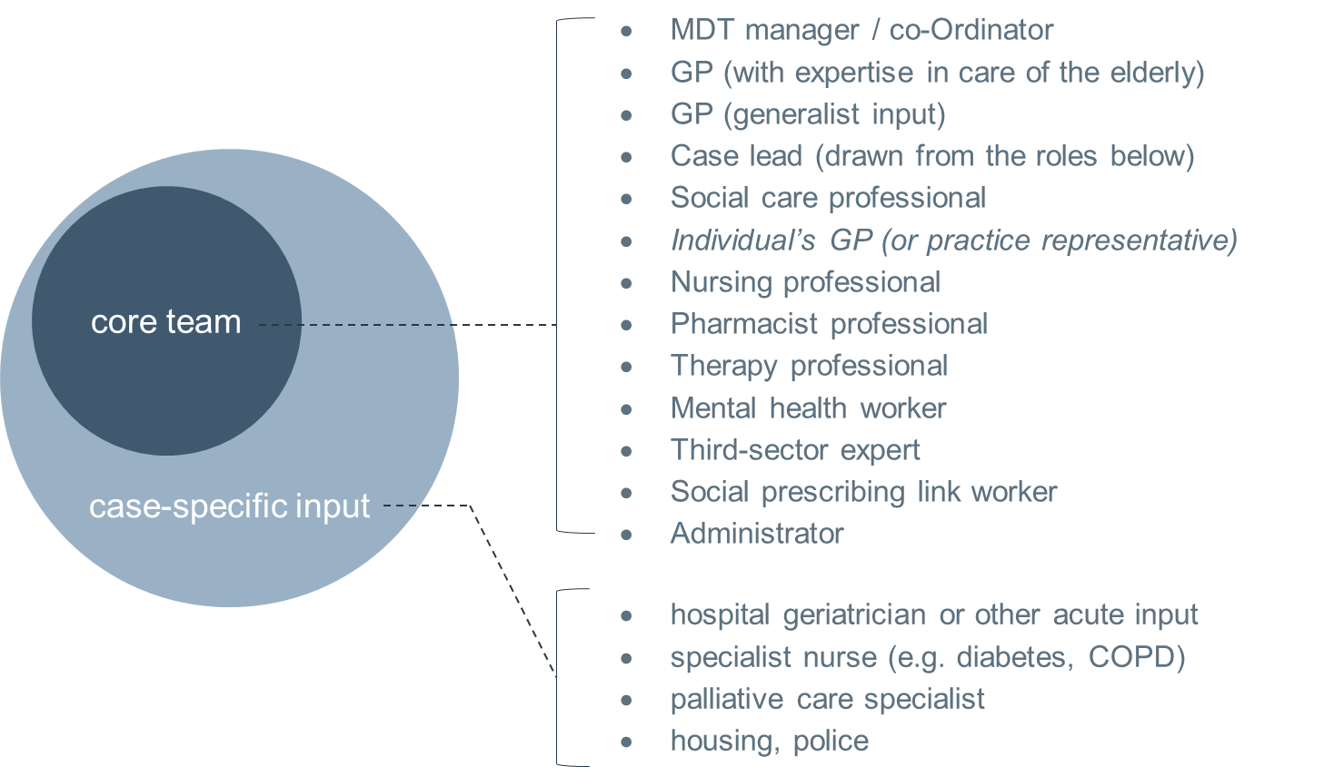
Figure 22 Integrated health and Care MDT Configuration
We have then quantified this workforce configuration at BLMK system level and also for each of our four places for the core team;

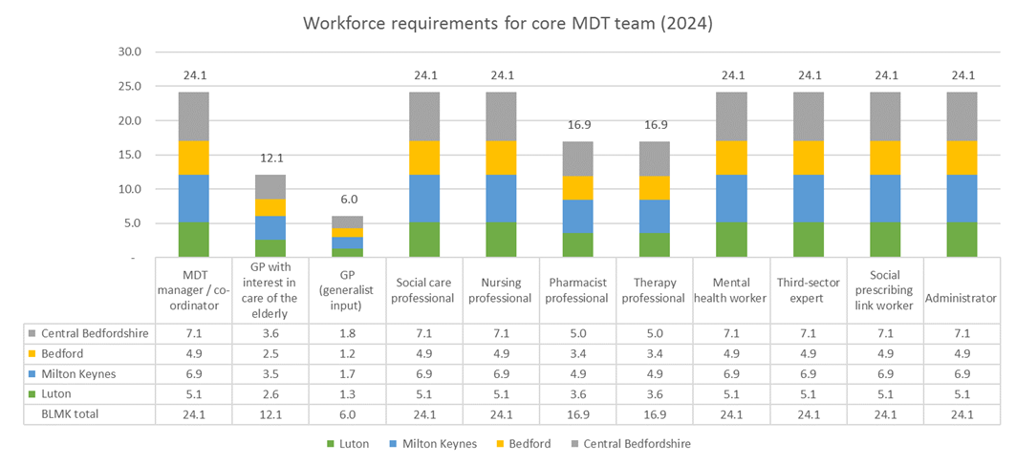
Figure 23 Workforce requirements to deliver the MDT model (Core team)

And for case specific input;

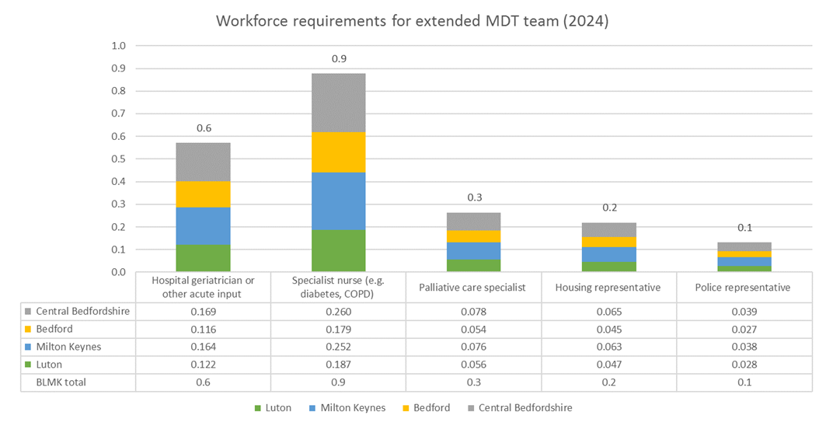
Figure 24 Workforce requirements to deliver the MDT model (Extended team)

Benefits to care professionals
- Care professionals are enabled to broaden their skills and capabilities by engaging with a wider team of professionals, always working to the top of their licence to deliver the most impactful care
- Care professionals feel more supported to deliver the best possible care, more engaged with their work, and supported to continuously improve the care they provide
- Increase motivation and enthusiasm
Implementation Timeframe
The implementation timeframe for delivery of this workforce model will be influenced by two factors:
- The pace of maturity development of our PCNs within BLMK
- The level of variation between the ‘on the ground’ development occurring within each PCN to the strategic modelling outputs
- The flow if relevant funding to support role implementation through the new Primary Care contracts:

Role | Overview | Reimbursement
Physician Associate (PA) | Taking on defined areas of clinical responsibility with ability to assess, diagnose and manage various medical problems as a self-assured, confident medical professions to free up GP’s time to provide more specialist input | 70% reimbursement (2020/21)
Clinical Pharmacist | Providing proactive input into people’s care, running own clinics and focusing on disease management as well as medicines optimisation and managing polypharmacy. In-reach to residential/nursing homes and those who are housebound | 70% reimbursement (from 2019/20)
First contact physiotherapists | Safely and effectively managing a musculoskeletal (MSK) caseload, enhancing patient experience and freeing up GP time to provide care to other patients | 70% reimbursement (2020/21)
Community paramedics | Providing home visiting (including residential/care homes) and urgent response and initial assessment e.g. following a 111 disposition, fall etc. | 70% reimbursement (2021/22)
Social prescribing link worker (new role) | Working with people to develop tailored plans and connect them to local groups and support services. | 100% reimbursement (from 2019/20)
Figure 25 National timeframes for funding new roles within Primary Care
We will work with regional and national leads to align local delivery to timescales to implement new workforce models by 2024.

GP resilience programmes across BLMK
Bedfordshire, Luton and Milton Keynes (BLMK) CCGs primary care infrastructure is fragmented and lacking resilience. An ageing GP workforce is a particular issue, and recruitment challenges for new GPs and practice-attached nurses in BLMK remain stubbornly difficult to resolve, even when incentive schemes are on offer.
The capacity, scale and resilience of the prevailing operational and business model in primary care across BLMK was acknowledged as unfit to respond effectively to future challenges prior to the introduction of the Primary Care Home model implemented by Primary Care Networks.
There is now considerable interest amongst local GPs to examine the benefits that may arise from introducing the new model(s) of care and realising the benefits of working at scale.
In order to proactively manage general practice risks The Primary Medical Care Information Sharing Group’s/ risk groups have been established at CCG level and report to the Primary Care Commissioning Committee to ensure a robust governance structure is in place.
These groups have been established to:
- Share intelligence between partners (NHS England, CQC, CCG and Healthwatch) in relation to any identified moderate risk which could impact on the quality and/or safety of care being provided within Primary Medical Services
- Ensure effective communication and dialog between partner organisations to ensure consistency of approach and to eliminate duplication of effort
- To agree responsibilities and actions to be taken to mitigate any identified risk
- To ensure continued focus until any issues of concern are resolved
A Risk Log has been developed by the PMCISG with appropriate data populated by each of the member organisations. This log is an iterative document, with agreed actions reported back to the group by the responsible organisation. These groups ensure proactive identification of practices facing challenges and requiring support for resilience and sustainability.
GP resilience programme 1:
A group of practices across BLMK have been identified as struggling to engage with local primary care development initiatives. They see no natural meeting place or purpose.
A number of these practices are verging on becoming financially unviable, but there is little business planning along with significant workforce and recruitment issues due to the practice not being an attractive proposition.
There is the real possibility of significant disruption to general practice e.g. in one area three practices are located within the same neighbourhood.
Clinical quality outcomes and clinical variation needs to improve, which will in turn improve overall variation and performance (e.g. GP Access and unplanned care activity).
BLMK ICS has identified and is now supporting a number of vulnerable practices. They are characterised by poor engagement and being disparately spread with poor connections. At its core, the ICS is putting in place a mechanism for coaching and mentoring whereby those practices are helped to see what changes would benefit the future sustainability of their businesses. This plan is being strongly supported by the LMC and has already commenced in all three CCG areas utilising the GPRP funding received in 2017/18 – 2018/19. Future funding will continue to support this model, and the second resilience programme as outlined below. 10 practices across BLMK have already been supported through this process.
We intend to use the Primary Care Home (PCH) model as the common design template across BLMK by which our vision for primary care will be achieved. The PCH solution will, of course, manifest itself in different ways in different parts of the footprint. However, we do expect some elements of the PCH solution to be common. For example, general practices will be supported to create coherent and cohesive collaboratives, to manage the health and well-being, and deliver “out of hospital” care, to their networks numbering between 30-50,000 people.
Since the identified struggling practices have neither existing meeting place nor purpose, the first phase involves working within individual high-risk practices to help them review their businesses: to include their income and expenditure, workload and quality, workforce and affordability. There is more in-depth work with practices that become fragile in this time and are at imminent risk of collapse. It needs to be a trusted, credible individual able to provide consultancy-style advice to Partners about the future of their business.
The second phase facilitates bringing the group of practices together by presenting common themes and options appraisals for ways to address those challenges. The outcome will be an agreed, co-designed, collaborative service model.
The third phase helps the group of practices to become more self-supporting by providing peer-to-peer support. Establishing buddying arrangements, the service model will be implemented as stronger practices are resourced to work alongside weaker ones, developing confidence. For example practices may identify workforce issues and where they want to share such resource.
The CCGs with the support of the LMC are using a specialist team consisting of experts with skills in successful primary care commissioning , business transformation and management in order to provide a structured work programme including;
- Brokering and business consultancy
- Identifying common themes and co-designing a service model
- Commercial advice and buddying

Figure 26 GP Resilience Programme Process

Stage 1 | Brokering and business consultancy  - A trusted individual to review high-risk practices’ viability and help partners gain insight into their business  - Working within each practice to identify their problems, develop insight, and plan for the future  - To undertake modelling to help partners see the future course of different scenarios  - To reduce any perceived threat by involving the LMC to broker and add credibility/trust  - Convincing practices that this is to help them and to share their information with the consultant
Stage 2 | Identifying common themes and co-designing a service model  - From the review of individual practices, to identify personalised high-impact actions and options appraisal  - Getting unity of purpose by deciding upon an area to work on: for example this may be demand management, workforce, and estates.  - Facilitation to bring practices together to see the commonalities, to agree to work together, and to choose which high-impact action to focus upon  - Facilitation to provide practices with a reason to meet together and develop relationships  - Facilitation to co-design a service model to develop collaboratively
Stage 3 | Commercial advice and buddying  - Workshop(s) providing specialist commercial advice about commercial models by which the practices can have an identity together  - Facilitating the conversation for the group of practices to decide upon a model  - Aligning their decision with Primary Care Home and the ICS  - Integrating the locality with the existing PCH work across the ICS  - Coaching and mentorship through practices buddying  - Buddies to help put into practice use of use of transformation funds, incentives, workforce development funds to pump-prime initiatives: building confidence  - Peer-to-peer support to improve clinical quality/QOF  - Implementation of the Primary Care Home collaborative model

GP resilience programme 2:
In order to accelerate the BLMK ambition the focus for this initiative is to select a handful of the most resilient, forward thinking and engaged practices across BLMK, investing expertise and resource here (as opposed to continually funding the least resilient and seeing only marginal return on investment) with the view that these practices will engage with most vulnerable practices within their Network and across BLMK helping them to share best practice and resource – and where acceptable looking at joint agreement or even contract mergers to ensure future sustainability.
This approach, over time, will allow many elements of the PCH solution to become common practice even for populations served by the most vulnerable practices, ensuring an iterative and sustainable model led by a number of primary care leaders. General practices will be supported to create coherent and cohesive collaboratives, to manage the health and well-being, and deliver comprehensive care, to their networks
The goal of this project is to help stable practices in BLMK to understand the potential impact of an ICS, not only to build their resilience so they are able to thrive within the new framework, but also to understand the opportunities of working collaboratively as primary medical service providers alongside and in partnership with the other health and social care providers – supporting the aims to implement Primary Care Home across the ICS. It will also put these practices into a strong position to support the resilience of their neighbourhood and, potentially, merge with weaker practices when appropriate.
The project aims:
- To develop an understanding of what being part of an ICS means for local GPs and their practices’, and how they will need to adapt to deliver services in this new environment.
- To develop and deliver a resilience programme geared towards strengthening stable practices and preparing them for the ICS.
- To identify further support for the practices to help deliver the action plans developed as part of the resilience programme.
- To facilitate collaboration between practices and other health and social care providers.
Project costs:
The total cost (c.£67k) is based on delivering this programme to eight practices within BLMK.
Proposed Timeline:
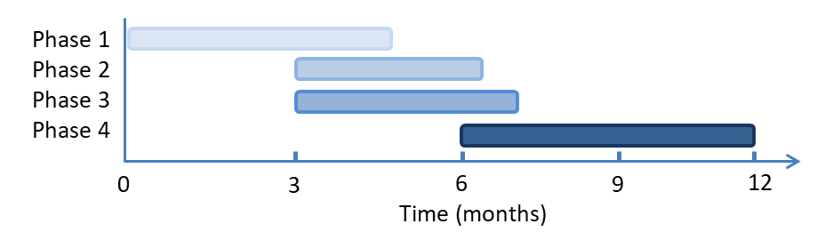
Figure 27 GP Resilience programme timeline
Some of the anticipated benefits from the GP resilience programme(s) are to enable the following improvements in primary care:
- Relationships and Regulations – working with other practices, internal partnership agreements, practice agreements
- Workforce – diversifying clinical workforce, reviewing administration staff roles, support for practice managers, recruitment, cross covering of workload, possible developments to look at shared back office systems, clinical and non-clinical staff
- Finance and Premises – understanding financial opportunities to working at scale, premises planning, collaboration
- Demand, Quality and Safety - workflow optimisation, management of care homes and home visiting, establishing demand, emergency/on the day demand management.
- Information sharing to enable Population Health management - data and information around complex/chronic conditions

BLMK governance for PCN development including GPFV initiatives
As depicted in figure 21 the BLMK primary care leads meeting currently acts as the working group to oversee PCN development initiatives including the ongoing GPFV work-streams. This is a non-decision making group that will have PCN representation. When required this group makes recommendations to the primary care strategy group, and CCG respective Primary Care Commissioning Committees.
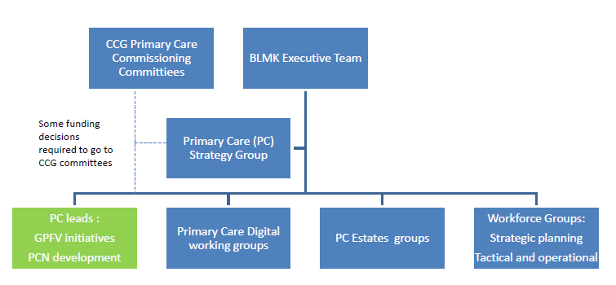
Figure 28 Governance for PCN development
Please see section 11 [governance] for the overarching BLMK ICS governance structure. Many of the working groups included in the diagram above link in with BLMK ICS Priority 1 – 5 boards.

Primary Care Commissioning Committees
Each BLMK CCG has a Primary Care Commissioning Committee to manage functions delegated from NHS England:
- GMS and APMS contracts (including the design of APMS contracts, monitoring of contracts, taking contractual action such as issuing branch/remedial notices , and removing a contract)
- Newly designed enhanced services
- Design of local incentive schemes as an alternative to the Quality Outcomes Framework (QOF)
- Decision making on whether to establish new GP practices
- Approving practice mergers
- Making decisions on discretionary payment
In addition, key responsibilities of the committee include:
- Utilise local knowledge from CCG GP members to influence the development of and investment in general practice to improve access to services and patient outcomes
- Develop and commission end to end care and increased autonomy to shape future Primary Care services
- Take an active role in driving forward the NHS Long Term Plan and Five Year Forward View agenda, including supporting the continued development of Primary Care Networks
- To manage the budget for commissioning of primary (medical) care services in Bedfordshire
- Plan, including needs assessment, primary medical care services in the CCG area
- Undertake reviews of primary medical care services in the CCG area
- Co-ordinate a common approach to the commissioning of primary care services generally
- Ensure collaborative working on monitoring and addressing issues of quality in primary care
- Support the development and implementation of a joint strategy for the enablers; primary care estates and premises, workforce development and IM&T infrastructure, which meets current and future needs
- Quality assurance of primary care services

Each CCG PCCC is accountable to the respective CCG governing Body.

Key element 2 - The NHS will reduce pressure on emergency hospital services

Emergency hospital services: current situation
There are 3 Acute Hospitals within the BLMK ICS: Bedford Hospital NHS Trust, Milton Keynes University Hospital NHS Foundation Trust and Luton and Dunstable University Hospital NHS Foundation Trust, all operating Type 1 A&E Departments.

Demand for our health services is increasing at a faster rate than ever before –around 10% more people every year come to our A&E departments, and more people than ever are being admitted to hospital.

Recent trends in A&E attendances at BLMK hospitals are depicted in the graphs below.

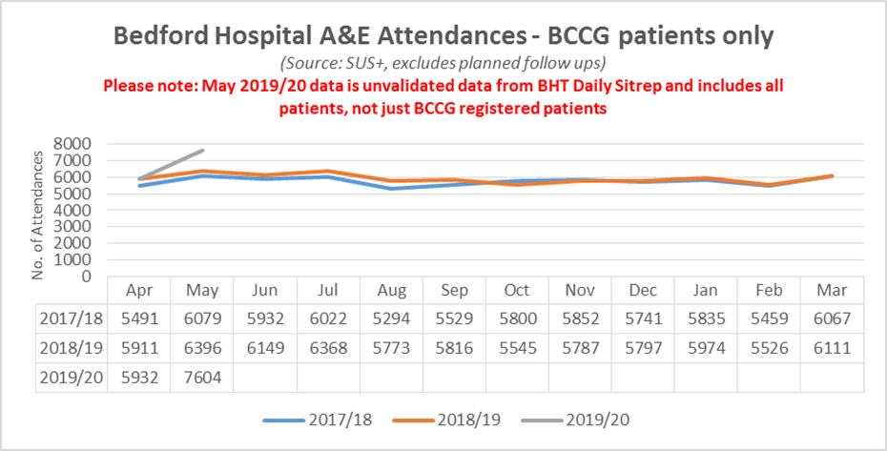

Figure 29 Bedford Hospital A&E attendances
Total attendances into BHT in 2018/19 increased by 2.95% over 2017/18.
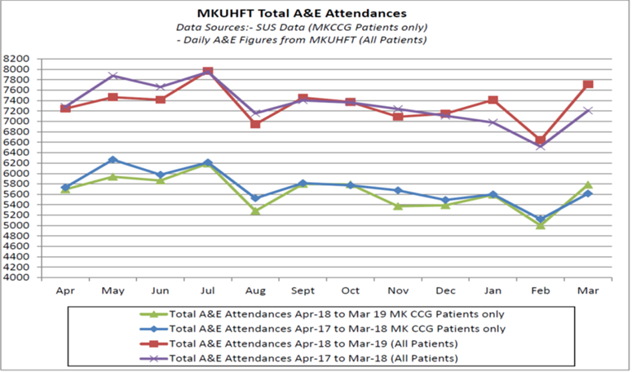

Figure 30 Milton Keynes Hospital A&E attendances
Total attendances into MKUHFT in 2018/19 increased by 0.05% over 2017/18 numbers, against a population increase of 1.5% (GP Registered Population figures). A&E attendances for MK patients reduced by 0.36% whilst Out of Area numbers increased by 1.53%.
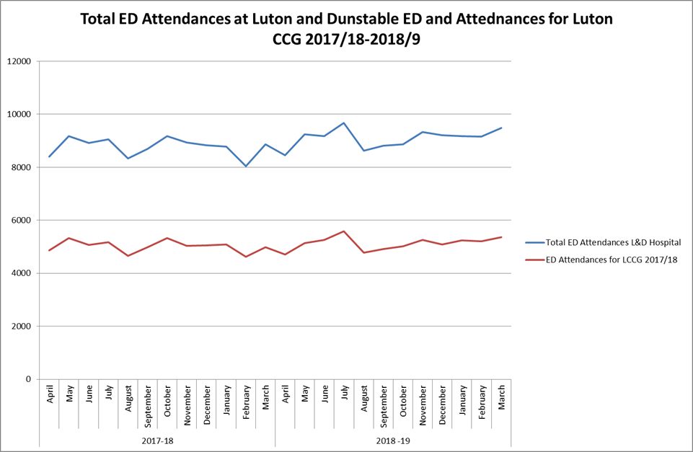

Figure 31 Luton and Dunstable Hospital A&E attendances
Average Total attendances at the Luton and Dunstable Hospital have increased by 3.81% between 2017/18 and 2018/19. The number of attendances for patients registered with a Luton CCG member practice has increased by 2.25% over the same period. This is against a population growth of 1.26%.

The NHS Long Term plan envisages Primary Care Networks joining up the delivery of urgent care in the community to reduce unnecessary attendances at A&E. Funding and responsibility for providing enhanced access services will transfer to each PCN by April 2021. Nationally, in the coming months, there will be an Access Review to establish a more coherent set of access arrangements to be implemented from 2020. When the model is published, ahead of PCN delivery from April 2020, CCGs will work with PCNs to implement.

In anticipation of the publication of the national specification, BLMK ICS is increasingly integrating primary and urgent care pathways as described in the sections below. This work will continue to develop, feeding into the range of anticipatory care models being used across BLMK are outlined in the previous chapter.

BLMK CCGs will be developing and publishing an urgent care strategy in 2019/20 to further develop what is outlined in this chapter.

Investment and Impact Fund
The Investment and Impact Fund is a new fund which Primary Care Networks will have access to and will help support implementation of the NHS Long Term Plan. It will help PCNs plan and achieve better performance against set metrics.

Funding will rise from £75 million in 2020/21 to £300 million in 2023/4.

PCNs and CCGs expect more information on the fund later in 2019/20, with ICSs expected to oversee schemes. It is anticipated that it is likely to cover five elements:

- Avoidable A&E attendances
- Avoidable emergency admissions
- Timely hospital discharge
- Outpatient redesign
- Prescribing costs

Improving access to primary care
Patient surveys
The 2018 GP Patient Survey revealed that were a significant number of patients who were dissatisfied with appointments times (just under a quarter of patients surveyed across BLMK).
A quarter of respondents stated that they had contacted another NHS service when they wanted to see their GP but were unable to as they were closed. Around a third of these people used A&E when this had occurred “considering all services contacted”.
As far as you are aware, what general practice appointment times are available to you?
Before 8am on at least one weekday |  |  |  | Weekdays between 8am and 6.30pm
BCCG | LCCG | MKCCG | National | BCCG | LCCG | MKCCG | National
11% | 11% | 13% | 10% | 72% | 68% | 71% | 70%
After 6.30pm on a weekday |  |  |  | On a Saturday
BCCG | LCCG | MKCCG | National | BCCG | LCCG | MKCCG | National
11% | 13% | 11% | 13% | 10% | 9% | 14% | 10%
On a Sunday |  |  |  | Don’t know
BCCG | LCCG | MKCCG | National | BCCG | LCCG | MKCCG | National
1% | 1% | 3% | 2% | 24% | 23% | 23% | 24%

How satisfied are you with the general practice appointment times available to you?
Very satisfied |  |  |  | Fairly satisfied
BCCG | LCCG | MKCCG | National | BCCG | LCCG | MKCCG | National
21% | 18% | 19% | 24% | 40% | 38% | 42% | 41%
Fairly dissatisfied |  |  |  | Very dissatisfied
BCCG | LCCG | MKCCG | National | BCCG | LCCG | MKCCG | National
13% | 10% | 11% | 10% | 8% | 14% | 9% | 7%
Figure 32 Patient survey data
Surveys undertaken by CCGs in 2018 ahead of commissioning extended access services also demonstrated significant patient interest in additional appointments on weekday evenings and weekends with the majority of responses indicating a willingness to travel to a practice other than their own.
Extended access
Since September 2018 patients in BLMK have had access to appointments 6:30-8:00pm on weekdays and at weekends (morning-lunchtime). Between ten and twelve bases are open during these hours. The service is available to all registered patients and appointments are accessed through their registered practice.
CCG area | Hours delivered weekly
Bedfordshire | 226.25
Luton | 117
Milton Keynes | 82
A summary of the hours delivered by extended access providers each week:

Figure 33 Summary of weekly extended access hours delivered
From March 2019 all services have met the seven core requirements published by NHS England, this includes: number of appointments (30 minutes per 1,000 patients), 100% population coverage and adequate promotion of the service.
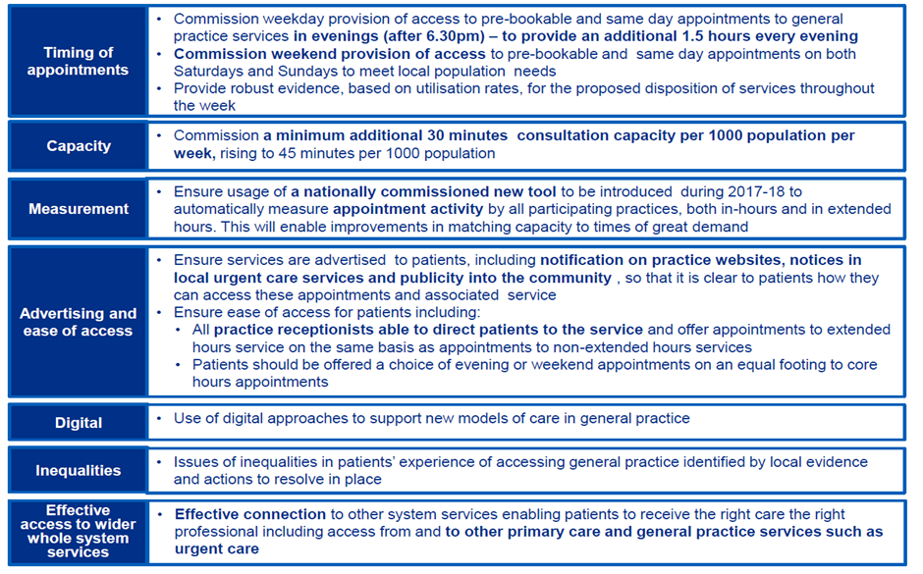
Figure 34 Extended access core requirements
All three CCGs are compliant with the pre-bookable and ‘on the day’ requirement outlined above with same-day appointments available in all BLMK services. In addition these appointments are available to be booked directly through 111 for all patients.
Extended hours DES
The Primary Care Networks DES includes the requirement for PCNs to deliver extended hours covering 100% of their patients outside of core hours (8:00am-18:30 on weekdays). The requirement is 30 minutes per 1,000 patients per week. The emerging Primary Care Networks are preparing to deliver extended hours from 1st July 2019. Learning from the delivery of extended access is feeding into mobilisation plans, this includes lessons around key enablers such as IM&T and information governance.
Below is a summary comparing the weekly DES hours delivered by practices (by CCG) for their own patients prior to delivery of the PCN DES along with the new requirement.
CCG area | Current extended hours DES activity per week | Requirement per week under PCN DES
Bedfordshire | 146 | 243
Luton | 114 | 118
Milton Keynes | 95 | 149
Figure 35 Current DES activity and PCN requirement
Access going forward
As extended access contracts come up for renewal across the three BLMK CCG areas in the next few years, arrangements for commissioning will be reviewed as per PCN DES guidance.
111/direct booking
BLMK CCGs have been working with practices, 111 providers, extended access services and IM&T providers to roll out direct booking from 111. This is being utilised in all extended access services and the vast majority of practices in BLMK with the rest set to come online during 2019/20.
An increasing number of alternate direct booking options are available to patients including:
- Urgent Treatment Centres
- Pharmacists
- Children’s Rapid Response Clinics.
- A 24/7 Clinical Advisory Service (CAS) within 111 provision is available across BLMK with plans to integrate with 999 to create a seamless patient pathway
From 1st July 2019 Primary Care Networks will delivery additional extended hours appointments (30 minutes per 1,000 population), the ambition is to make ‘on the day’ appointments accessible to patients via 111 direct booking during 2019/20.
We aim to deliver a consistent offer and access points to care – no matter which Primary Care Network patients are registered with.

Complex Care/Care homes
In 2020/21 PCNs will be required to implement the Enhanced Health in Care Homes model tested by Vanguard sites in other areas. The exact requirements of this element of the contract will not be published until later in 2019/20 but guidance states that: The aim of this service will be to enable all care homes to be supported by a consistent multi-disciplinary team of healthcare professionals, delivering proactive and reactive care. This team will be led by named GP and nurse practitioners, organised by PCNs.
In anticipation of this, work is underway in BLMK to align care and nursing homes with emerging PCNs. Primary Care Investment Scheme funding has been used to provide care home visiting/elderly frail visiting services in many areas of BLMK.
BLMK has developed and is now adopting a house of care approach, which provides a standardised framework for each ‘place’ to develop local models of care; ensuring key components of care feature in all models and are aligned to the aspirations of our Primary Care Networks.
High Intensity User Programmes are an integral element of providing enhanced support to people with complex needs across BLMK. Each place has initially prioritised different cohorts – and ‘place’ models will evolve and be developed through shared learning across primary care networks, place and at ICS level.
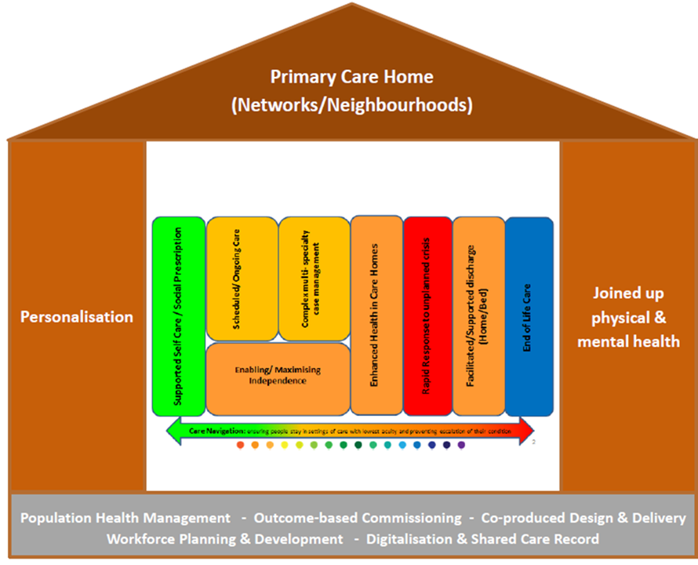
Figure 36 BLMK House of Care
BLMK has undertaken self-assessment against ‘NHSE Enhanced Health in Care Homes Framework’ and identified and agreed ten ‘system-wide’ priorities to drive forward further implementation of the EHCH framework; complimenting current planned initiatives ‘at place’.
BLMK has also undertaken self-assessment against ‘National Ambitions for Palliative & End of Life Care’ and identified two major ‘system-wide ‘ priorities to drive forward improvements in care at end of life, in particular to reduce need for emergency hospital admissions for people in last 3 months of life.
BLMK has and will continue to work alongside NHSE and local stakeholders to develop robust methods of measuring impact of our house of care approach; ensuring that the benefits and limitations of the plethora of data tools and data sets are recognised.
In addition the following work has begun and will continue into 2019/20 and beyond:
  - A remote monitoring solution has been successfully piloted across a number of BLMK care homes with support from the community-based Complex Care Team and GPs, this has helped reduce the number of ambulance call outs and admissions from these care homes. Further rollout of remote monitoring across BLMK is now planned.
  - Clinical Pharmacists and Pharmacy Technicians are in place across the ICS area. The aim of the service is that all care home residents have annual medication reviews as part of a multidisciplinary team. The review is a holistic as well as clinical review with a focus on reducing medication errors, improving adherence, de-prescribing, reducing polypharmacy and wastage, optimising medication particularly in relation to frailty, dementia, covert use of medicines, antipsychotic use and reduction of falls. Alongside this, a medicines management review is performed by the care home technician.

Work is ongoing across BLMK to improve information sharing with care homes with each working towards achieving one or more of the following standards:
Bronze
- Establish baseline of care technology
- Ensure all care homes have good Wi-Fi access, to enable care professionals remote access to their clinical systems on site at a care home and use of telecare facilities.
- Roll out secure email (nhs.net), to enable secure basic sharing of information to/from care homes, GPs, Community, Acute, Ambulance
Silver
- Access to SystmOne for care home staff and care professionals including L&D Hospital, Ambulance - an initial pilot of the community module with our 6 Nursing Homes
- Better use of technology e.g. telemedicine - how could we utilise Airedale model, particularly across ICS.
Gold
- Electronic access to shared care records, sharing care plans and EOL advance care plans, linked health & social care datasets etc.
The following work streams are helping to achieve the standards set out above:
- DSP Toolkit - training and publishing.
- NHSmail2 – issuing shared and individual NHS mail accounts.
- Wi-Fi Audit – audits are underway. Comms and engagement with parent and subsidiary organisation. Network & Wi-Fi – planning for procurement & roll out.
- SystmOne Record Access - Pilot planned for SystmOnline Proxy access pilot with up to 5 care homes.

Mental Health and Learning Disabilities
In BLMK there will be a move towards reorganising core community mental health services to reflect new and integrated models of primary and community mental health care which are place-based, multidisciplinary services across health and social care and aligned with the care networks as described in the previous chapter on Element 1 of the NHS Long Term Plan.
BLMK ICS priorities for 2019/20 ongoing:
Adult and Older Adult Community Mental Health Teams and Services for People with the most complex needs – Mental Health Priorities 2019/20
- Use additional 2019/20 baseline funding to stabilise and bolster core adult and older adult community mental health teams and services for people with the most complex needs, including people with diagnoses of personality disorder and eating disorders. Alongside this, undertake preparatory work for the mobilisation of a new integrated primary and community model as part of the Long Term Plan. Develop and implement robust plans across the system to spend additional baseline funding effectively and appropriately on community mental health for adults and older adults.
- Prepare for the mobilisation of the new community model by undertaking self-assessment against the Community Mental Health Framework, including determining readiness between 2019/20 and 2023/24 to receive transformation monies to test and/or adopt the new model, including 4 week waiting times. This preparation should include strengthening local relationships, including with local authorities and VCSE services, developing an understanding of local need through information and data, workforce planning, and involving local communities and people with lived experience from the outset.
- Align plans with other local plans to transform CYP and young adult services, to transform primary care (working towards geographical alignment with Primary Care Networks), to adopt the Comprehensive Model of Personalised Care and for Ageing Well (for older adults). Assess readiness and plan to transform three complex needs areas: personality disorder, adult eating disorder and those in mental health rehabilitation pathways. This pathway includes: Understanding and commencing the adoption of new adult eating disorders model of delivery as per forthcoming national guidance; Ensuring participation by providers within the local system in the forthcoming national stocktake of Personality Disorder Care; and understanding existing local and current out of area provision for mental health rehabilitation need.
- Work towards understanding the current demand for and provision of Older People’s MH (OPMH) services through ensuring provider participation in OPMH stocktake. Work towards ascertaining training and workforce needs in OPMH expertise through adoption of the HEE OPMH Core Competency Framework and exploration of credentialing. Ensure and support establishment of links with Frailty/Ageing Well/Healthy Ageing teams and build shared understanding of current plans and priorities with a view to alignment. Adopt shared care approaches between relevant MDTs – e.g. Frailty and OPMH MDTs – to support holistic care and consistent provision of OPMH support.

Physical Health and Severe Mental Illness – Mental Health Priorities for 2019/20
At least 60% of people with a severe mental illness should receive a full annual physical health check.

Common Mental Health - IAPT Services Mental Health Priorities for 2019/20
Improving timely access to treatment provided by Improving access to psychological therapies (IAPT) for people with common mental health problems (people with anxiety disorders and depression) and supporting with recovery.
Increasing the number of mental health therapists co-located in primary care by 2020/21 and delivering IAPT-Long Term Conditions services.
Expansion of access, including for underrepresented groups like older people and BME

Adults and Older Adults with the most complex needs (Moderate to Severe Mental Illnesses) – The Long Term Plan
By 2023/24, 370,000 adults and older adults with severe mental illnesses will have greater choice and control over their care, and be supported to live well in their communities via new and integrated models of primary and community care
Set clear standards for patients requiring access to community mental health treatment and roll them out across the NHS over the next decade. Test four-week waiting times for adult and older adult community mental health teams, with selected local areas.

Dementia – The Long Term Plan
Better support for people with dementia through a more active focus on supporting people in the community through enhanced community multidiscplinary teams and the application of the NHS Comprehensive Model of Personal Care. Supporting the Alzheimer’s Society to extend its Dementia Connect Programme

Physical Health and Severe Mental Illness – The Long Term Plan Ambition
Further increase the number of people receiving physical health checks to an additional 110,000 people per year, bringing the total to 390,000 checks delivered each year including the ambition in the Five Year Forward View for Mental Health.

The Long Term Plan Ambition for Common Mental Health – IAPT Services
Continue to expand access to IAPT services for adults and older adults with common mental health problems, with a focus on those with long-term conditions. By 2023/24, an additional 380,000 adults and older adults will be able to access NICE-approved IAPT services

Alongside this work the following primary care-facing initiatives are expected to contribute to a reduction in emergency attendances and admissions.
Bedfordshire – Work is being carried out:
- To further integrate IAPT and CAMHS primary care link workers within primary care
- To develop mental health input into the Cluster MDT meetings
- To continue to embed mental health services within an enhanced primary care provision
- To support with the roll out of Social Prescription
- To support with the Recovery College being more embedded within primary care networks

In Bedfordshire, work has commenced with developing mental health support within the De Parys Cluster (Bedford Town Centre), with a focus on integrating the Memory Assessment Service, a CAMHS primary care link worker, IAPT services and the Recovery College with primary care. Work is also going to commence with developing the step up and step down processes between the CMHT’s and the De Parys PCN.

Milton Keynes – Work is being carried out to further develop Primary Care Plus involving mental health specialists in primary care to undertake medication reviews and support with a roll out across all 7 clusters.

Luton – Work is being carried out as follows:
- Consultant-led team in primary care
- Development of Total Wellbeing Service (which includes IAPT, social prescription, PAM, healthy lifestyle programmes): personalisation approach to assessment; service provided in GP practices and community settings; integration with LTC pathways

There is also mental health input into the development of integrated health and care hubs across the ICS.

Perinatal Mental Health Services
A dedicated specialist community perinatal mental health services for young women and mothers has been established across Bedfordshire and Luton in line with the national 2018/19 wave 2 funding. The Long Term Plan for 2019-2020 will further promote more perinatal mental health services for young women and mothers in the community and will:

1. Increase access to evidence-based care for women with moderate to severe perinatal mental health difficulties and a personality disorder diagnosis and extending services to preconception to 24 months after birth, in line with the cross-government ambition for women and children focusing on the first 1,001 critical days of child’s life.

2. Expand access to evidence-based psychological therapies within specialist perinatal mental health services so that they also include parent infant, couple, co-parenting and family interventions.

3. Increase access to evidence-based psychological support and therapy in a maternity setting by implementing maternity outreach clinics that will integrate maternity, reproductive health and psychological therapy for women experiencing mental health difficulties directly arising from, or related to, the maternity experience.

4. Ensure partners of women accessing specialist perinatal mental health services and maternity outreach clinics receive evidence-based assessment of their mental health and are signposted to support as required.

In addition CAMHS are supporting two IAPT trainees to work alongside the perinatal psycho therapists.

SIM model
BCCG, BBC, CBC, LCCG, LBC, Bedfordshire Police and ELFT Mental Health Services have partnered with the High Intensity Network to develop and implement a Bedfordshire Serenity Integrated Mentoring (SIM) model. Following successful recruitment and intensive training of a specialist police officer and mental health nurse, a soft launch of the service will commence on 2nd July 2019.
The SIM model of care introduces a specialist trained police officer into the community mental health care pathways to help support service users struggling with complex and behavioural disorders. The model encourages service users to better self-manage their behaviour, to consistently de-escalate and to find better coping mechanisms that pose less risk to themselves and others, that avoids the criminal justice system and that places less unnecessary demand on emergency and healthcare services.
Dementia diagnosis
Dementia diagnosis rates in Milton Keynes and Luton are in line with the national target of 67%. The current rate for Bedfordshire is 60.3% which is significantly short of the national target.
The following actions in primary care to support practices with diagnosis:-
  - PMS scheme and Cantab project which encourages GP’s to assess and diagnose
  - Dementia tracker – so practices know gap to ambition
  - Practice visits
  - Nurse visits to the 5 lowest performing practices
  - Provision of memory service information on GP screens
  - Care home project running

Primary Care CAHMS practitioners
BCCG are working in partnership with ELFT CAMHS to deliver a Primary Care service with CAMHS practitioners embedded in each of the Networks within Bedfordshire. The practitioners will provide consultation, training and assessment and act as a conduit into core services if risks escalate. Their primary focus is early intervention and raising awareness of mental health.

Children
Rapid Response
Childrens’ Rapid Response service are already available in the Milton Keynes and Luton CCG areas. These services will continue to develop to increase admission avoidance. The same service is currently mobilising in Bedfordshire, targeting seven high-volume health conditions in particular:

- fever (with or without a focus)
- bronchiolitis
- gastroenteritis
- head injury
- asthma / viral induced wheeze
- seizure and abdominal pain

The services comprise of telephone triage, advice and support and clinic based appointments.

The objective of the service is to provide a community-based paediatric admission avoidance and care service offering advanced nursing care and short-term intensive support (for up 72 hours) as an alternative to A&E attendance, CAU / PAU attendance and inpatient treatment for children and young people presenting with 7 high-volume health conditions

The four main sources of referral are:
- A&E
- GP’s
- 111
- Acute Assessment Units (CAU / PAU)

Admission avoidance:
The ICS has stated the ambition to deliver the following primary care-based projects aimed at helping to avoid unnecessary attendances and admissions:
- Develop resilient and confident primary care teams to look after CYP with acute presentations with symptoms in the community
- Develop Digital based solutions for CYP and carers to help with their self-care
- Develop provision across BLMK for CYP with Complex and challenging behaviour. Increased investment is required in intensive, crisis and forensic community support. This will enable more people to receive personalised care in the community, closer to home, and reduce preventable admissions to inpatient services.

As stated in the 2019/20 operating plan a strategy developing ongoing schemes is to be produced in 2019/20.

Workforce Configuration
PCN MDT Workforce Model

The PCN integrated health and care workforce model described in section 5.2 has been triangulated with planning assumptions for impact upon emergency services. We have used the (limited) evidence base on MDT-style working for a frail elderly population to calculate the potential benefits in terms of impact on activity, relating to:

Activity | Activity Planning Assumption (Full Year 1 of full workforce model implementation) – based upon patient cohort group | Source
Non-elective (NEL) admission avoidance (including associated A&E visit) | 20 % of cohort NEL admissions avoided through MDT case management | King’s Fund, ‘Community Services: How they Can Transform Care” (2014)
Avoidance of first outpatient appointment following NEL admission | 100% of patients seen in outpatients following hospital admission minus the national average DNA rate of 8.5% | (https://www.nhsbenchmarking.nhs.uk/projects/2017/4/10/outpatient-services)
Avoidance of follow-up outpatient appointments following NEL admission | Reduction 2,792 appointments | https://www.nhsbenchmarking.nhs.uk/projects/2017/4/10/outpatient-services
Reduction in ambulance conveyances of NEL admissions | Reduction in 977 conveyances

Figure 37 PCN MDT planning assumptions

Several important qualifications must be noted:

- These are cautious estimates and take the lower range of benefits from the evidence base
- The benefits set out here focus on NEL admissions, as reflects the evidence base – they therefore do not include wider financial and non-financial benefits relating to improved outcomes, improved experiences of care, and greater professional satisfaction
- The evidence base is not sufficiently detailed to be able to pinpoint benefits related to specific team members’ input

Our integrated health and care PCN workforce model cannot work in isolation to support the real pressure that our emergency care services currently face, therefore we will also consider workforce implications beyond that of the PCN MDT model and how staff work in a coordinated, joined up way across service provision.

Wider Workforce Implications

Through the work of BLMK Local Workforce Action Board we will:

- support staff in general practice teams and PCNs to consider how the demand for urgent/same day/out of hours appointments can be supported more effectively through utilisation of new roles and ways of working
- support the upskilling and development of multidisciplinary staff working within clinical assessment services as part of integrated 111 services
- implement our Education Framework for Home-Based Care Staff (staff working within nursing, residential and domiciliary care settings) and carers and volunteers for dementia, falls and end of life/palliative care by March 2020
- work with health providers of emergency services to quantify workforce shortages/hotspots and develop attraction, recruitment and retention strategies

Key element 3 - People will get more control over their own health and more personalised care when they need it

Personalised Care Programme
BLMK ICS are demonstrator site for the Personalised Care Programme, working with NHSE to embed the Comprehensive Model of Personalised Care across our health and care system. We are currently working to further scale up the following across our system:
- Person centred care and support planning
- Patient Activation Measure (PAM)
- Shared decision making
- Personal health budgets (PHB)
- Social prescribing
- Self-care and peer support

As part of our commitment to embedding a personalised approach within our health and care system, Bedford, Luton and Milton Keynes (BLMK) have made specific reference to personalisation within the BLMK Joint System Commissioning Intentions 2019/20. Within those commissioning intentions, we state that:
‘BLMK will deliver the Personalisation programme to ensure people have choice and control over decisions that affect their own health and wellbeing within a system that harnesses the expertise, capacity and potential of people, families and communities in delivering better outcomes and reducing health inequalities.’

The role of Primary Care in personalising healthcare services.
The involvement of primary care will be crucial to the successful expansion of the personalised care approach across the BLMK system. Our aim will be to improve the quality of care for people with co/multiple-morbidities (through personalised care and support planning, structured medication reviews, and more intensive support for patients who need it most)
Primary care will take a central role in delivering the personalised approach, including:

- Care navigation and case management across Primary Care Networks (PCNs), with a focus on frequent attenders and users of health and social care services.
- Embedding social prescribing referral pathways, link-workers (care coordinators) across the networks to ensure an expanded social prescribing offer.
- Ensuring the Shared Decision Making approach is fully embedded, ensuring people feel empowered to make choices about their own care and that they are fully involved in the decision making process along with their GP (Appendix K).
- Cohort identification for those people whom will benefit most from a personalised approach. Appropriate patients will be identified as part of the multi-disciplinary approach, which will involve personalised care

Workforce within Personalised Care
  - BLMK are implementing an ICS level workforce strategy to ensure that frontline staff have the skills and core competences to offer truly personalised care. This will include some level of mandatory training for all staff on the personalised care approach, why we are committed to it and the benefits to the person and the system.
  - Person centred care and support planning training is to be offered to all staff involved in care planning.
  - We will continue to review the care planning process to ensure quality. Those delivering the conversations/completing the plans as well as the clients will be contacted for evaluation purposes.
  - We will ensure that the personalisation training across BLMK is co-produced with staff, ensuring they feel engaged and are able to influence how we deliver the change.
  - An ICS level communications strategy will ensure that both staff and the public are aware of the Personalised Care approach and what it will mean for them in practice.
  - We will ensure there is frequent and detailed communication with staff about the changes that are occurring and how these may impact on their roles and day-to-day working. For example, we will be working with staff to ensure they are comfortable with why personalisation is important, how it will benefit people, what is required from them to ensure they deliver a truly personalised approach.
  - As well as training and communicating the approach with existing staff, we will work system wide to ensure that personalisation is embedded in job adverts and specifications, to ensure that new staff holds the competences to deliver personalised care.
  - BLMK will work with NHSE to ensure best use is made of the plans for regional GP trainers to help train their colleagues in personalised care approaches. How services will be delivered, what role new technology might play and the timeframe for implementation any proposed solutions.

Technology
BLMK are reviewing the technology required to speed up the process of Patient Activation Measure (PAM) completion by the patient. This will include possible use of and/or distribution of tablet computers in practices. The use of the PAM ‘App’ will ensure a user-friendly experience for people, as well as timely results for staff. This should be in place towards the end of 2019.
As part of wider IT plans for BLMK, a digital shared care record will enable the recording and sharing of the personalised care plans amongst various (relevant) system stakeholders. This will also enable the recording and sharing of PAM scores.
The Personalised Care programme reports to Priority 2 of the ICS. We have steering group and board group meetings, attended by senior ICS staff. These board meetings are to also be attended by senior level staff from relevant providers across the system.
The progress of the personalised care programme will be updated to the ICS exec team at least every six months, or more frequently if required.
Each CCG and Local Authority has a nominated lead to ensure personalised care continues to scale up as per the programme plans.
Going forward we will seek to ensure each PCN has a personalisation lead to help embed the approach.
BLMK will ensure that resources are in place to ensure the continued expansion personalised care post the Personalised Care Programme, which comes with NHSE funding attached (£225k for 19/20 for example).
We have already embedded staff across the system to focus on personalised care. For example we have Personal Health Budget leads within each CCG and Personalisation leads in place, in addition to the Personalised Care programme manager working across BLMK ICS.

Workforce Configuration
PCN MDT Workforce Model
The PCN integrated health and care workforce model described in section 6.1 describes how we will utilise new roles, such as social prescribers, as a core component to our MDT workforce model. These roles are essential to connect people to local groups and support services. Personalisation of care, however, will not be achieved solely through these new roles.
We recognise that there is a significant cultural shift required to support person centred care and to move from a ‘what is the matter with you’ approach to a ‘what matters to you’ ethos, that is underpinned by a community asset approach which creates support networks through a wide range of leisure, education, public voluntary and charitable sector services. As such we are currently reviewing the training and development requirements for all health and care staff that will underpin a personalised care culture:
Wider Workforce Implications
Through the work of BLMK Local Workforce Action Board we will:
- Review of current local, regional and national offers of education and training to support social prescribing (motivational interviewing and guidance), shared-decision making, care planning (including advanced and anticipatory), and health coaching.
- Profile training offer to relevant health and care staff groups, identify delivery mechanism, costs and sources of funding
- Develop training programme offer and roll out across BLMK, supported evaluation and impact measures
- Support each of our four places to consider learning from the ‘Wigan Deal’ and take forward a community asset OD programme to support health and care staff to work with local people around ‘what matters to you’.

Key element 4 - Digitally-enabled primary and outpatient care will go mainstream across the NHS

The Current Situation
Within the BLMK ICS, there are a number of connected programmes of work already successfully supporting the delivery of digitally enabled services within primary care. Theses main programmes of work include:
- BLMK Strategic Interoperability Programme – programme to implement an integrated Health and Social Care Record across all main providers (with a Patient Portal and providing pseudonymised data for Population Health Management)
- Information Sharing Phase 1 (ISP1) Programme – delivering a range of tactical digital solutions to support new ways of working in primary care, including Online Consultations
- Care Homes Digitalisation – delivering robust Wi-Fi, NHS Mail and Information Governance training to all BLMK care homes, GP Patient Data access to selected care homes
- As a sub-set of the programmes above, a dedicated workstream around data sharing and Information Governance within BLMK
- Business as Usual GP IT improvement workstreams, including IM&T infrastructure.

Key achievements to date have included:

- The deployment of SystmOne as the GP IT system for 99/102 GP practices in BLMK, and across many of the main community, mental health and urgent care providers, providing a digital platform for information sharing and interoperability
- Establishment of an ICS-wide Data Sharing Agreement, which has been signed and implemented by providers across the patch, including the vast majority of GP practices
- Completion of a robust baselining exercise mapping interoperability gaps within the system
- Phased deployment of SystmOne to support information sharing across Primary Care multi-disciplinary teams and urgent care pathways (e.g. Emergency Departments, therapy services, acute and community End of Life teams, extended access Hubs)
- GP Collaborative Working Digital Toolkit developed as framework for supporting emerging Primary Care Networks with understanding and addressing their digital requirements
- ICS-wide procurement and phased implementation of Online Consultations solution within primary care
- Successful remote monitoring pilot in care homes, and digitalisation of care homes across BLMK in the form of Information Governance training, nhs.net access, and SystmOne access in some cases
- Development of the Outline Business Case for the Strategic Interoperability Programme, resulting in securement of £6.6m HSLI delivery funding
- Establishment of robust governance structures to underpin these workstreams.
- Improvements to core GP IT infrastructure, including phased roll-out of HSCN (Red-Centric) Network.

Delivering Digitally Enabled Healthcare within Primary Care
Building on the successes over the last few years, the local digital programmes remain key to supporting delivery of the wider BLMK primary care strategy.
Increasing the ways that patients can access information and advice digitally will play a role in managing demand for services and physical space in primary care settings. It will also help to empower people to take more responsibility for their own health and well-being, enable delivery of more personalised care, and meet modern expectations and preferences about access to services. In addition, building on the successful local pilots around remote monitoring, technology will increasingly play an important role in enabling new care approaches, helping to improve patient experience and outcomes.
Technology will play a key enabling role for the local Primary Care Networks, and will help to underpin the delivery of high quality and new services for patients. Provision of timely data and information sharing between providers will help to achieve local ambitions around the population health management approach, enabling the delivery of more targeted, proactive and preventative care.
Digital tools will also increasingly help to achieve more consistent delivery of high quality care, and help to reduce unwarranted variation.

We will…
- Help maximise collaboration and transformation within Primary Care Networks by supporting digital interoperability between practices
- Help facilitate the introduction of new clinical roles working within Networks by supporting more agile working arrangements
- Continue to support more integrated working across the wider Primary Care multi-disciplinary team, through improved information sharing between systems, and implementation of collaboration tools (including enabling virtual meetings, and file-share arrangements)
- Improve digital access for patients to information and advice through a range of approaches including use of NHS APP
- Continue to trial new forms of technology-enabled care
- Enable access to information to guide clinical decision making, including developing systems to underpin the local population health management approach
- Continue to embed and adapt the BLMK Information Governance framework to facilitate information sharing between providers and specifically develop the approach for secondary use of data to aid population health management.

Impact for Workforce
The digital strategy is one of a number of enablers supporting new ways of working in primary care. It has been developed in parallel with the BLMK workforce strategy, and estates strategy to ensure an aligned approach.
Many of the digital intentions will have a workforce impact, and this is being addressed within each the individual projects. For example, the recent successful remote monitoring in care homes pilot required training for care home staff, and an extension to the service specification with local community nursing teams to ensure rapid access to advice and support. Similarly, the phased implementation of online consultations has required significant changes to operational processes within GP practices, and a local GP champion has been recruited to offer guidance and support around this.
As further digital services are offered to patients, it is expected that some people will need support with learning how to use technology to access advice and care. This will be factored into the planning for some of the larger integrated health and care Hubs being developed across BLMK (e.g. Health Information booths, space for virtual consultations with primary and secondary care clinicians), and will be factored into emerging roles such as social prescribers and clinical navigators as required.
Utilising new forms of technology to support the operational management of practices and Networks, and to provide care to patients may require greater IT skills from GP practice staff. The need for further structured training will be considered, e.g. potential digital module within local Practice Manager Development Programme.
There has been strong alignment between the digital programme and commissioners, and this will be further enhanced through a greater focus on clinical leadership and involvement in the delivery of the digital workstreams going forward.

NHS Future Collaboration Platform
BLMK have adopted and created a designated area for the Primary Care Networks in BLMK to share information electronically across different organisations using the NHS Future Collaboration Platform.
Each individual network has the opportunity to co-ordinate, plan and deliver the care for their population their own defined workspace area within the platform.
As the NHS Future Collaboration Platform is web based, the PCN’s are able to communicate effectively and work collaboratively with all organisations within their network.
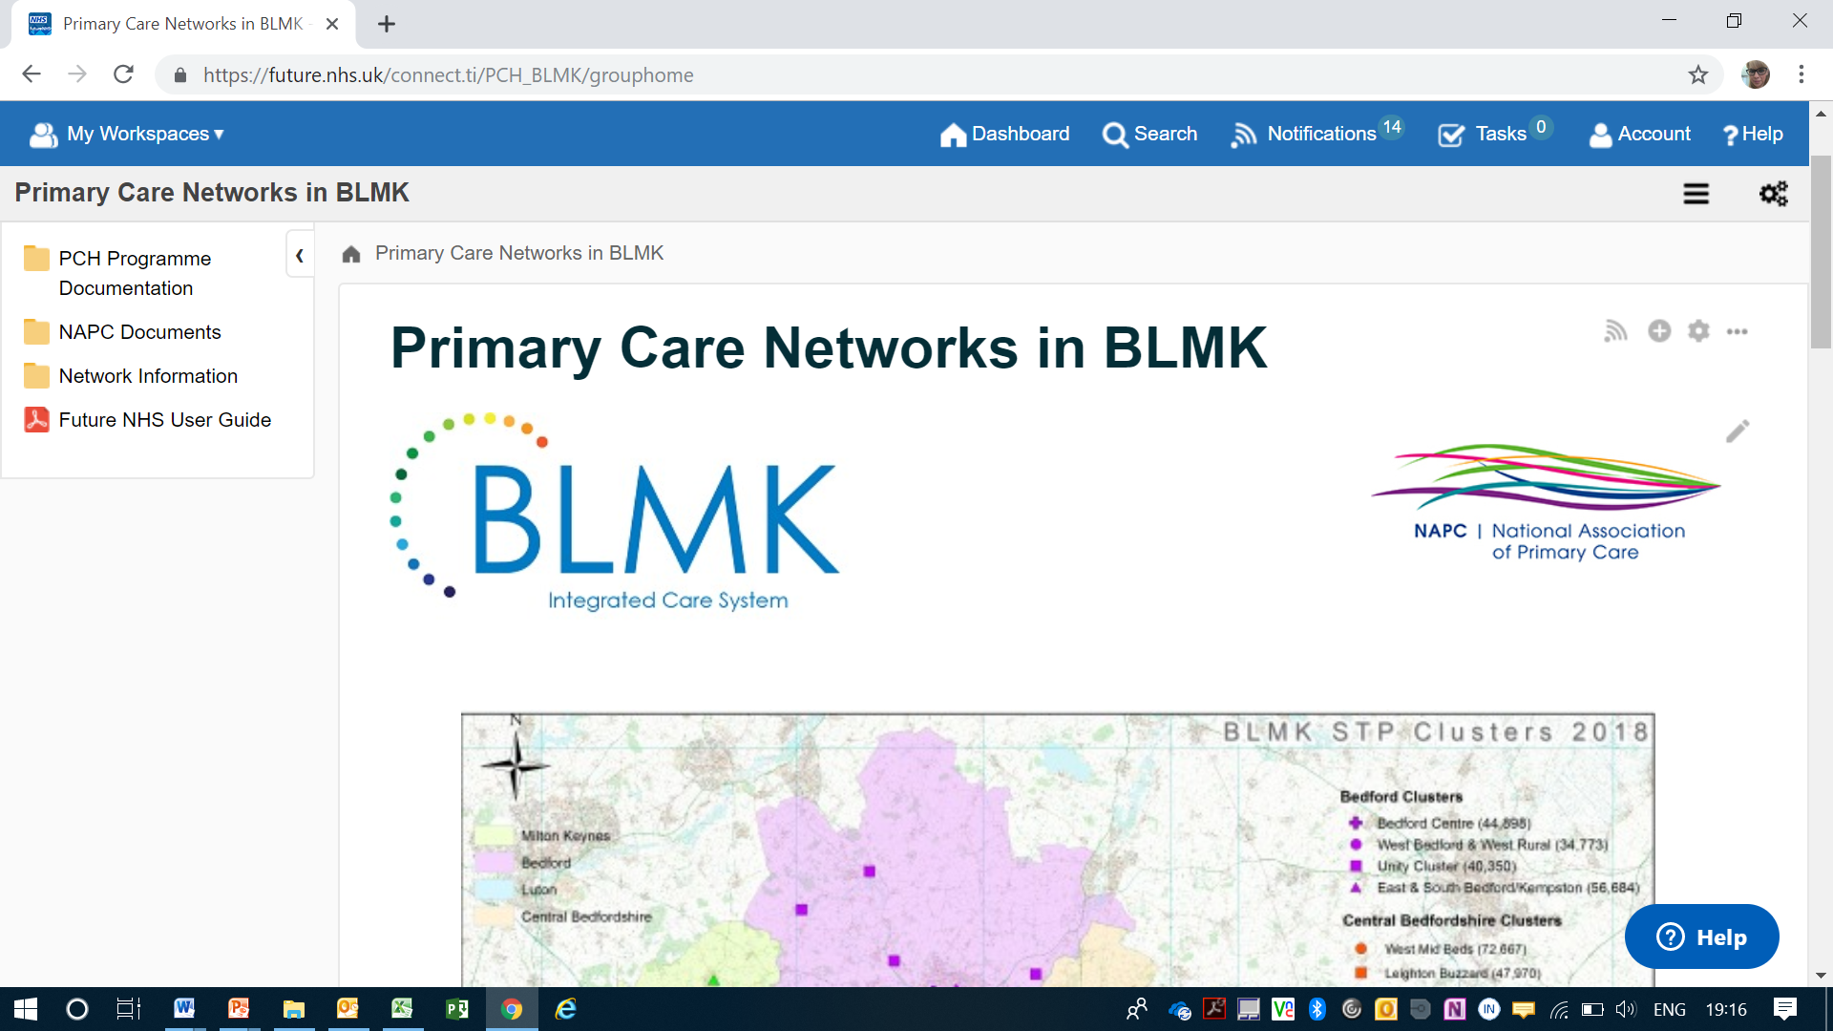
Figure 38 NHS Future Collaboration Platform

Delivery
The following projects will support delivery of this Strategy.
Objective | Projects | Timescale
Enable interoperability within Primary Care Home networks | Develop digital offer/catalogue of services to support interoperability within Primary Care Networks (PCNs) | Oct 2019
Enable interoperability within Primary Care Home networks | Work with system suppliers to improve interoperability functionality between practices, and consider opportunities about improving interoperability through GP IT Futures Programme | Ongoing into 2020
Enable interoperability within Primary Care Home networks | Deploy productivity and collaboration tools across practices (e.g. Microsoft 365, file-share technologies including the Future NHS Collaboration Platform, Skype for Business) | Ongoing into 2020
Enable interoperability within Primary Care Home networks | Enable agile working across priority clinical settings through deployment of mobile equipment | 2020/21
Deployment of high value and low cost proven technology-enabled care | Continue implementation of online consultations within primary care. Will consider other innovative pilots for digital access to other services within PCNs, including Skype consultations. | Ongoing into 2021
 | Review evaluation of remote monitoring pilot and support development of business case for business-as-usual funding/grants for larger pilots | Sep 2019
Enable greater focus on self-care and self-management through improved digital access for patients | Commission a market appraisal of technology available to support patients to access care, information and advice remotely, with a view to developing an initial strategy – including a local view on implementation of the NHS App within BLMK. | Oct 2019
Continue to develop information sharing for provider services to access key primary care clinical information | Continue to enable access to the GP record within provider settings (Acute, Community, Mental Health, Out of Hours), where there is a clear identified need and clinical benefit – with priority focus on enabling integrated working, improved management of patients with complex/multiple needs, and improved clinical decision making in urgent care settings. | 2019/20
 | Scope and pilot tactical solutions to enable improved information sharing between health and social care. | 2019/20
Enable access to information to guide clinical decision making | Establish IT enabled access to clinical templates (e.g. Ardens) | Dec 2019
 | Support development of risk stratification to identify patients for intervention, within the Population Health Management Programme | Pilots underway
Figure 39 Digital developments timeline
As the tactical work above is ongoing BLMK will continue to take forward the Strategic Interoperability Programme which aims to deliver a BLMK ICS shared care record and the digital architecture to develop population health analytics tools for the system. An options appraisal and Outline Business Case have been produced and the programme is now in the requirements gathering stage.

Governance and Operational Arrangements
Robust and well-established governance arrangements are in place to oversee delivery of the ICS/CCGs’ digital strategies, as set out in the diagram below. The overarching digital strategy is overseen by the ICS Digital Transformation Board, led by the Chief Information Officer. This includes oversight of the strategic interoperability programme, and the more tactical primary-care facing Information Sharing Phase 1 Programme (ISP1), to ensure strong synergy between both elements. Formal accountability for the ISP1 Programme sits with the joint Executive Team across the three BLMK CCGs, to ensure strong alignment with primary care commissioning and development.
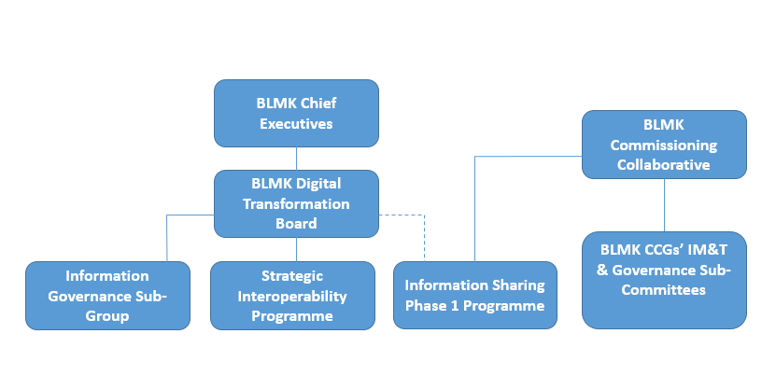
Figure 40 Digital strategy governance

Resources
Significant resources have been secured and established to support delivery of this element of the primary care strategy, including,
- £6.6m HSLI (Health System Led Investment) Funding to support implementation of the integrated health and care record across BLMK
- £850k ETTF (Estates & Technology Transformation Fund) funding in 2019/20, and a further £1m approved in principle for 2020/21
- ICS Chief Information Officer and Digital Programme Lead
- ISP1 Programme Lead and dedicated Programme Manager
- Dedicated ICS Information Governance Lead

The ongoing revenue implications of each project are assessed and signed off by the appropriate Board prior to implementation. The impact of increased agile working in particular will require further assessment during 2019/20.

Workforce Configuration
The workforce implications for our digital programme are being explored locally and also informed by national findings, such as through the Topol Review. We have worked with staff to develop the following framework, with the aim of enhancing the skills and competencies that enable staff to inform and deliver digital solutions:

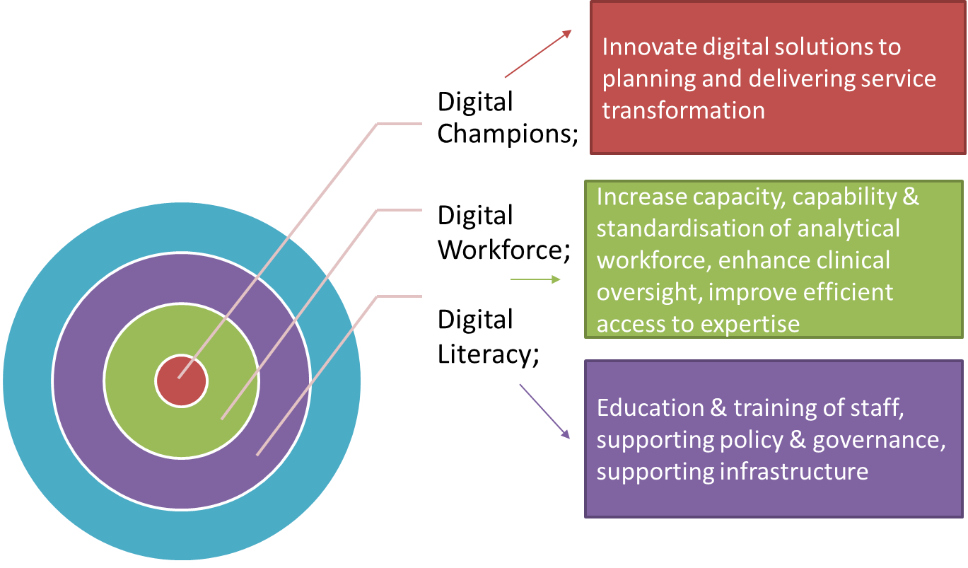

Figure 41 BLMK Digital Programme Workforce Implications

As digital solutions are evolving within primary care we will:
- Support the identification and development of clinical and non-clinical digital champions
- Adopt a co-design approach to digital solutions with health and care staff, ensuring staff inform how digitally and technology enabled care services (TECs) and will enable health and care staff to work more effectively across organisational and sector boundaries to support personalised care
- Develop training and education offers aligned to digital and TECs which will increase the confidence and competence of our health and social care workforce to work within a digitally enabled environment

Key element 5 - Local NHS organisations will increasingly focus on population health – moving to Integrated Care Systems everywhere

Population Health
Population Health is an approach aimed at improving the health of an entire population. It is about improving the physical and mental health outcomes and wellbeing of people, whilst reducing health inequalities. It involves actions to reduce the occurrence of ill-health, including addressing wider determinants of health, and requires working with communities and partner agencies. The King’s Fund (2018) suggests that action is needed in four domains to improve population health and reduce health inequalities: (1) the integrated health and care system, (2) our health behaviours, (3) the places and communities we live in and (4) the wider determinants of health.
Population Health Management (PHM) is a tool that can help us to improve population health through data driven planning and delivery of proactive care to achieve maximum impact. It includes population segmentation and other methods to identify ‘at risk’ cohorts; designing and targeting interventions to prevent ill-health, to improve care and support for people with ongoing health conditions and reduce unwarranted variation in outcomes. PHM includes a range of activities, including the use of intelligence and insight to inform strategic planning of service transformation at ‘system’ and ‘place’ levels, through to direct patient care applications such as data-driven predictive risk scoring and disease registry management.
Whilst existing activities such as Joint Strategic Needs Assessments and RightCare analyses are part of the broad PHM approach, sophisticated understanding of our population cohorts, their needs and resource use at the PCN level will require system-wide progress in data warehousing, data linkage and data science. The figure below sets out the priorities for PHM in BLMK in 2019/20.
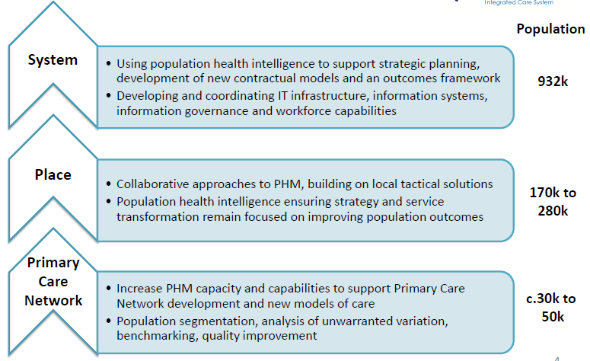
Figure 42 Population health priorities

Primary Care Network PHM group
An operational task group consisting of CCG and practice representatives and wider stakeholders has been established to support PCNs with PHM. The role of this group as it matures is to oversee and support Practices/Networks with:
  - population segmentation
  - identifying appropriate training resources
  - development of Network PHM leads
  - development of place-based digital solutions to identify (and track the utilisation of resources for) PCH population segments
  - embedding a mechanism to iteratively analyse the needs of the Network population
  - translating analytical findings in a way that provides useful intelligence and insight to inform service model re-design and workforce requirements
  - designing relevant metrics using available datasets to track the progress and impact of Network interventions

Understanding the Primary Care Network population health needs to support the local development of care and support models

Since BLMK has been working with the NAPC it has been recognised that the varying levels of maturity and challenges both at network as well as ‘place’ level have required a flexible, responsive and inclusive approach. Using tried and tested PCH methodology we have co-designed and tested an approach for developing fully integrated community-based healthcare through expanded community teams focused on identified and agreed priority patient and population cohorts.
The approach to service redesign from a PHM perspective is continually evolving but is not yet fully embedded or understood by all PCNs for all population cohorts. This is a significant principle behind the creation of PCNs and is a key consideration for continued PCN development.
The Primary Care Home enablers will continue to be widely adopted across BLMK to ensure PHM is at the heart of all Quality Improvement (QI) and care model re-design initiatives. The model below summarises the key steps currently being adopted and adapted by PCNs within BLMK to finding, engaging and involving the widest possible range of local people in shared goals for their local population.
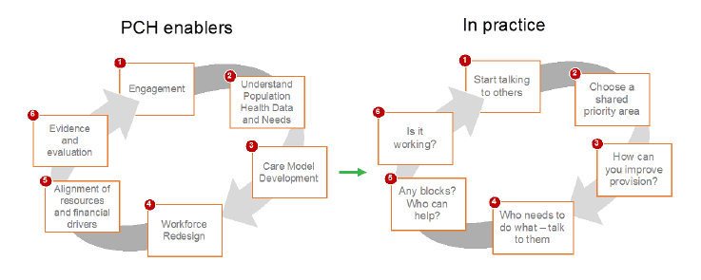
Figure 43 Engagement model
As highlighted within the model, population health data is a fundamental requirement to support the PCH approach, and has predominantly been accessed through individual practice systems to-date - this is now available for all PCNs, helping networks to:
- Identify and agree shared priorities with partner organisations across their local communities
- Confirm outcomes, success measures and monitor progress
- Develop new models of care that build on existing resources, and are relevant and appropriate to meet the needs and wants of the local population

We recognise the need to build strong, effective and sustainable patient / public engagement and leadership particularly to help maintain a focus on personalisation that also considers Mental Health needs alongside physical needs as part of an informed population health management approach to designing new PCN and place based service delivery models.

Working in partnership with the NAPC, BLMK has adopted and developed the NAPC ‘3 by 3 table’ concept for PCN population segmentation. PCNs and their constituent practices have been supported to segment their population according to age group and level of need (see figure 44 below). A further distinction is made for those who are generally well or have some long term conditions/needs, as to whether they are considered to be at low or higher risk of increasing health, and Mental Health, need, depending on the presence or absence of risk factors and the number of conditions/health needs they currently have. A standard list of read codes has been developed with clinical input so that practices can run searches and populate the grid.

Once the grid has been populated PCNs are supported, with the addition of local knowledge and other data sources, to identify a population segment for initial QI and workforce development focus.

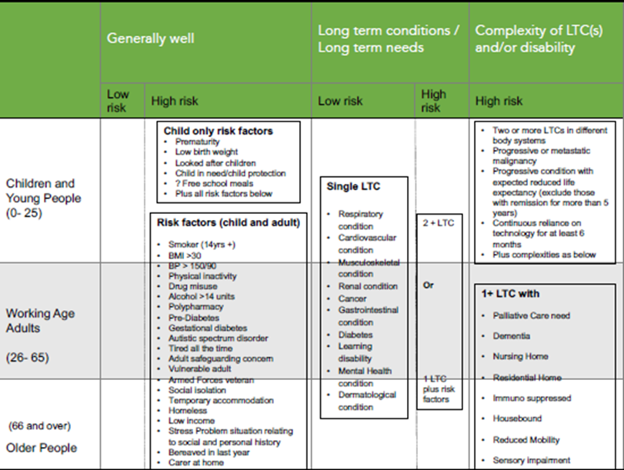

Figure 44 Population health grid
Some analytical and QI resource has been identified to support accelerated PCNs to develop their PHM approaches, and work is underway with public health colleagues to produce PCN locality data briefings, but the next step for BLMK ICS is to determine what infrastructure, intelligence and intervention support is required to scale PHM across the BLMK PCNs.

Where PCN development is working well, there is a balance of clinical and operational leadership. Establishing the meaning and approach to leadership development in relation to PCN development has also been critical. The focus on building leadership skills and capacity as part of the day job has been positively received and is enabling a real-life approach to leading change. We have also identified the need for targeted action to engage all professional groups, including Practice Nurses, and ensure they are properly sighted on national / BLMK strategy and the critical role clinical leaders will play in delivering it.
Workforce Configuration
Our approach to PCN development has population health as its starting point to developing effect integrated health and care workforce teams, this occurs ‘on the ground’ level, with PCNs adopting the NAPC cycle to PCN development, which starts with population health cohort identification and within our strategic workforce modelling approach:
Figure 45 Population Health Approach to Workforce Modelling for MDT
PCN MDT Workforce model
This approach is enhanced further through the identification of the development of BLMK system, population health cohort (people aged 65 years and over with complex care needs) and staff reported outcome metrics:
System metrics | User-focussed or -reported metrics⁴ | Staff-reported metrics
- Number and rate of unplanned (or avoidable) acute admissions in people age 65 years or more  - Rate of unplanned hospitalisations per 100,000 population aged 65 and over for chronic ambulatory care sensitive conditions  - Proportion of people aged 65 and over who were still at home 91 days after discharge from hospital into reablement / rehabilitation services  - Emergency readmissions within 30 days of discharge from hospital for those aged 65 and over  - Permanent admissions to residential and nursing care homes, per 100,000 population | - Self-reported well-being  - Quality of life measurement in people aged over 65  - Proportion of people who use services and their carers who reported that they had as much social contact as they would like  - Proportion of people with a care plan who were involved in putting it together  - The difference between the number of people with a care plan and the number who say that they have a care plan  - Percentage of adult carers who have as much social contact as they would like  - The proportion of carers who report that they have been included or consulted in discussion about the person they care for | - ‘I feel that my role makes a difference to patients / service users’  - ‘I am able to deliver the care I aspire to’  - ‘I have adequate materials, supplies and equipment to do my work’  - ‘There are enough staff at this organisation for me to do my job properly’  - ‘The team I work in has a set of shared objectives’  - ‘I am involved in deciding on changes introduced that affect my work area / team / department’
Figure 46 MDT workforce model metrics

The table above outlines a suite of metrics ranging from system metrics (which can act as proxies of outcomes such as independence and quality of life) to user-focussed or user-reported metrics and staff-reported metrics, relating to experiences of receiving or providing care through the case management function that have been agreed by BLMK stakeholders. This will enable us to measure the extent to which the PCN MDT Workforce model impacts BLMK Integrated Care System metrics and support an understanding of the extent to which local health service staff are genuinely providing joined up, personalised and anticipatory care.
Similarly we have developed a set of design principles, which underpin the workforce model.
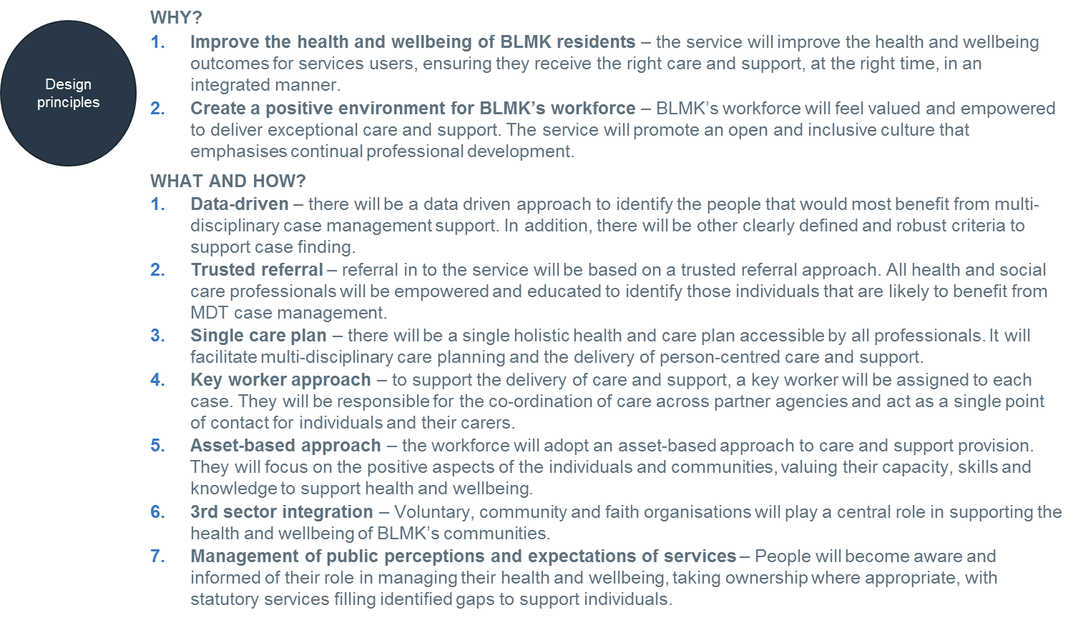
Figure 47 Design principles
These statements set out the Why? for the development of MDTs – that is, what they are designed to achieve. They additionally outline key information on the What? and How? This enables us to identify a consistent set of principles that are developing PCNs can apply to ensure consistent outcomes for the population health of local people in BLMK ICS

Governance

Integrated Care System
BLMK ICS is currently undertaking a governance review. This will be completed by September 2019 and reflected in updates to this strategy.
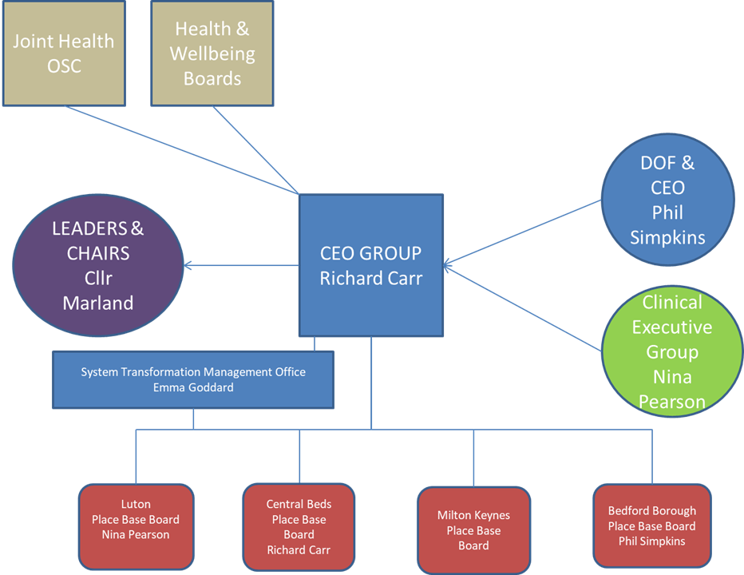
Figure 48 ICS governance

ICS priority workstreams
BLMK have identified a total of five ICS priorities to deliver the future vision for health and social care. The five priorities all overlap, and the benefits expected will only be fully realised if all five proceed in parallel.
The development and transformation of primary care is addressed under Priority 2 with the aim to deliver high quality, scaled and resilient primary care, community and social care services across BLMK.
All five priorities are outlined below:
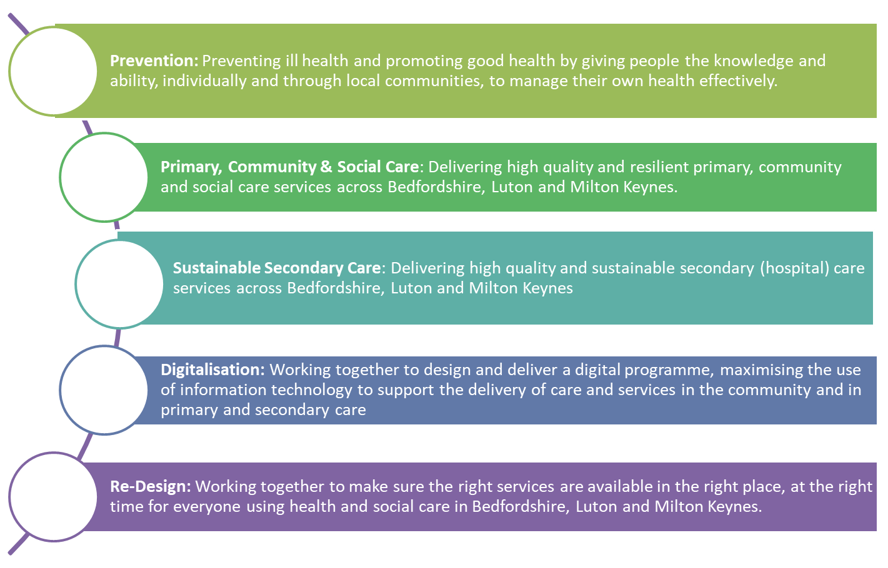
P5
P4
P3
P2
P1
Figure 49 BLMK ICS Priorities

Workforce
The BLMK ICS Workforce Programme is overseen by the BLMK Local Workforce Action Board (LWAB). The operating model is supported by three sub-groups: Workforce Modelling and Supply, Leadership and OD and Education Partnership.
Seven networks/groups outlined in the diagram below feed these priorities which are supported by the Workforce Development Academy (WDA).
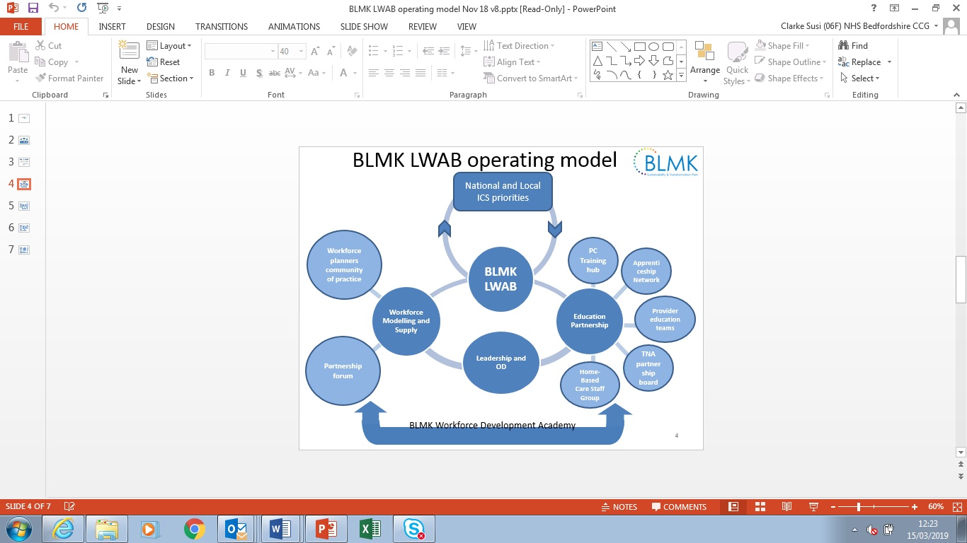
Figure 50 LWAB operating model

Measurement

GP Patient Survey
BLMK CCGs will continue to review the GP Patient Survey results, providing a targeted response where possible to improve results annually, particularly where a negative variation from regional/national results appear. Learning between teams/providers that are members of different CCG areas currently will be facilitated where appropriate.
A summary of BLMK CCG results from key questions from the 2018 survey:
Q1. Generally, how easy is it to get through to someone at your GP practice on the phone?
Easy |  |  |  | Not Easy
BCCG | LCCG | MKCCG | National | BCCG | LCCG | MKCCG | National
69% | 53% | 58% | 70% | 31% | 47% | 42% | 30%

Q5. Which of the following general practice online services have you used in the past 12 months?
Booking appointments |  |  |  | Ordering repeat prescriptions |  |  |  | Accessing my record
BCCG | LCCG | MKCCG | National | BCCG | LCCG | MKCCG | National | BCCG | LCCG | MKCCG | National
20% | 13% | 20% | 13% | 19% | 19% | 21% | 14% | 4% | 4% | 5% | 3%

Q6. How easy is it to use your GP practice’s website to look for information or access services?*
Easy |  |  |  | Not Easy
BCCG | LCCG | MKCCG | National | BCCG | LCCG | MKCCG | National
82% | 70% | 78% | 78% | 18% | 30% | 22% | 22%

Q16. On this occasion (when you last tried to make a general practice appointment), were you offered a choice of appointment?
Yes |  |  |  | No
BCCG | LCCG | MKCCG | National | BCCG | LCCG | MKCCG | National
59% | 53% | 56% | 62% | 41% | 47% | 44% | 38%

Q22. Overall, how would you describe your experience of making an appointment?
Good |  |  |  | Poor
BCCG | LCCG | MKCCG | National | BCCG | LCCG | MKCCG | National
66% | 55% | 60% | 69% | 17% | 26% | 22% | 15%

Q26. Last time you had a general practice appointment, how good was the healthcare professional at each of the following
Giving you enough time
Good |  |  |  | Poor
BCCG | LCCG | MKCCG | National | BCCG | LCCG | MKCCG | National
85% | 82% | 82% | N/A | 4% | 6% | 5% | 4%
Listening to you
Good |  |  |  | Poor
BCCG | LCCG | MKCCG | National | BCCG | LCCG | MKCCG | National
88% | 85% | 85% | N/A | 4% | 5% | 5% | 3%
Treating you with care and concern
Good |  |  |  | Poor
BCCG | LCCG | MKCCG | National | BCCG | LCCG | MKCCG | National
85% | 81% | 83% | N/A | 4% | 6% | 6% | 4%

Q28-30. During your last general practice appointment…
Felt involved in decisions about care and treatment
Yes |  |  |  | No
BCCG | LCCG | MKCCG | National | BCCG | LCCG | MKCCG | National
93% | 89% | 89% | N/A | 7% | 11% | 11% | 7%
Had confidence and trust in the healthcare professional
Yes |  |  |  | No
BCCG | LCCG | MKCCG | National | BCCG | LCCG | MKCCG | National
96% | 93% | 93% | N/A | 4% | 7% | 7% | 4%
Felt their needs were met
Yes |  |  |  | No
BCCG | LCCG | MKCCG | National | BCCG | LCCG | MKCCG | National
94% | 92% | 93% | N/A | 6% | 8% | 7% | 5%

Q48. Overall, how would you describe your last experience of NHS services when you wanted to see a GP but your GP practice was closed?
Good |  |  |  | Poor
BCCG | LCCG | MKCCG | National | BCCG | LCCG | MKCCG | National
67% | 61% | 60% | 69% | 16% | 20% | 21% | 15%

Q31. Overall, how would you describe your experience of your GP practice?
Good |  |  |  | Poor
BCCG | LCCG | MKCCG | National | BCCG | LCCG | MKCCG | National
82% | 75% | 77% | 84% | 7% | 12% | 9% | 6%
Figure 51 Patient survey data
It is anticipated that increased provision of appointments through extended access and extended hours DES schemes as well as implementation of ongoing transformation plans around estates, workforce and digitisation will lead to an increase in satisfaction reflected by patients in the GP Patient Survey in the coming years.

National Reporting
BLMK ICS has an established work stream driving workforce transformation across the three CCGs with the majority of schemes aimed at developing primary care directly. This work stream will continue to work with CCGs to achieve the outcomes agreed in the workforce plan.
We will continue to report against national GPFV/PCN metrics through completion of NHS England monitoring surveys/returns. The majority of returns are currently returned at CCG level but we expect surveys to increasingly be completed at BLMK level. We will continue to use the annual planning cycle, and it’s outputs such as the annual operating plan and annual assurance statements, to set delivery plans and targets against identified deliverables. Submitted/published delivery plans and trajectories will be used to hold the CCG and wider system to account and inform more detailed pieces of operational planning work. This planning will include adherence to the GPFV MoU and include relevant learning and actions stemming from mid and end of year GPFV MoU reviews.

Patient Participation Groups
As Primary Care Networks (PCNs) are established across the country, there is an opportunity for Patient Participation Groups (PPGs) to adapt and evolve in order to maximise their reach and impact in the face of the shifting health and care landscape.
Following incorporation as a standard part of the General Medical Services (GMS) contract for GPs, all GP Practices should have an established Patient Participation Group (PPG), however, their form, function and effectiveness varies significantly. Whilst there are some examples of good practice, PPGs can lack diversity and connection to the wider community, and can have a tendency to focus on reactively addressing concerns.
Most PPGs can be described as either following a traditional face-to-face model, or as operating virtually. In the former, a small, defined group of patients meet with the Practice Manager and perhaps a GP Partner for a couple of hours every month or so, usually at the Practice, with an agenda being set and action notes circulated after each meeting. In the latter, a newsletter or e-bulletin is circulated with requests for feedback, perhaps through online survey(s). In both cases, views are sought on areas of concern raised by patients (for example car parking issues) and matters of interest to the Practice (for example a forthcoming CQC inspection or understanding how to improve Friends and Family Test results).
Some PPGs have taken forward innovative approaches to engaging with their wider community and / or increasing the diversity / representativeness of their membership. Others have taken a more proactive approach to supporting population health and wellbeing, for example setting themselves up as ‘flu jab champions’ or promoters of cervical screening. Although informal evidence suggests that these examples are limited in number, it is important capture and to spread their learning and encourage adoption of good practice more widely.
There are, in particular, lessons to be learned from Practices that serve a more defined or ‘specialised’ patient list, for example people with experience of homelessness, asylum-seekers and refugees, and those living with drug and alcohol addiction, who have often ‘thought outside of the box’ in developing ways to adapt their PPG to engage with these particular groups.
In order to respond to GP Practices becoming part of PCNs, there are a number of opportunities for PPGs to develop (which PPGs could take forward individually or with other PPGs), and which PCNs may wish to explore and proactively support. It should, however, be noted that many PPGs will lack the capacity and / or resources to take forward these approaches without support (financial or otherwise) from the GP Practice and / or PCN:
- Broadening the scope of existing PPGs’ ‘agenda’ or remit to include services beyond General Practice, and to include health and wellbeing as well as use of services – this could include feeding views into the PCN as well as into the Practice;
- Broadening membership to increase diversity and to include members of the public / those who do not (commonly) access services as well as active, registered members of the GP Practice – bringing different viewpoints. This may require changes to ways of working, including format, time, frequency and venue for meetings (and exploring virtual approaches which complement face-to-face activities);
- Connecting up existing PPGs who are part of a single PCN through a network and / or through the establishment of a ‘hub and spoke’ model / an overarching / coordinating ‘PCN patient group’ – providing a clear route for views to influence the PCN (as well as the Practice), included as part of governance structures;
- Amalgamating two or more existing PPGs to reduce administrative burden, increase energy and diversity, and provide more of a social network for members – this could take place alongside broadening PPGs’ scope and membership, and creating a PCN PPG umbrella or coordinating approach as outlined above;
- Development of themed PPGs or PPG ‘task and finish’ groups operating across the PCN, potentially time-limited and drawn from members of existing PPGs and other patient groups, to support PCN decision-making on particular issues, for example rollout of virtual clinics, promoting the use of community pharmacists;
- Consideration of more active, potentially more formal or defined connection and joint working between PPGs / an overarching PCN PPG and local Healthwatch(es);
- Connecting GP Practice PPGs with other existing patient groups, including those ‘hosted’ by other health and social care providers and community-led activities, for example cancer support groups, carers’ groups, and with community-led ‘health and wellbeing’ groups such as walking and singing groups;
- Exploring the connection between Foundation Trust members, PPGs, other patient groups, community groups and local Healthwatch(es).
As PCNs will include a number of different service providers, including (typically) more than one GP Practice, there is a real opportunity to consider the evolution of PPGs into groups which represent patient, carer and public interests more widely, rather than as groups which focus solely on issues relating to one Practice.
This would not necessarily see a PPG ‘divorced’ from its associated or ‘home’ Practice but rather expanding its agenda or remit to look at areas of concern, interest or potential impact across the PCN footprint. This could include access to NHS dentistry, improving opportunities for physical activity, or support for people with a learning disability, for example. Musculoskeletal (MSK) services, pharmacy and community services are already emerging from initial discussions as themes where PPG input would be useful, and it will be important for PPGs to also connect into social prescribing activities, and especially to link workers (who will be established in each PCN).
The expansion of PPGs’ remit also provides potential scope for consideration of how such groups can support other providers across the PCN to engage.
Some PPGs already have good connections and relationships with their local Healthwatch, and it is common for members to be part of both groups. There are mutual benefits in local Healthwatch organisations connecting more formally or directly with PPGs in their area, especially around primary medical care issues / topics, sharing expertise and resources – this would in turn support the PCN.
Local Healthwatch can also act as a conduit to ‘seldom heard’ groups within their community – especially where they have focused on particular groups, for example d/Deaf people or people with a learning disability – and can also share expertise and offer a link into their activities in this regard. It is important that local Healthwatch, PPGs and PCNs avoid duplication in engagement approaches and structures, coordinating and collaborating as much as possible.
Working with emerging and ‘front-runner’ PCNs, PPGs and NAPP, NHS England is proposing to develop a set of resources which can support PPGs to evolve to reflect the establishment of PCNs and to increase their reach, diversity and effectiveness, and to support PCNs to connect with and include PPGs as part of their public engagement approaches and decision-making structures. These resources could include ‘how to’ or bite-sized guides, template documents, webinars and good practice examples.
In taking forward any or all of the above options, PPGs and PCNs should consider some core principles, ensuring that:
- It is clear how patient, carer and public views can influence decision-making, both who and what is included within the scope or remit of the group or activity
- Connections are made between different community involvement activities and local groups
- Activities are as inclusive and accessible as possible, proactively including ‘seldom heard’ groups, those who do not use services and those that experience health inequalities
- An ‘assets-based’ approach is taken, recognising that everyone ‘brings something to the table’, linking to community leaders and reaching out to where people already are
- Everyone involved is treated with respect and relationships are nurtured – focusing on ongoing dialogue and partnership

Finance

Primary Medical Care Allocations
From 2019/20 onwards all three BLMK CCGs have delegated responsibility for Primary care Medical Services budgets. The budgets have had a history of underspend across the CCGs but the 2019/20 plan is much tighter as the level of allocation growth does not match the expenditure requirements and population growth.
The allocations to be received by each CCG until 2023/24 is listed in Appendix M. Forecast levels of spend can be seen in Appendix N with the majority of funds being spent on baseline contractual aspects, such as global sums, PMS, QoF. Part of the allocation has been set aside for the new PCN DES payments outlined in the section below.
Growth in allocations for future years will be required to meet the growth in population across the three CCGs. This will include new practices with a planned development in Milton Keynes opening in 2020. Any further transfer of funds into primary would require a stepped change in acute activity trends.

Funding the New Models of Care
To make these changes sustainable across the BLMK ICS, the model will be underpinned by changes to the contracting, payments and investment schemes to ensure that the care at, and close to home sector is sustainably funded. The recurrent £1.50 per head of population to come from CCG baseline allocations will be made available to PCNs over the next 5 years to enable some of the desired outputs/outcomes that are in line with National and Local Strategy:
- Full engagement of the PCN in developing, and implementing, local plans to implement the NHS Long Term Plan
- Using a population health management approach that is simple, uses existing data to help the Network properly understand the needs of the population - and tailor services accordingly
- Improved quality and performance across member practices
- Professional leadership of the new Quality and Outcomes Framework ‘Quality Improvement’ activity across the Network
- Development of excellent relationships across the network to enable organisational collaboration for better patient outcomes
- Working as a network to share resources that maximise improved patient experience, outcomes and enjoyment for professionals working as part of an integrated team
- Working collaboratively with health, social care and voluntary sector providers to identify solutions, eliminate duplication of effort, mitigate risk and reduce cost
- Demonstrable strategic leadership for workforce development, through assessment of clinical skill-mix and development of the network workforce strategy
- Network implementation of agreed service changes and pathways, working closely with member practices, the wider PCN and the commissioner to develop, support and deliver local improvement programmes
- Clear engagement and co-production with people to redesign care, reduce health inequalities and improve personalised care and support
- Practices within the network taking part in research studies and acting as a link between the network and local primary care research networks and research institutions
We also know PCN development funding will be available for ICSs. It is vital that all support offers represent value for money, enable the transfer of skills and knowledge and therefore add sustainable value to the health and care system.
The National PCN development prospectus sets out a co-produced description of what must be included in the development support modules directly linked to the PCN maturity matrix set in the context of PCNs being the foundation of Integrated Care Systems (ICSs). It aims to provide the context for Regions, working with their systems, to develop local specifications that drive the delivery of high quality development support. The following modules are likely to be available:
- Module 1: Pre-foundation, state of readiness diagnostic
- Module 2: Organisational development and support
- Module 3: Change management, quality and culture(s)
- Module 4: Leadership Development
- Module 5): Supporting collaborative working (MDTs)
- Module 6: Asset based Community development & Social Prescribing
- Module 7: Population Health Management Approaches to Change Patient Care
BLMK is in a great place to work with NHSE East region to utilise these modules, having already assessed the development of its 22 PCNs as highlighted in the map in Appendix L.
This has helped the BLMK system to establish a clear understanding of the development needs for each of its PCNs and the resource requirements to meet these needs, as set out in Figure 54 below – we estimate that to meet these needs as described would require funding c.£390k. Once we receive information on the funding available to the ICS for PCN development we will be able to assess affordability, and if necessary prioritise the necessary interventions.
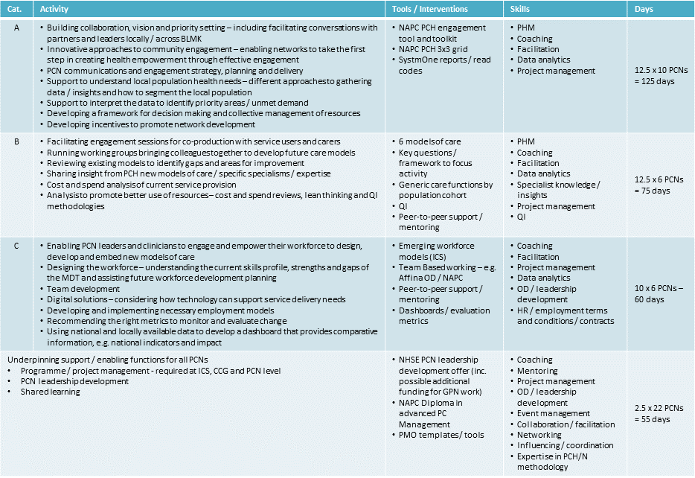
Figure 52 PCN support
In the meantime the following support as set out in Figure 53 from our delivery partners (NAPC) has been agreed to ensure maintained momentum in the short-term across BLMK. This is affordable as part of our current agreement.
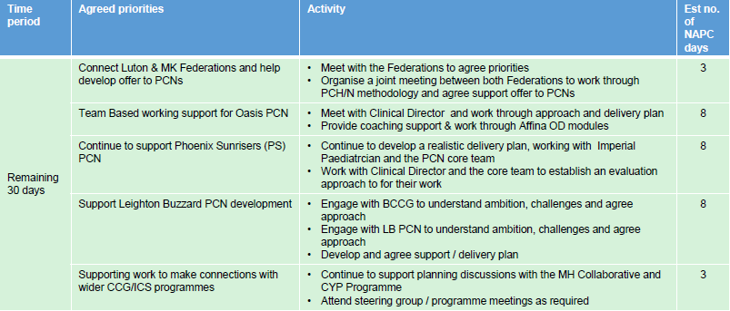
Figure 53 NAPC PCN support

PCN DES payments
BLMK CCGs will ensure successful flow of funds to Primary Care Networks to enable them to begin delivery of the PCN DES. The payments included in 2019/20 are set out below:
Payment type | Amount | Total across BLMK | Effective date
Network engagement funding – an annual payment paid to individual practices for participation in a Network. | £1.76 per patient | £1,632,265 | 1st July 2019
Network payment – a recurrent monthly payment, paid to the nominated account within the network from the CCG central allocations, intended to support the day to day operation of the network but allocation to be decided by the network. | £1.50 per patient per year or £0.125 per patient per month | £1,480,296 | Paid in July but backdated to 1st April 2019
Extended hours funding – the current extended hours DES will transfer to the network DES from 1st July 2019. Funding paid monthly to the nominated account and networks to decide how it is allocated between practices. | £1.099 per patient per year or £0.122 per patient per month | £1,084,563  (9 months) | 1st July 2019
Workforce – 100% funding for 1wte Social Prescriber and 70% funding for 1wte Clinical Pharmacist. Paid monthly. | Up to £37,810 annually for the Clinical Pharmacist  Up to £34,113 annually for the Social Prescriber | Dependent upon PCN take-up of offer | 1st July 2019
Clinical Director – funding provided on a sliding scale depending on network size. Paid monthly. | 0.15wte per 30,000 population (£20,627)  0.2wte per 40,000 population (£27,503)  0.25wte per 50,000 population (34,379)  Works out at £0.514 per patient per year or £0.057 per patient per month | £507,248 | 1st July 2019
Figure 54 PCN DES payments

GPFV
The following allocations for 2019-21 against ongoing delivery of the GP Forward View have been agreed by BLMK CCGs and NHS England in a Memorandum of Understanding.

Bedfordshire, Luton and Milton Keynes
 |  |  |  |  |  | 19/20 |  |  |  | 20/21
 |  |  |  |  |  | allocation |  |  |  | ring-fenced allocation
Practice Resilience |  |  |  |  |  | £130,334 |  |  |  | £138,480
GP Retention |  |  |  |  |  | £206,880 |  |  |  | £207,720
Reception and Clerical |  |  |  |  |  | £170,770 |  |  |  | £171,525
Online Consultation |  |  |  |  |  |  | £278,586 |  |  |  | £272,550
Practice Nursing |  |  |  |  |  |  |  |  |  |  | £69,240
Total |  |  |  |  |  |  | £786,570 |  |  |  | £859,515
Figure 55 GPFV MoU allocations

Investment and Impact Fund

As stated in the chapter on Element 2 in this document the Investment and Impact Fund is a new fund which Primary Care Networks will have access to and will help support implementation of the NHS Long Term Plan. Funding across England will rise from £75 million in 2020/21 to £300 million in 2023/4.

As more detail is published regarding the fund PCNs and CCGs will develop plans to implement against the framework.

Investment in Estates and Technology
In addition to business as usual expenditure on IM&T and GP IT capital bids BLMK are seeking to maximise the opportunity for ETTF funds.
Estates and Technology Transformation Fund (ETTF)
The BLMK allocation of ETTF funding for 2020/21 has been confirmed, and priorities have been discussed in principle with NHS England.
2019/20 ETTF Funding
The following schemes were allocated ETTF funding in 2019/20. The figure below provides a position update for these projects.
Scheme | Value | Position Update | Revised Budget for 2019/20
Kingsway | £502,000 | (Luton Estates scheme)  Scheme still at planning stage. NHSE have reallocated funding into 2020/21. | £0
Brooklands | £1,425,900 | (MK Estates scheme)  Scheme delivered by MK Council. Awaiting approval of OBC and Section 2 contract arrangements from NHSE. On track for receiving capital this year. | £1,425,900
GHH Hub Business Case | £164,000 | (Bedford Estates scheme)  OBC due for completion Sep 2019, subject to interdependent commissioning issues (including hydrotherapy pool). This remaining funding relates to FBC - on track for commissioning FBC prior to year-end. | £164,000
GHH Phase 1 | £450,000 | (Bedford Estates scheme)  On track for capital delivery of first phase of Hub scheme during 2019/20 | £450,000
MK Central Surgery | £116,000 | (MK Estates scheme – not included in previous paper to Executive)  On track for capital delivery during 2019/20 | £116,000
ISP1 Programme | £500,000 | (Digital programme across the three CCGs)  Executive Team previously agreed increasing allocation to £850,000. NHSE have now confirmed this increased allocation in principle. Updated PID to be submitted to NHSE.  On track for delivery during 2019/20 | £850,000
TOTAL |  |  | £3,157,900
Figure 56 2019/20 ETTF funding

Risks associated with 2019/20 funding:
- Brooklands is a national pilot scheme for using new legal arrangements for transferring ETTF funding to a Local Authority (Section 2 contract). Delays in structuring legal agreements could delay receipt of capital funding, with potential revenue implications for MKCCG. NHSE are currently reporting confidence in being able to complete in 2019/20.
- GHH Hub Business Case. Delays in confirming the long-term commissioning arrangements for the hydrotherapy pool at Gilbert Hitchcock House would cause delays in finalising the OBC for the Hub scheme – which may prevent the £164,000 funding for the FBC being spent during 2019/20. Mitigations could include reallocating the funding into 2020/21, or Bedford Hospital Trust funding the FBC following national approval of the OBC.

2020/21 Funding
NHSE have confirmed that £3.96m ETTF Funding is available to the BLMK CCGs in 2020/21. The figure below sets out the proposals that have been agreed in principle with NHSE for this funding. These proposals have been developed with estates and digital leads across the three CCGs and in discussion with relevant ICS leads.
There will be flexibility to reallocate funding between schemes later in 2019/20 if required.

Scheme | Value | Comments
Kingsway | £502,000 | (Luton Estates Scheme)  Funding reallocated from 2019/20 to provide sufficient time for patient consultation and completion of project. Potential to increase the value of the contribution if any of the other schemes are delayed.
Red House | £700,000 | (MK Estates Scheme)  Extension of existing GP premises. PID approved by MKCCG, OBC in development. Further detail is needed later this year to confirm if this scheme will be eligible for ETTF funding.
Whitehouse | £1,100,000 | (MK Estates Scheme)  Capital towards scheme. Potential to increase the value of the contribution if any of the other schemes are delayed. Also requires Section 2 contract arrangements, so dependent on successful completion of Brooklands legal arrangements.  Scheme, being delivered by MK Council, expected to be delivered by March 2019.
ETTF Legacy Fund | £690,000 | (BLMK-wide)  Funding to support quick-win priorities to be potentially identified through Estates Strategy development.
ISP1 Programme | £1,000,000 | Continuation of ISP1 Programme, with priority focus on digital enablement of Primary Care Networks (potentially including hardware to support new agile working arrangements – e.g. members of staff working across multiple practices). PID to be submitted to NHSE providing an outline of programme for 20/21.
TOTAL | £3,992,000 | (Slightly over BLMK allocation, approved in principle by NHSE)
Figure 57 2020/21 ETTF funding
Risks associated with 2020/21 funding:
- Further detail required by NHSE regarding Red House scheme to confirm eligibility for ETTF funding. Potential revenue implications for MKCCG if the scheme is not eligible for this capital contribution.
- Funding towards Whitehouse scheme dependent on the same new legal arrangements as are being developed for the Brooklands scheme. Delays in structuring legal agreements could delay receipt of capital funding, with potential revenue implications for MKCCG. Considered low-risk at this stage.
- Risk of perceived inequity of funding allocation across BLMK (no Bedfordshire estates schemes included in proposals). This is due to the necessary constraints around which schemes this funding can be used towards, i.e. practical completion expected during 2020/21.
In addition to ETTF significant resources have been secured and established to support delivery of the digital element of the primary care strategy, including,
- £6.6m HSLI (Health System Led Investment) Funding to support implementation of the integrated health and care record across BLMK
- ICS Chief Information Officer and Digital Programme Lead
- ISP1 Programme Lead and dedicated Programme Manager
- Dedicated ICS Information Governance Lead

The ongoing revenue implications of each project are assessed and signed off by the appropriate Board prior to implementation. The impact of increased agile working in particular will require further assessment during 2019/20.

Investment and Impact Fund

As stated in the chapter on Element 2 in this document, the Investment and Impact Fund is a new fund which Primary Care Networks will have access to and will help support implementation of the NHS Long Term Plan. Funding will rise from £75 million in 2020/21 to £300 million in 2023/4.

As more detail is published regarding the fund PCNs and CCGs will develop plans to implement against the framework.

Risks & Mitigations
Delivery of the BLMK Primary Care Strategy relies on the funding streams outlined in this section being made available to CCGs, Primary Care Networks and other relevant providers. Alterations to the above may result in some work streams taking longer to complete or not taking place at all. Aside from the general risk around receipt of funding the following risks to delivery remain:

- Resilience – current ageing workforce and pressure this is putting on GPs and current configuration of practices and capacity to deliver transformation
- Resilience – increasingly, funding having to be diverted to support practices (caretaking arrangements, procurement and APMS contract premiums, mergers, section 96 support etc)
- Workforce – plans to develop PCNs and develop practice resilience rely on the delivery of new roles and the upskilling of existing skills
- Digital – There is a risk that digital enablers fail to provide the functionality needed by PCNs/the wider health economy to deliver the new model of care
- PCNs developing and maturing - development will rely on strong clinical leadership and engagement. They need to be forward thinking, entrepreneurial and deliver.
- Estates - delivery of major estates programme and primary care seizing the opportunity that this presents.

As part of this strategy mitigations are being developed for each of these risks.

Useful Data Sources

Data Source | Link
National general practice profile from PHE can be useful source of demographics info and mapping solutions. | https://fingertips.phe.org.uk/profile/general-practice/data#page/8
Weighted populations and allocations | https://www.england.nhs.uk/allocations/
GP practices data | https://digital.nhs.uk/services/organisation-data-service/data-downloads/gp-and-gp-practice-related-data  and  https://digital.nhs.uk/data-and-information/publications/statistical/patients-registered-at-a-gp-practice
Workforce data | https://www.nwrs.nhs.uk/
GP Patients survey | http://www.gp-patient.co.uk/
Figure 58 Useful data sources

Appendices

Appendix A: BLMK PCNs (list)

Appendix B: The Core Elements of Primary Care Home
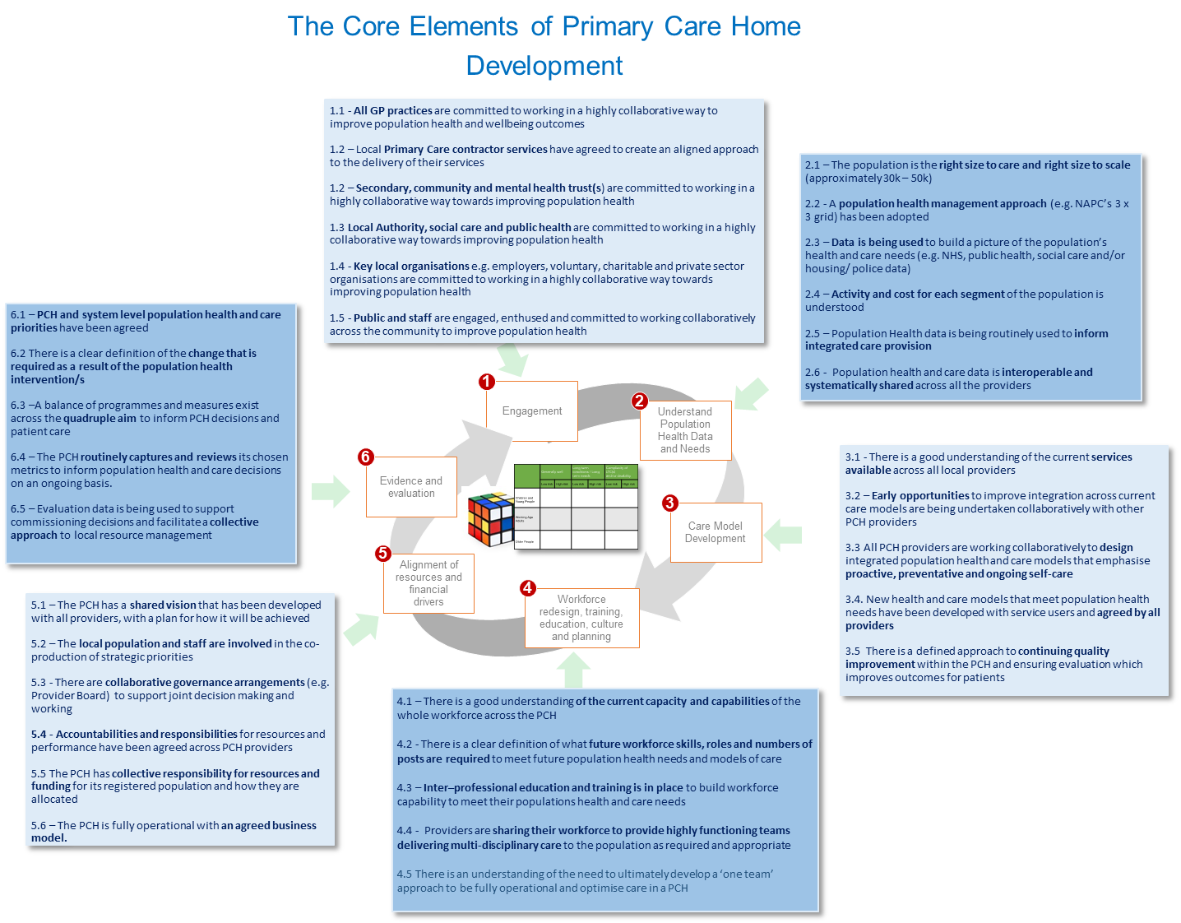

Appendix C: Time series of baseline figures for GP’s (workforce)

Appendix D: BLMK ICS Leadership & OD plan

Appendix E: BLMK Local Workforce Plan

Appendix F: Hubs - Service Model Framework
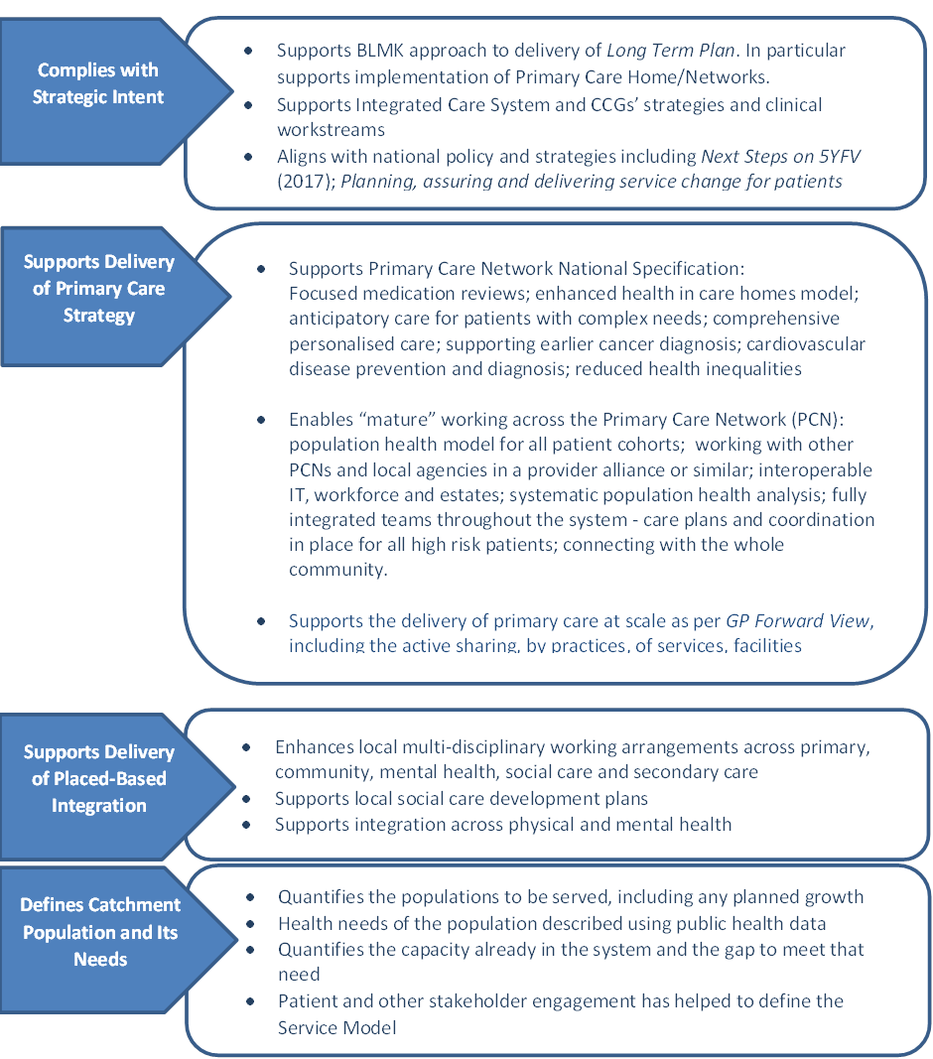

Appendix G: Priority Primary Care Estates Scheme
Scheme | Description | Expected Delivery
Kingsway (Luton) | Refurbishment of a GP premises to enable co-location of two surgeries | 2020/21
Red House (Milton Keynes) | Expansion of a GP premises to provide much-needed additional capacity | 2020/21
Whitehouse (Milton Keynes) | Integrated health and care hub being developed in partnership with Milton Keynes Council to serve large new housing development (list size of up to 22,000) | 2020/21
Gilbert Hitchcock House Hub (Bedfordshire) | Integrated hub to enable co-location of three surgeries into one building, alongside a range of integrated services. | 2022/23
Chiltern Vale Hub (Bedfordshire) | Integrated health and care hub being developed in partnership with Central Bedfordshire Council, including relocation of a number of GP practices in Dunstable town centre | 2022/23
Ivel Valley Hub (Bedfordshire) | Integrated health and care hub being developed in partnership with Central Bedfordshire Council, including relocation of up to two GP practices in Biggleswade | 2022/23
Kempston Hub (MSCCC) | Proposed relocation of up to three GP Surgeries into one Hub facility in Kempston, with potential to provide a range of other health and community services from the same building | 2022/23
Biddenham Primary Care Home Hub | Proposed relocation of the two Bromham branch surgeries into a new facility between Bromham and Biddenham. | 2020/21
Wootton Healthy Living Centre – new premises | (High Street GP facility)  Proposed relocation of the surgery in Wootton into new permanent premises. Planning for this new facility will be carried out in conjunction with the planning for the proposed Kempston facility, to maximise opportunities to improve access for Wootton residents to a wider range of services. | 2021/22
Shortstown Surgery – new premises | (High Street GP facility)  Relocation of Shortstown Surgery into new facility. | 2019
Marston Surgery | Reconfiguration of GP surgery premises to provide much-needed additional capacity | 2019

Appendix H: BLMK Cluster Maturity Map – March 2019
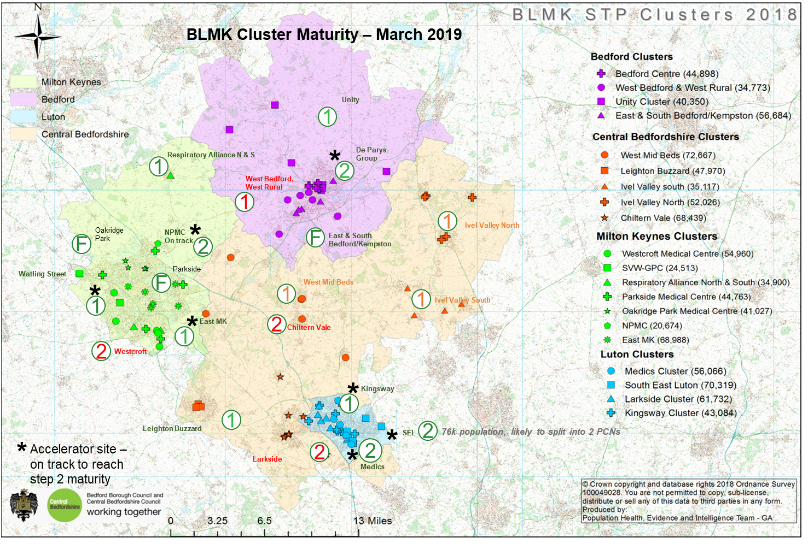

Appendix I: NHS E Maturity Matrix
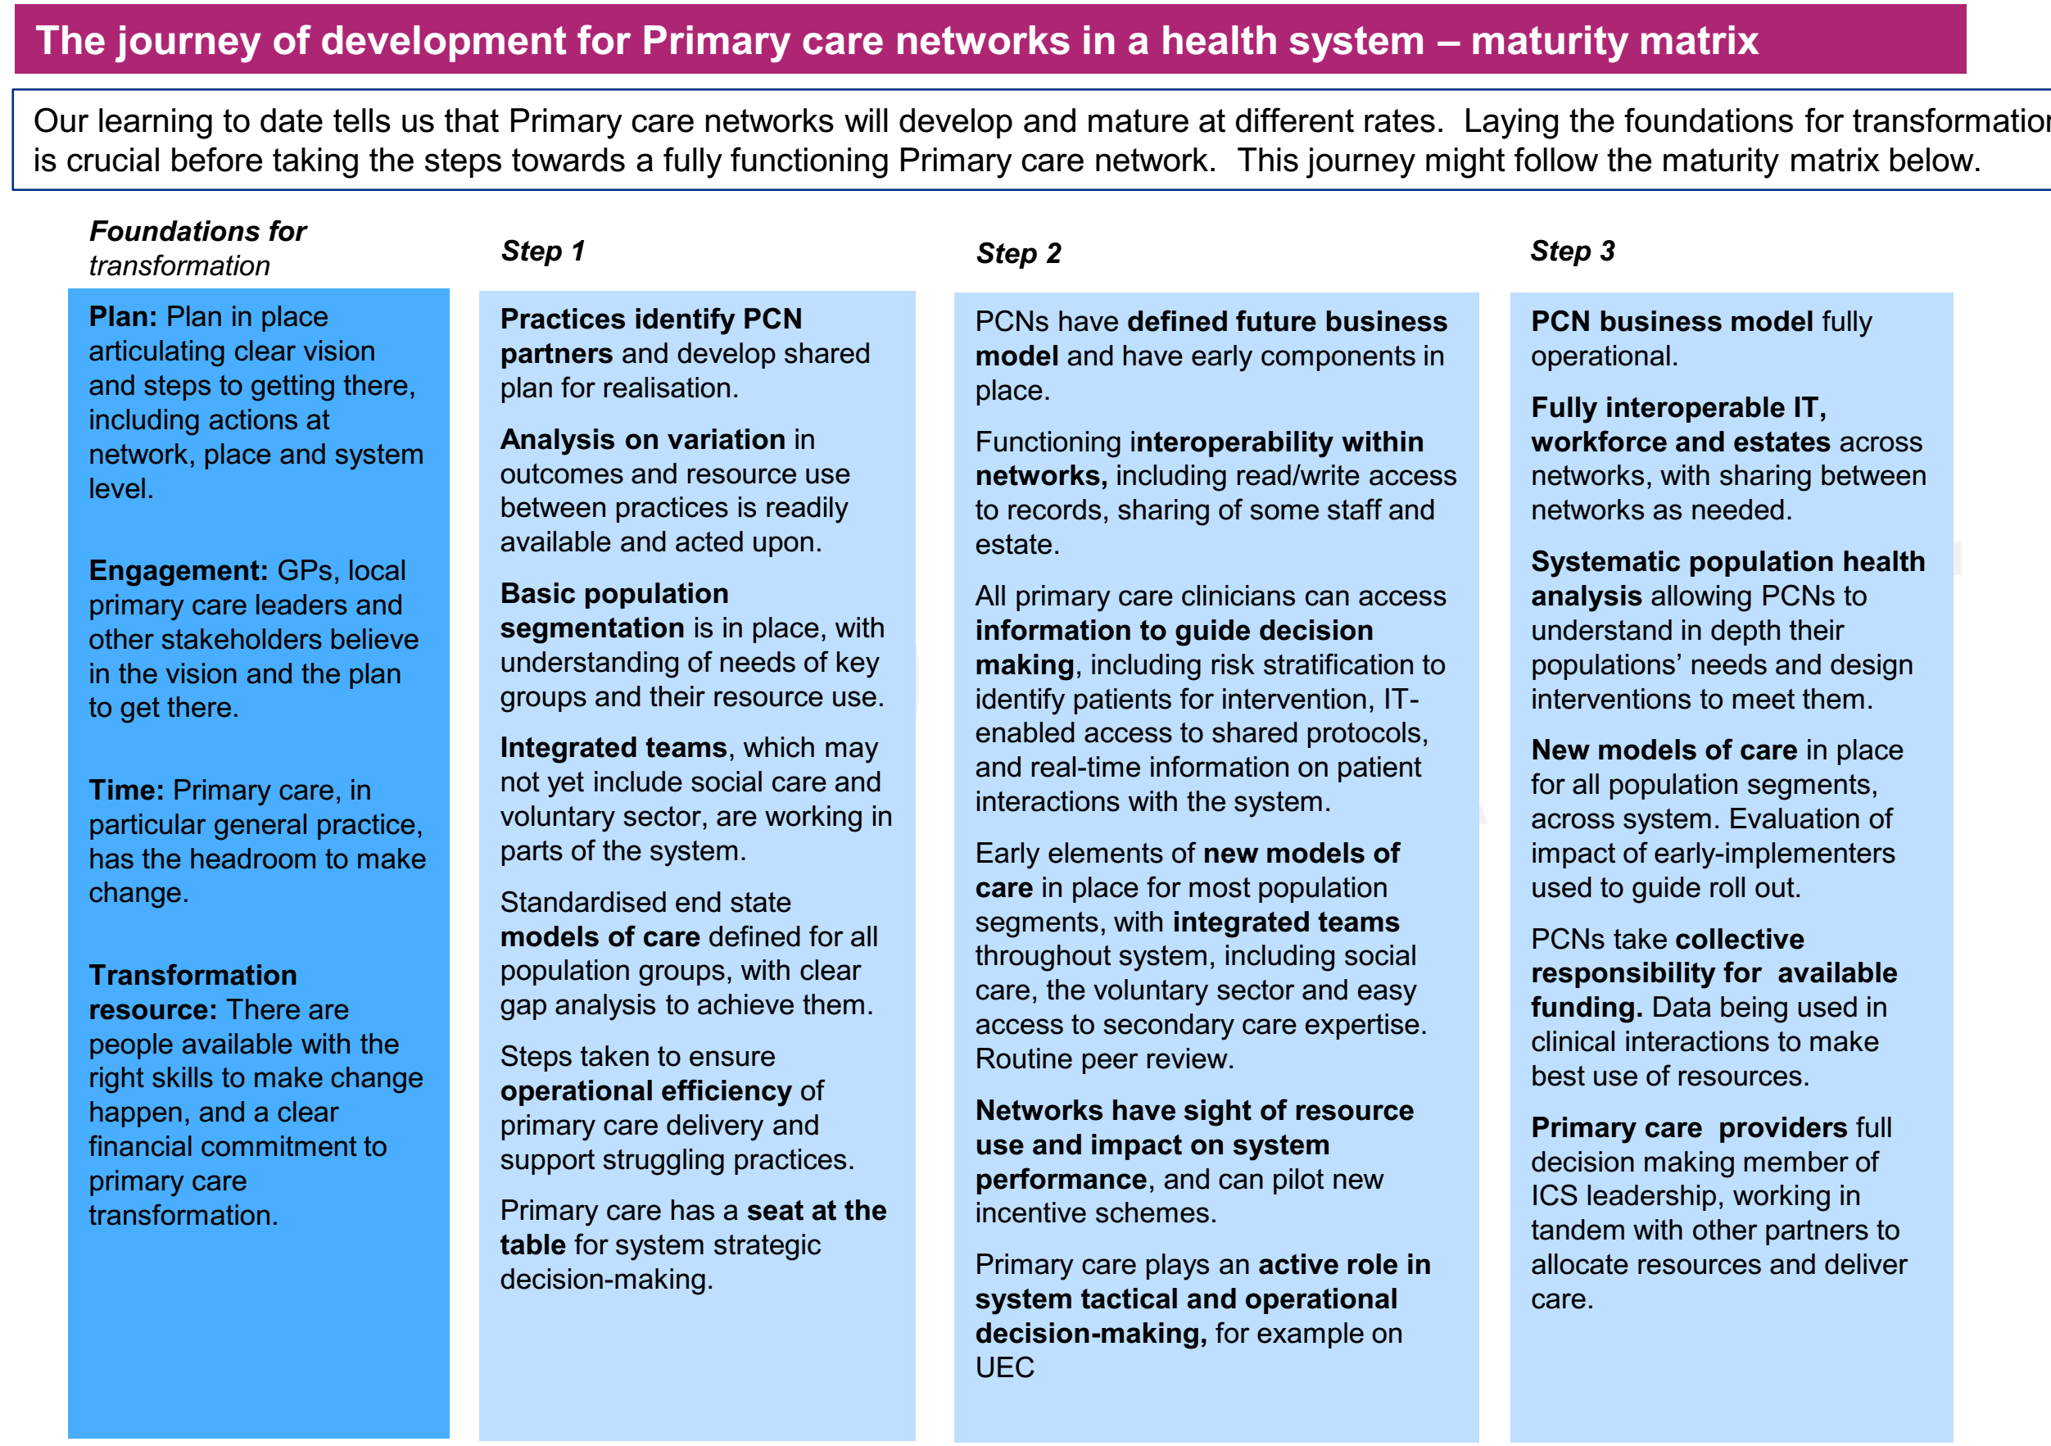

Appendix J: Complex Children

Appendix K: Personalisation Programme
BLMK are initially targeting the following cohorts for the purposes of expanding the personalised care approach:
- Mental Health (S117) and Learning Disabilities
- Long term conditions: Cancer, Diabetes, ABI/Stroke
- Frailty
- End of Life (EOL)
- Maternity
- Wheelchairs
- Carers

Mental Health and Learning Disabilities

- BLMK are developing a personalised offer for those entitled to Section 117 aftercare. This will include personal health budgets (PHB) in readiness for the legal ‘right-to-have’ developments. Several events have been held with the NHSE Personalised Care team in order to develop the process for the S117 cohort, which involved NHS commissioners, local council commissioners and mental health providers.
- We are committed to creating more confident and empowered people with serious mental illness to self-care. We will ensure that the mental health providers and adult social care teams use the personalised approach to develop the skills and knowledge of the people and staff to manage personal budgets.
- Some people with complex needs Learning Disability clients who have moved out of inpatient facilities and are living in their own homes or supported accommodation and receive complex packages of care and being assessed for suitability of PHB offer.

Maternity:

There are approximately 1000 births per month across BLMK. We will continue to work towards implementing the recommendations from the Five-Year Forward View as documented in the Better Births report from 2015. Particular focus will be on ensuring that all women have a personalised care plan (as mandated by 2021), developed with her midwife and other health professionals, which sets out her decisions about her care, reflects her wider health needs and is kept up to date as her pregnancy progresses.

Continuing Healthcare:

BLMK will continue to work together to further develop CHC functions, processes and policies in order to ensure a high-quality personalised approach. We are committed to meeting the requirements of Personal Health Budgets being the default position for CHC. This will be achieved by:
- Converting those living/receiving domiciliary care to a PHB at review
- The default offer of a PHB for newly funded CHC patients receiving domiciliary care

End of Life (EOL)

An End of life transformation programme is currently underway, which includes:
- Focus on advanced care planning in Primary Care – training and education around good conversations with people
- To identify more people who are in last year of life (with long term conditions)
- Implementing EPaCCS (Electronic Palliative Care Co-ordination system

Wheelchairs

Our wheelchair providers currently offer personalised care and support plans and personal wheelchair budgets are now being offered across BLMK.

High Intensity Service Users

BLMK plans include Multi-Disciplinary Team (MDT) intervention, along with multi-agency case management for risk-stratified patients with complex needs delivered at place. We will continue to focus on high intensity users’ schemes to optimise admission avoidance pathways.

High-intensity service users have been identified and have been offered a period of intensive support, including a personalised offer and what matters conversation. We are in the process of developing a PHB offer for this cohort.

ABI/Stroke

We are exploring the possibility of PHBs for those that have an ABI or have suffered a stroke, and may benefit from care at home rather than in a nursing home setting. This will be particularly relevant following a period of intense rehabilitation as people are returned to their local community.

Long-term Conditions and Frailty

BLMK will continue to make use of frailty index risk assessment tools in order to identify those who would benefit from personalised anticipatory care and support planning, self-care management, heath coaching, community support, advice and guidance, navigation and rapid response MDT intervention, to identify and monitor those at risk of acute admissions.

Person Centred Care and Support Planning

BLMK are committed to ensuring that people receive a truly person centred approach to care planning, continuing the shift to ‘what matters to you’ rather than ‘what is the matter with you’. We will continue to expand on this approach through further comprehensive staff training and review.

Shared Decision Making (SDM)

We have shared decision making in place across our respiratory pathway within Bedfordshire, but are committed to developing and expanding the approach. We are working with the NHSE personalised care team and the SDM lead to fully embed SDM in a RightCare specialty pathway.

Shared Decision making training will be rolled-out to include primary care as we seek to ensure the approach is business as usual going forward.

Social Prescribing

Social prescribing is in place across BLMK and we are committed to further expanding the offer, to include the use of additional link workers as per the NHSE funding for additional link-workers for Primary Care Networks.

Solutions will include linking people to local groups, activities and new hobbies. Individuals will have support tailored to their needs, ranging from very regular, intensive support to single-contact interventions.

Self-Care and Self-Management

Within the self-care/self-management programme, there are three main areas of activity:

- Directory:
We will further develop local directories to ensure it is a trusted source of current information for services and support to help people to manage their conditions in the community.

- Health coaching – capacity building:

There will be continued training for various professional groups, including adult social care, housing, revenue and benefits. GPs and practice staff covering the following:
    - Conversational skills
    - Behaviour change theory
    - Motivational interviewing
    - Goal-setting

There has been interim local evaluation of this training and has highlighted what participants are doing differently as a result of the programme:
    - Asking more open questions
    - Rethinking and rewording how I ask questions
    - Encouraging people to think and make decisions
    - Recognising the power of small, realistic steps
    - Actively listening
    - Movement from an advice giver to a coach
    - Using the range of tools

- Population management/self-care:
There will be continued work on place based population health analytics to identify areas of opportunity with an aligned menu of interventions. This will be available within primary care and will link to the outcomes framework.
The objectives of this activity fall within two strands:
    - Population identification/stratification
      - Improve approaches to identify the population cohort at risk of high secondary care usage
      - Ensure clear support, pathways and service options are available to those identified, linking to current services
    - Developing self-care and self-management in the community:
      - A Staff Health Coaching Programme will strengthen the customer service offer for prevention and early intervention

This approach will involve risk segmentation methodology developed locally using the following segmentation criteria:
    - Utilisation levels
    - Level of chronic disease burden
    - Cost of care
    - Presence of specific disease state

Co-production

We have established a strategic co-production group of people with lived experience of personalised care across BLMK. This group sits on the Personalised Care steering group and will have a direct impact on decisions and strategy as we further embed the Personalised Care approach.

Patient Activation Measure (PAM)

The Patient Activation Measure is in use across BLMK as part of the social prescribing pathway. The score is used to determine the level of support appropriate to achieve maximum outcomes for people.

Appendix L: PCN Network Map – Required Support from May 2019
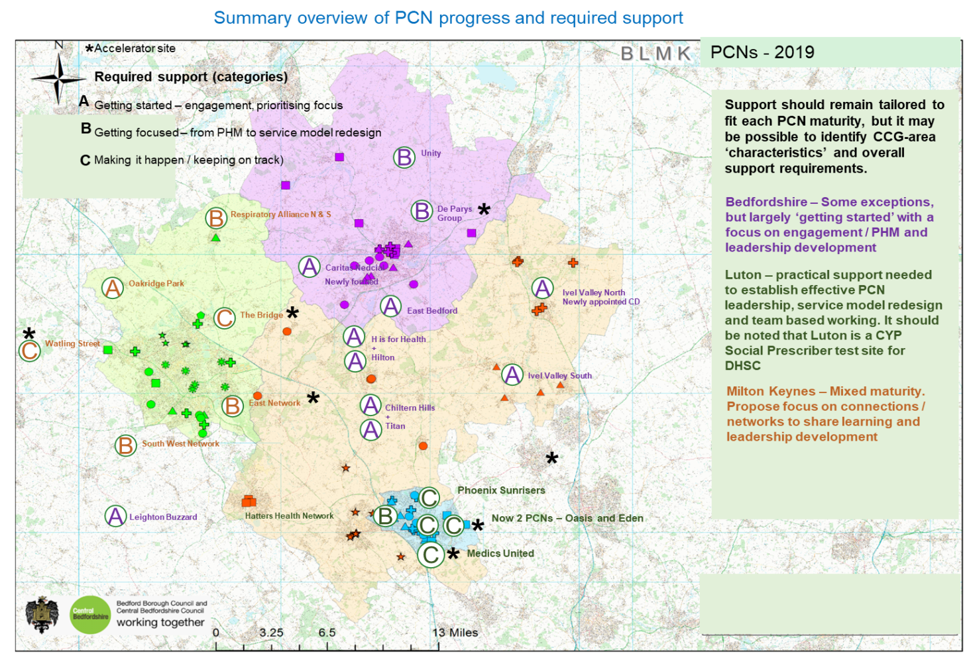

Appendix M: Primary Medical Allocations

Appendix N: Primary Care Medical Services Forecast Spend
Bedfordshire Delegated Budget 19/20- 23-24
 |  | 19-20 | 20-21 | 21-22 | 22-23 | 23-24
Population Growth |  |  | 2.00% | 1.92% | 1.64% | 1.64%
Inflation |  |  | 2.30% | 2.80% | 2.50% | 2.70%
 |  | £000 | £000 | £000 | £000 | £000
Main Contract |  | £43,044 | £44,173 | £45,703 | £47,598 | £49,663
Primary Care Networks |  | £1,671 | £2,647 | £3,610 | £4,924 | £6,457
Enhanced Services |  | £1,487 | £1,535 | £1,608 | £1,674 | £1,747
Premises |  | £5,030 | £5,246 | £5,494 | £5,721 | £5,970
Primary Care Other |  | £1,077 | £909 | £929 | £951 | £973
Quality & Outcomes |  | £5,456 | £5,691 | £5,959 | £6,206 | £6,476
Prescribing |  | £1,823 | £1,901 | £1,991 | £2,074 | £2,164
Other |  | £3,220 | £3,775 | £4,405 | £4,513 | £4,630
Central Costs |  | £30 | £81 | £83 | £85 | £87
Contingency |  | £314 | £329 | £349 | £368 | £390
QiPP Required |  | -£360 | -£445 | -£397 | -£453 | -£619
Total Annual Expenditure |  | £62,792 | £65,842 | £69,734 | £73,661 | £77,937
Allocation |  | £62,792 | £65,842 | £69,734 | £73,661 | £77,937

Luton Delegated Budget 19/20- 23-24
 |  | 19-20 | 20-21 | 21-22 | 22-23 | 23-24
Population Growth |  |  | 2.00% | 1.92% | 1.64% | 1.64%
Inflation |  |  | 2.30% | 2.80% | 2.50% | 2.70%
 |  | £000 | £000 | £000 | £000 | £000
Main Contract |  | £20,531 | £21,193 | £22,045 | £22,959 | £23,955
Primary Care Networks |  | £902 | £1,453 | £2,042 | £2,841 | £3,773
Enhanced Services |  | £677 | £706 | £740 | £770 | £804
Premises |  | £3,259 | £3,399 | £3,559 | £3,707 | £3,868
Primary Care Other |  | £373 | £344 | £317 | £325 | £334
Quality & Outcomes |  | £2,455 | £2,560 | £2,681 | £2,792 | £2,913
Prescribing |  | £269 | £281 | £294 | £306 | £320
Other |  | £2,303 | £2,519 | £2,746 | £2,846 | £2,956
Central Costs |  | £60 | £61 | £63 | £64 | £66
Contingency |  | £328 | £976 | £818 | £184 | £191
QiPP Required |  | £0 | £0 | £0 | -£44 | -£944
Total Annual Expenditure |  | £31,157 | £33,493 | £35,305 | £36,750 | £38,235
Allocation |  | £31,157 | £33,493 | £35,305 | £36,750 | £38,235

Milton Keynes Delegated Budget 19/20- 23-24
 |  | 19-20 | 20-21 | 21-22 | 22-23 | 23-24
Population Growth |  |  | 2.00% | 1.92% | 1.64% | 1.64%
Inflation |  |  | 2.30% | 2.80% | 2.50% | 2.70%
 |  | £000 | £000 | £000 | £000 | £000
Main Contract |  | £24,163 | £25,181 | £26,034 | £26,782 | £27,577
Primary Care Networks |  | £1,175 | £1,611 | £2,120 | £2,939 | £3,973
Enhanced Services |  | £757 | £790 | £827 | £861 | £899
Premises |  | £4,055 | £4,229 | £4,429 | £4,612 | £4,812
Primary Care Other |  | £491 | £410 | £330 | £367 | £406
Quality & Outcomes |  | £3,063 | £3,195 | £3,345 | £3,484 | £3,635
Prescribing |  | £189 | £197 | £207 | £215 | £225
Other |  | £944 | £1,228 | £1,546 | £1,585 | £1,628
Central Costs |  | £93 | £145 | £150 | £153 | £157
Reserves |  | £332 | £69 | £30 | £183 | £329
Total Annual Expenditure |  | £35,262 | £37,055 | £39,017 | £41,182 | £43,642
Allocation |  | £35,262 | £37,055 | £39,017 | £41,182 | £43,642

Appendix O: Engaging the team
We’ve learnt through the existing BLMK primary care development programme that the following ways of working create a productive environment for PCNs and their MDTs to flourish.
Help people to feel part of something
- a network of people first; task second
- let the network evolve and grow naturally – decide together who to involve / include
- have fun at meetings, and meet socially outside work

Recognise the need for leadership to set the pace and maintain momentum, but
- Don’t tell people the answer; work it out together
- Pick up the phone and speak to people to find out what matters to them and how they want to get involved
- Look for the common ground; what we can all agree on (population health is a great way of refocusing the debate)
- Find the potential dissenters and give them a role to support and drive the work

Let people go at their own pace
- People can’t own something they feel they’ve had no contribution to, or interest in - it takes time to get and keep them involved
- Different people coming along to meetings. If we’ve identified a gap in representation, or someone has been unable to attend - always catch them up before we move on to the next thing
- If people want to get involved, don’t kill enthusiasm by saying no; find something for them to do

Keep it practical and simple
- Use stories / case studies to bring ideas / concepts to life – not everyone understands theoretical / policy language
- Ask targeted questions to help people think through the why, what and the how
- Focus on one thing at a time – help people to see this is possible to do
- Keep the priority cohort (segment of the population) to a manageable size – c300, to review functions and develop new models of care

Metrics from existing tools and reporting frameworks, including ASCOF, PHOF, EQ5D, HES, GP patient survey
Statements are taken from the NHS staff survey and could be applied to all MDT care professionals

